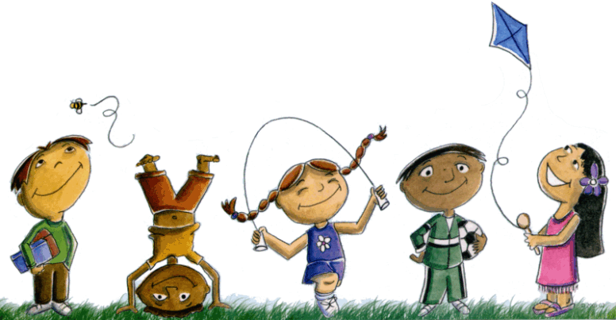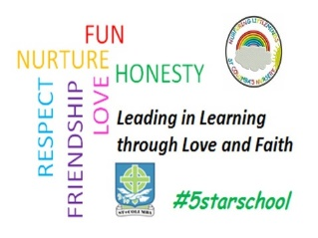St. Columba’s Nursery Class

Home Learning Health and Wellbeing Activities Week 2

|  |  |  |
| --- | --- | --- |
| Paper Fish Race     * Cut out fish shape from paper. * Stand at one end of room. * With another piece of paper / card wave it at the paper fish to move it. * Race to the other side of room. | Image result for den building free clipMake A Den  Den building is a fun way to make maths exciting!   * You will need-open ended materials e.g.: sheets, pegs, blankets, cardboard boxes, under a table * As the Den is being constructed children develop their maths through talking, counting, using number language, how big, how wide, how tall, exploring shape and space, estimating and measuring. | Help to prepare a meal at home  [Related image](https://www.google.co.uk/url?sa=i&rct=j&q=&esrc=s&source=images&cd=&cad=rja&uact=8&ved=2ahUKEwiK1tuUoY7gAhU2AmMBHQ_WA9sQjRx6BAgBEAU&url=https://hub.careinspectorate.com/improvement/care-inspectorate-programmes,-projects-and-publications/our-creative-journey/creative-examples-materials/&psig=AOvVaw1Vwgv6cYgYPmYvsrqNAcIm&ust=1548688606734178)   * This could involve chopping/slicing fruit/veg. * Counting out amounts needed. * Spreading skills etc. * Discuss what is healthy/unhealthy. |
| Try Yoga   * Develops strength and flexibility * Increases body awareness, balance, and coordination * Provides an emotional regulation tools * <https://www.cosmickids.com/> | Make A Paper Plate Picture    Draw or stick objects onto a paper plate to make a mounted picture. | Play a memory game   * Put 5 objects on a tray. * Ask your child to look and name each object. * Cover the tray with a dish towel. * Take an object away. * Uncover the objects, can your child tell you what is missing. |