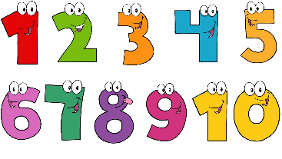
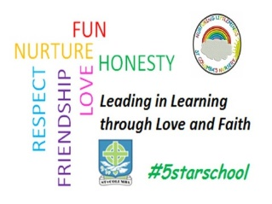
St. Columba’s Nursery Class
Home Learning Number Activities Week 1

Counting Skills  - There are lots of opportunities to encourage counting as you go about your daily routine.  - Count steps as you climb the stairs, the number of dogs you see in the park, items on the conveyor belt at the supermarket  - Sing number songs and rhymes together. | Counting Skills  - Count fingers and toes with your child when putting on gloves, socks or getting dried.  - Count real objects, for example, cups, shoes, socks, packets. As your child becomes more confident doing this, begin to add and take away. For example `If I add 1 more, how many will I have now? | Counting Skills  - Encourage your child to place their finger on objects as you count out loud. This will help them count objects only once as they count.  - Encourage counting forwards and backwards to build confidence with counting.
Number Recognition  - Play number games with your child, for example, matching games, number bingo, snap.  - Look for notices and signs when you are out that have numbers on them, for example, speed signs, phone numbers. | Number Recognition  - Use words such as first, second or third to help your child understand the order of things. | Number Recognition  - Play number spotting games at home or at the shops and look for numbers on packages, clocks, coins, buses and car registrations.  - Look for numbers on houses and flats.

