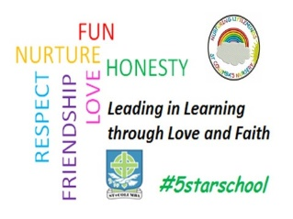St. Columba’s Nursery Class

Home Learning Literacy Activities Week 1

|  |  |  |
| --- | --- | --- |
| I can listen   * Go on a sound walk * Ask your child the question, what can you hear? * Take a pencil and paper and record what you hear by drawing pictures or writing the words. * Not only is a sound walk fun, but it also allows children to become more aware of the world around them and heighten their sensory awareness- so they are learning and developing as they play! | I can listen   * What’s in the bag? * Put some small toys in a small cloth bag eg;toy animals, a cup, toy car. * Turn the bag while singing, “Turn, turn, and turn around…put my hand in, what have I found? * Put your hand inside and chose something * Holding the item in the bag, describe the item * Use one description at a time, so your child can build an image in their mind * Playing the games provides the opportunity to develop listening skills | I can listen   * Ready, Steady, Pop * You will need-bubbles * Blow some bubbles and ask child to pop them * Then try blowing the bubbles, but this time the child has to wait until you say, “ready, steady, POP” * You could also try introducing another child where they take turns popping the bubbles |
| Mark Making   * Go outdoors * The natural world provides lots   Of inspiration for mark-making with leaf and bark rubbing, flower pressing, sticks, rocks and creations using fir cones and seed pods.   * Why not get some washable chalk and write on the ground? | Mark Making   * Make play dough * <https://www.bbcgoodfood.com/howto/guide/playdough-recipe> * Rolling and kneading the dough is great to develop strength in finger muscles needed for holding and controlling writing implements | Mark Making   * Mark Making doesn’t have to be using pens, pencils and brushes. * Try….Your hands!, Sponge, Foil, cling film, greaseproof paper, Feathers, leaves, sticks, pipe cleaners, Cotton Wool String * Pens, Pencils, Crayons * Spatulas, Spoons, Forks, Whisk |