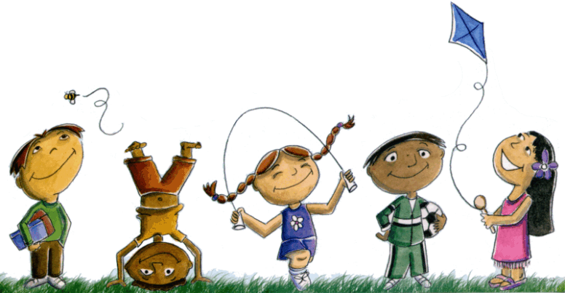
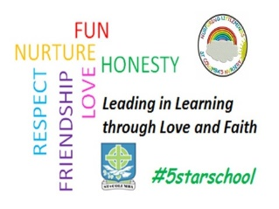
St. Columba’s Nursery Class
Home Learning Health and Wellbeing Activities Week 1

Talking and Sharing  - Make a treasure box with your child  - Decorate a shoe box-you will need, paint, glue, fabric, stickers, pens, wrapping paper  - Collect things that are important to your child to put in the box  - Encourage your child to share and talk about the objects and why they are special | Hand Washing Song  - Hand washing can be a fun activity  - Sing the hand washing song (to the tune of Row, row, row your boat)  - Wash, wash, wash your hands, wash them nice and clean, Wash the backs and wash the palms, and the fingers in between | Go on a bug hunt  - Talk about where you could find some minibeasts, where they live and what they eat  - Go to your local park or your garden  - Explore under rocks and logs  - Take a magnifying glass to look at them more closely
Try Yoga  - Develops strength and flexibility  - Increases body awareness, balance, and coordination  - Provides an emotional regulation tools  - https://www.cosmickids.com/ | Sensory Play  - Sensory play arouses children’s imaginations, creativity and curiosity and is great fun! Gloop is an interesting mixture with a unique texture and is great for sensory play.  - Try making gloop  - https://www.learning4kids.net/2012/05/02/how-to-make-gloop/ | Developing coordination  - Make homemade bean bags using old socks and rice or pasta  - Use a large container to throw the bean bags into  - You can make this trickier by using smaller containers or moving the container further away

