Welcome to

St Columba’s Nursery Class
Philip Avenue
Boghall
Bathgate
EH48 1NQ
01506 653822
Nursery Handbook for Parents/Carers
2019-2020

Welcome

Welcome to St Columba’s Nursery class. Starting nursery is a major step in your child’s development and we aim to work in close partnership with parents/families to make the transition from home to nursery as smooth as possible for you and your child.

We look forward to having your child with us at St Columba’s Nursery Class. Staff are committed to creating a safe, happy and stimulating environment where each child is treated as an individual and encouraged to achieve their full potential.

We hope that you find the information in this handbook informative and relevant. Please speak to a member of staff if you have any questions or comments.

Thank you
The Nursery Team

Our Staff

Head Teacher
Miss F Smyth
Principal Teacher
Mrs K Potter
Early Learning and Childcare Area Support Manager
Mrs A Anderson
Early Years Officers
Mrs C Gouws
Miss L Lund
Mrs E Notman
Early Years Practitioners
Miss K Coyle
Mrs M Dori Muir
Mrs A Sommerville
Mrs M Wright
Mrs J Currie

Our Vision
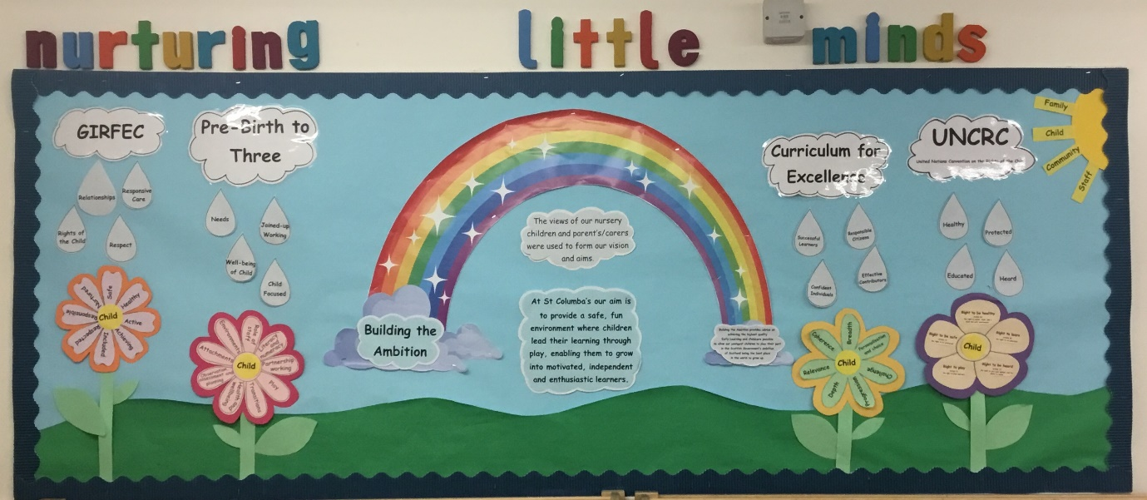
At St Columba’s our aim is to provide a safe, fun, nurturing environment where children lead their learning through play supported by staff. Enabling them to grow into motivated, independent and enthusiastic learners.
Play
Safe
Fun
Nurtured
Staff

Nursery Class Hours 2019-20

AM Session Monday-Thursday
08.00-12.45

PM Session Monday-Thursday
13.15-18.00

Full Day Session
08.00-18.00

School Holidays
Holidays and term dates can be accessed online at:
https://www.westlothian.gov.uk/article/30307/School-Terms-and-Holidays-20192020

Arriving at nursery
- Children must be brought and collected from nursery by a responsible adult (over 16).
- Parents/carers should notify nursery staff if someone different is going to pick up your child and provide a prearranged password.
- There is always an opportunity at the start and end of sessions to talk to the nursery staff.
- Please telephone the school office to advise if your child will be absent for any reason.
- To keep our children safe, please do not use the staff carpark for the dropping off and collecting of children.

Settling in

- Some children settle in quickly at nursery, some children take longer to accept separation.
- We will work closely with you to help your child settle happily.
Parking

- Please do not use the school car park for setting down and collecting children. This is to keep all our children safe.

Absence/Illness
- If your child has been recorded as absent, and no prior notification of absence has been given by the parent / carer we will contact you via a Group Call.
- The school will attempt to contact you within one hours of school starting on the first morning of absence on the emergency contact number provided and stored on your child’s personal plan.
- Parents / Carers must provide the nursery with emergency contact name and number and ensure this is kept up to date. In particular this applies to mobile phones. (Please keep your mobile phones on while your child is at nursery and update us immediately if you change your number).
- If your child has sickness or diarrhoea, the care commission recommend you to allow 48 hours after the symptoms disappear before returning to nursery. Please let the nursery know if your child has an infectious illness such as chicken pox, measles, whooping cough, mumps, rubella, infective hepatitis, swine flu or any other infectious illness.
Administering of medicine
- Please advise staff of any child’s health issues e.g. allergies, the need for inhalers or any other medication. This information is stored on your child’s personal plan.
Data Protection
- Under the terms of Data Protection Act 1998 any personal information given is held securely and treated confidentially.

Clothing
- All children are allocated a peg for jackets/coats and a box for shoes
- To encourage independence skills please provide named clothing and indoor shoes, elasticated front or velcro fastening gym shoes and trousers with elasticated waist bands
- Please also be aware that children play and explore in the nursery garden daily and engage in messy play activities, so their clothing may get dirty. We recommend that children wear old clothing and have welly boots.
- Please provide a change of clothing e.g.; pants, socks, top, bottoms.

Uniform
- Should you wish sweatshirts and polo shirts with the nursery logo can be ordered online or complete the order form in your enrolment pack.

Toys
- We kindly ask that toys be left at home.
- Toys can become lost or broken and this can cause upset for children.

Nursery Snack
- There is a compulsory fee for nursery snack of £1.50 per week.
- You have the option to pay weekly or if you prefer you can pay the fees for the full term.
- We provide a healthy snack each day and a drink of milk or water.
- Children help to choose which snacks they would like and snacks are chosen in line with the Scottish Government’s “Setting the Table” nutritional guidelines.
- Children attending for a full day session should bring a packed lunch.
Online Learning Journals
- We use online Learning Journals to keep you updated with your child’s learning in nursery.
- Each child has their own profile where you can see their achievements, observations and photographs.
- We value your input into your child’s Learning Journal. Please leave comments whenever possible.
Keeping in touch
- Informal discussions
- Parental consultation evenings
- Review of Child’s Personal Plan (minimum 6 month)
- Our notice board in the cloakroom
- Nursery handbook
- Website
- Nursery blog
- Twitter
- Child’s online journal
Curriculum

- To achieve our learning aims we follow Curriculum for Excellence, GIRFEC, the Scottish Government ‘Building the Ambition’ document and the self-evaluation guide “How good is our Early Learning and Childcare”.
- We also ensure the UNCRC Rights of the Child is evident in all practice within our nursery.
- Our children make their own choices for learning through their play.

At St Columba’s Nursery we……

Positive Behaviour

Part of a child’s development is learning to live, learn and play alongside and with others. Staff encourage children to share and express their needs and feelings in a positive way by
- Having a calm and consistent approach
- Supporting children to resolve conflict
- Helping children find positive ways to deal with their feelings
- Recognising positive behaviours

We hope this booklet has been helpful to you, if you have any questions, suggestions or comments please speak to a member of the nursery team.

The Nursery Team

