****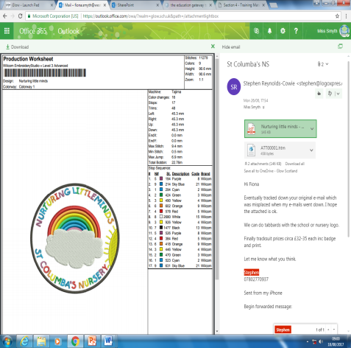

St. Columba’s Nursery

Week Beginning 23rd September 2019

Nurturing Little Minds

Headteacher: Miss Fiona Smyth



|  |
| --- |
| Wednesday 25th September Parent Council Meeting |
| Friday 27th September MacMillan World’s Biggest Coffee Morning 9.30 – 11.30am |  |
| . |  |
|  |

PARENT COUNCIL

Wednesday 25th September

6.00pm

If you have some time to spare please come along and support our Parent Council. New members are welcome!

OCTOBER HOLIDAY

The nursery will be closed from Monday 14th October.

All children return Monday 21st October – normal session times



Snack Reminder

Please remember to pay your child’s snack money. The cost for snack is £1.50 per week. Parents can pay weekly, monthly, per term or yearly.

DROP OFF

Please remember to take your child into the playroom when dropping off at nursery.





Please remember to hand in your stickers from ALDI. Every sticker counts!

FRIDAY 27th SEPTEMBER

MACMILLAN COFFEE MORNING  
Please come along and join us.

Tickets are available from Nursery Staff and cost £1.

Donations of raffle prizes and home baking would be greatly appreciated.

Change of Clothes

Please ensure your child has a full change of clothes in their bag.

We encourage the children to use the outdoor area in all weathers. Please ensure that your child is dressed appropriately for the weather and has suitable footwear. Wellies are always good for the outdoor area as the children enjoy exploring muddy puddles!



Advance Notice

We have attached our Parental Engagement Calendar and our Financial Planning For Parents Calendar to help you plan for the year ahead.

We hope you find this useful.



St Columba’s Nursery Class

Family Engagement Calendar

**All dates subject to change and additional dates will be added**

|  |  |  |  |
| --- | --- | --- | --- |
| Date | Time | Event | Who |
| Friday 6th September 2019 | 9.30 – 10.30 | Meet The Family | All children and families |
| Tuesday 10th September 2019 | During normal session times | Stay and Play | All children and families |
| Friday 20th September 2019 | 1pm-3pm | Family Fundraiser | All children and families |
| October 2019  Date to be confirmed | 9.15 – 10.15 | Forest Fun Autumn Taster Session | All children and families |
| Monday 21st October 2019 | During normal session times | Stay and Play  Numeracy Focus | All children and families |
| Thursday 24th October 2019 | TBC | Ante – Pre Parent’s Night | Ante Pre Children and families |
| Week beg: November 2019 | 6 week block  TBC | PEEPS GROUP | All children and families |
| 1st November 2019 | 9.15 – 10.15 | Friday Christmas Fayre Club | All children and families |
| Thursday 14th November 2019 | During normal session times | Stay and Play  Box Clever / Sign A Long Focus | All children and families |
| 15th November 2019 | 9.15 – 10.15 | Friday Christmas Fayre Club | All children and families |
| 21st November 2019 | 4pm-8.30pm | Pre School Children Parent’s Night | Pre School children and families |
| 22nd November 2019 | 9.15 – 10.15 | Friday Christmas Fayre Club | All children and families |
| 6th December 2019 | 1pm-2.30pm | Christmas Fayre | All children and families |
| 11th December 2019 | TBC | Nursery Nativity | All children and families |
| 16th December 2019 | TBC | Nursery Christmas Party | All children |
| 10th January 2020 | 9.15 – 10.15 | Hot Chocolate & Story Morning | All children and families |
| Tuesday 22nd January 2020 | During normal session times | Stay and Play | All children and families |
| January 2020 | TBC | Pre School Literacy Transition Session | Pre school children and families |
|  |  |  |  |
| Friday 7th February 2020 | 9.00 – 10.00 | Family Drop In Session | All children and families |
| Tuesday 25th February 2020 | During normal session times | Stay and Play | All children and families |
| February 2020 | TBC | Pre School Numeracy Transition Session | Pre school children and families |
| Friday 13th March 2020 | 1pm-2.30pm | Family Fundraiser | All children and families |
| March 2020 | TBC | Pre School Health & Well Being Transition Session | Pre school children and families |
| Monday 16th March 2020 | During normal session times | Stay and Play | All children and families |
| April 2020 | During normal session times | Stay and Play | All children and families |
| May 2020 | During normal session times | Stay and Play | All children and families |
| 4th June | TBC | Parent/Teacher/Child Conference | Pre school children and families |

St Columba’s Primary School

Financial Planning for Nursery Parents

|  |  |  |  |
| --- | --- | --- | --- |
| **Termly** | | | |
| **Date** | **Class** | **Event** | **Cost** |
| Weekly | Nursery | Snack | £1.50 per week. Can pay weekly, monthly or termly |
| Friday 20th September | School & Nursery | Family Fundraising Event | Variable |
| Friday 27th September | School & Nursery | MacMillan Coffee Morning | Variable |
| TBC | Nursery | Payment for Christmas Pantomime | TBC |
| Thursday 21st November - | Nursery & P1-P7 | Scholastic Book Fayre | Variable |
| Friday 2nd December | Nursery &  P1-P7 | Christmas Fayre | Variable |
| Wednesday 11th December | Nursery | Nursery Nativity |  |
| Monday 16th December | Nursery | Nursery Christmas Party |  |

|  |  |  |  |
| --- | --- | --- | --- |
| **Term 2** | | | |
| **Date** | **Class** | **Event** | **Cost** |
| Weekly | Nursery | Snack | £1.50 per week. Can pay weekly, monthly or termly |
| 5th March | Nursery | Photographer In – Individual / Family Photographs | Variable |
| Friday 13th March | Nursery & School | Fundraiser | Variable |
|  |  |  |  |

|  |  |  |  |
| --- | --- | --- | --- |
| **Term 3** | | | |
| **Date** | **Class** | **Event** | **Cost** |
| Weekly | Nursery | Snack | £1.50 per week. Can pay weekly, monthly or termly |
| 21st May | Nursery | Photographer in – Nursery Graduation Photograph | Variable |
|  | P1 - P7 | Uniform Order | Variable |
| TBC | Nursery | End of School Year Trip | *  To be confirmed |