****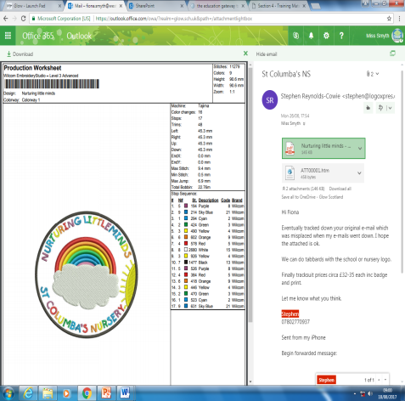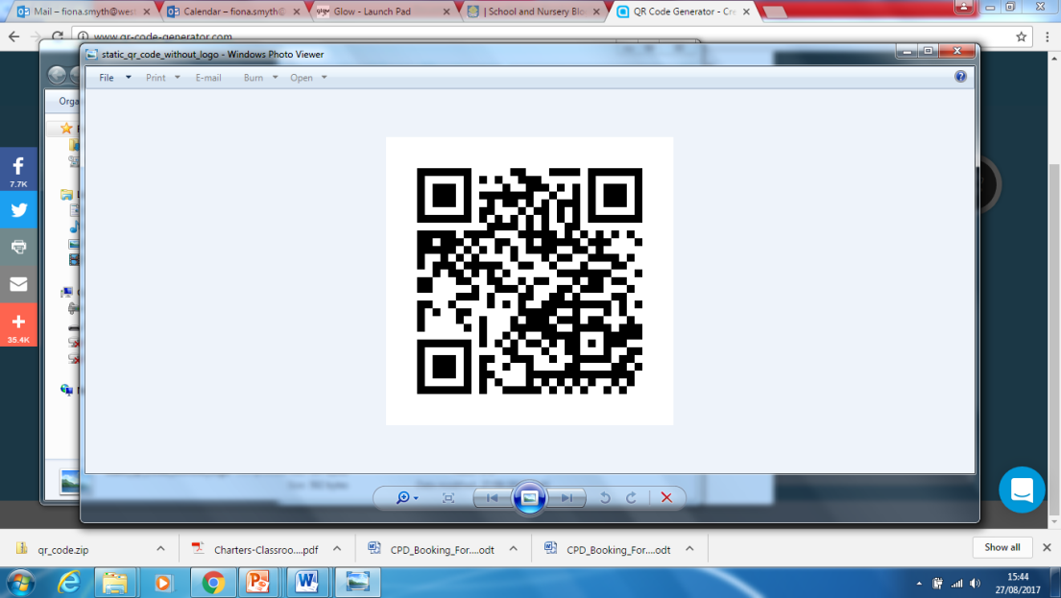

St. Columba’s Nursery

Week Beginning 9th September 2019

Nurturing Little Minds

Headteacher: Miss Fiona Smyth



|  |
| --- |
| Tuesday 10th September Stay & Play Session. Please see noticeboard for times |
| Monday 16th September Holiday |  |
| Friday 20th September School & Nursery Family Fundraiser 1.00pm – 3.00pm Details to follow. |  |
| Friday 27th September MacMillan World’s Biggest Coffee Morning 9.30 – 11.30am |

1 DAY HOLIDAY

The nursery will be closed Monday 16th September.

All children return Tuesday 17th September – normal session times





Thank you to the families who came along to our session on Friday morning. It was lovely to see you and we hope that you found it useful.

Don’t worry if you didn’t manage this time, there will be other opportunities throughout each term.

Snack Reminder

The cost for snack is £1.50 per week. Parents can pay weekly, monthly, per term or yearly.

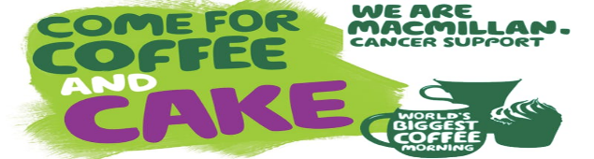



Aldi are giving away stickers for school sports kits if you spend over £30. If you shop in Aldi, can you collect the stickers and hand them in to the school. We need 300 of them!

SAVE THE DATE!!!

St. Columba’s School and Nursery Class are delighted to host a Macmillan Coffee Morning on Friday 27th September from 9.30 – 11.30am. Please come and join us, and help raise funds for Macmillan Cancer Support.

Donations of raffle prizes and baking would be greatly appreciated.

NURSERY GROUND FORCE DAY!

We are looking for parents / grandparents to help us get our nursery garden back into tip top shape after the summer holidays.

If you can spare a couple of hours on a Friday morning to help tidy our wonderful outdoor space please give your name to a member of staff.

Thank you.



Change of Clothes

Please ensure your child has a full change of clothes in their bag.

We encourage the children to use the outdoor area in all weathers. Please ensure that your child is dressed appropriately for the weather and has suitable footwear. Wellies are always good for the outdoor area as the children enjoy exploring muddy puddles!

