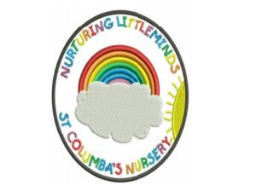
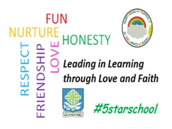
St. Columba’s Primary School
Transition to Primary 1 2018 /2019

MONTH | ACTIONS
December 2018 | P.1 Parent Information Open Evening for prospective new families
January – February 2019 | Applications to Pupil Placement for P.1 August Intake
February 2019 – after break | Pre-school children to accompany nursery staff when going to school office / photocopying room / gym hall etc  P.1 Class Teacher to visit both nursery AM and PM sessions x2 to begin to establish relationships with the children
March 2019 | When current P.1 class at P.E pre-school children to visit P.1 classroom (2 sessions AM & PM)  Additional visits to begin for children who will require enhanced transition  Buddy applications from P.5 & 6  New P.1 Welcome Booklets to be made
April 2019 | Pre-school children to join current P.1 class for milk and story (AM & PM)  Once list of P.1 intake received CT /SLT to visit children who attend other nurseries & times for visiting to be issued to parents  Welcome Booklets to be issued  Buddies allocated and training session provided
May 2019 | Buddies to visit children in nursery ( minimum of 2 visits)  Health Fun Hour session (sport stations) with buddies and current P.1s followed by altogether snack. Include children from other nurseries
June 2019 | Induction Sessions with all new P.1s –  Session 1 - children to be in P.1 class and parents in hall ‘Meet The Parents’ – opportunity for parents to meet each other, have a cup of tea and information session. At end of session (1 hour) parents allowed to go and see child in class setting.  Session 2 – Children only. Parents to drop off and return at end of time.

