****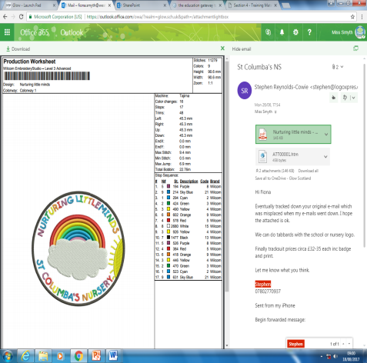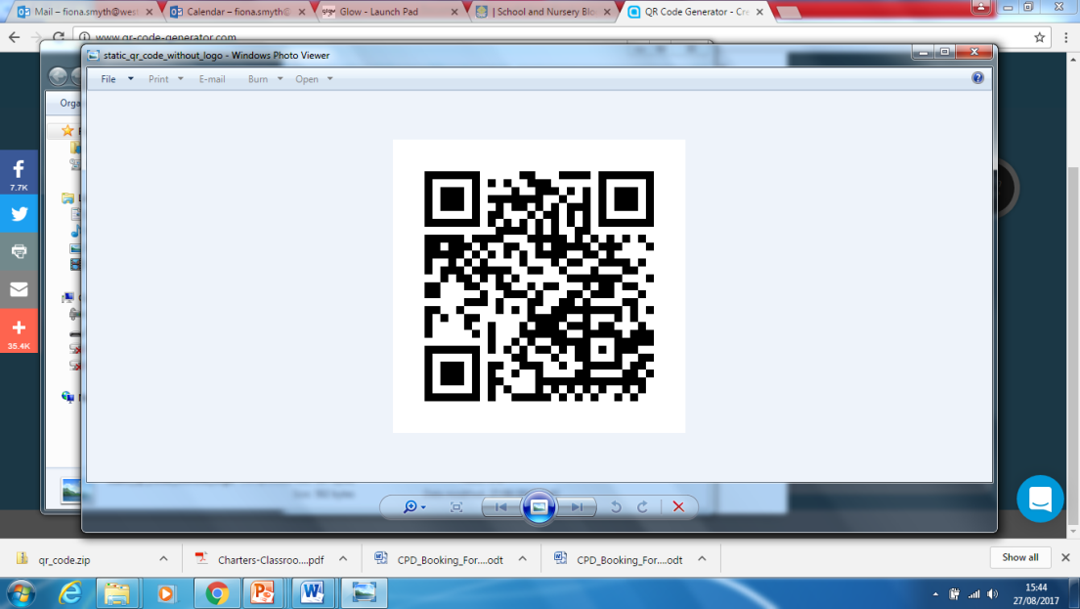

St. Columba’s Nursery

Week Beginning 16th April 2018

Nurturing Little Minds

Headteacher: Miss Fiona Smyth



HMI

As you will already be aware we will have HM Inspectors in and around the school and nursery. The inspection team arrive on Monday 14th May and will depart on Wednesday 16th May. We hope they enjoy their time here whilst at St. Columba’s.

|  |
| --- |
| New P1 St. Columba’s P.S open day 23rd May  10-12noon then 2.3.30pm |
| Week beginning 21st May- Stay and play week |  |
| Friday 1st June- Reports to parents |  |
| Saturday 2nd June- Newlands Day celebrations- superheroes |
| Monday 4th June- Holiday |
| Tuesday 5th June Health week begins |
| Nursery Graduation Monday 25th June |

‘Nurturing Little Minds’

We now proudly display our vision and values for our nursery children.. It includes current national guidelines including Getting it Right for Every Child, Curriculum for Excellence, Pre Birth to Three and UNCRC. These have been used along with our children and families to create our shared vision for the nursery. If you have any questions please ask any member of staff.

Please take time to have a look.

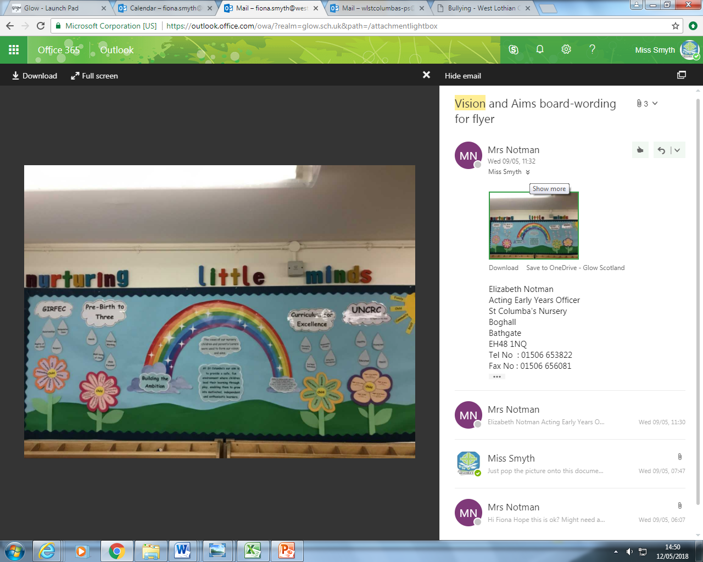

Sunscreen

Now that the sun has decided to put his hat on (well for a wee while) can you ensure you apply sunscreen to children before they arrive at nursery. Sunscreen can only be reapplied in nursery if you complete the correct paperwork.

Amendments

On last week's update it stated that the sports day was on the 10th of June, this is a Sunday. The sports day will be on Wednesday 6th June.

My apologies 😄

Newland’s Day

Our theme this year is superheroes.

We are looking forward to as many of you walking or pushing a buggy as possible, keep your eyes peeled for a letter regarding costumes coming out this week!

Stay and Play

Nursery stay and play sessions will run from week beginning 21st May. Keep your eyes peeled on the information board for your child’s group day. Remember if you cannot come along on the specified day just speak to your child’s keyworker and we can arrange another visit.

Headlice

Please keep checking your child’s hair for any visitors. It is important to check there are no eggs left in the children’s hair so they do not spread across the nursery

Graduation pictures

Nursery graduation pictures were taken on the 9th of May. We are hoping they will be with you in the next few weeks so you have a photograph of your child’s time at nursery.