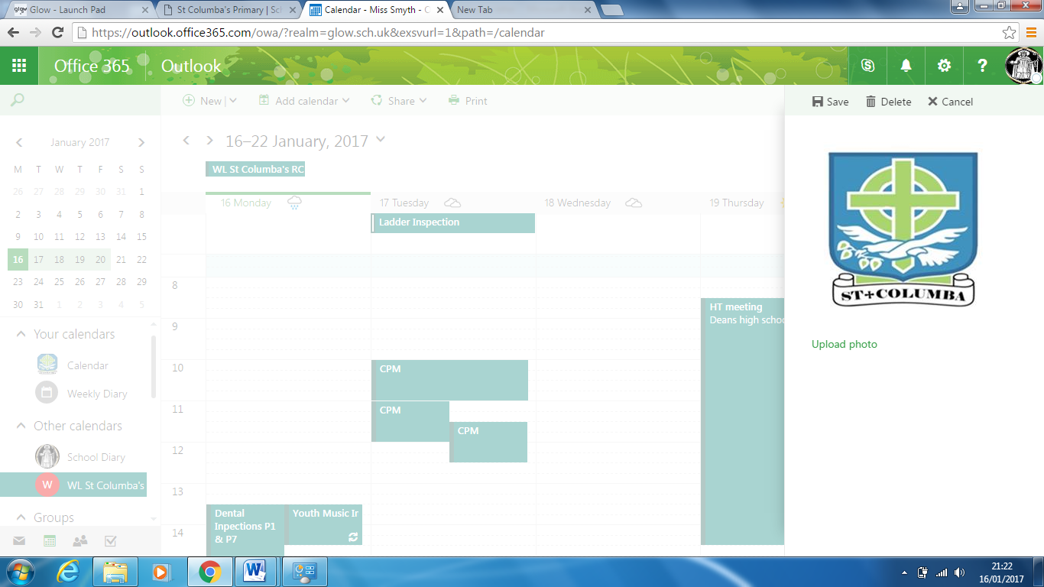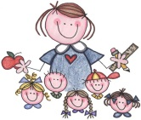

Consequences

* Verbal reminder
* Time out
* Loss of playtime/lunchtime
* Contact made with parents/carers by class teacher
* Dialogue with SLT to arrange next steps

Parents Will: Contribute to, be aware of and support the school Behaviour Policy.

Trust the school to investigate incidents that have been reported.

•Encourage children to resolve conflicts by themselves using Peer Mediators or/and school staff.

•Approach school staff for advice on behavioural strategies.

•Make an appointment to discuss in detail any concerns.

•Encourage your child to ask for help when they need it.

•Encourage your child to be polite and respectful to everyone at all times.

• Encourage your child to play and work collaboratively at school.

Written in consultation with staff, pupils and parents. February 2017

Positive Recognition

* A smile
* Positive praise
* Stickers
* Dojo points- 10 to be collected in a week
* Golden time
* Phone call home
* Certificate
* Class treat
* Everyday is a fresh start!

Staff will:

* Contribute to, be aware of and support the school Behaviour Policy.
* Focus on positive behaviour highlighting School and Class Charter and their corresponding actions.
* Send children to management for praise for positive behaviour e.g. effort, good work. – HT golden ticket
* Encourage positive behaviour by using House Points, Golden Time and class dojo points.
* Communicate effectively with pupils.
* Use and encourage restorative approaches to build positive relationships.
* Involve pupils in their own behaviour management.
* Give extra support to the pupils who need individual help to manage their behaviour.
* Inform parents at an early stage of any behaviour concerns.
* Inform management and other adults that may need updated of behavioural incidents.

**Pupils will:**

* **Learn, understand and act upon the Four Basic Rights and their corresponding actions.**
* **Contribute and follow the Class and school Charter.**
* **Acknowledge unacceptable behaviour and do your best to restore relationships with peers and adults.**
* **Use good manners at all times.**
* **Be respectful to all our peers, staff and equipment.**
* **Follow instructions sensibly and responsibly.**
* **Not disrupt class lessons.**
* **Be a good role model to others.**
* **Be proud of St Columba’s school and follow the examples set to us by Jesus.**
* **Be part of the systems in school (House points, class Dojo points, Golden Time) to help promote positive behaviour.**

St. Columba’s Primary Promote Positive Behaviour 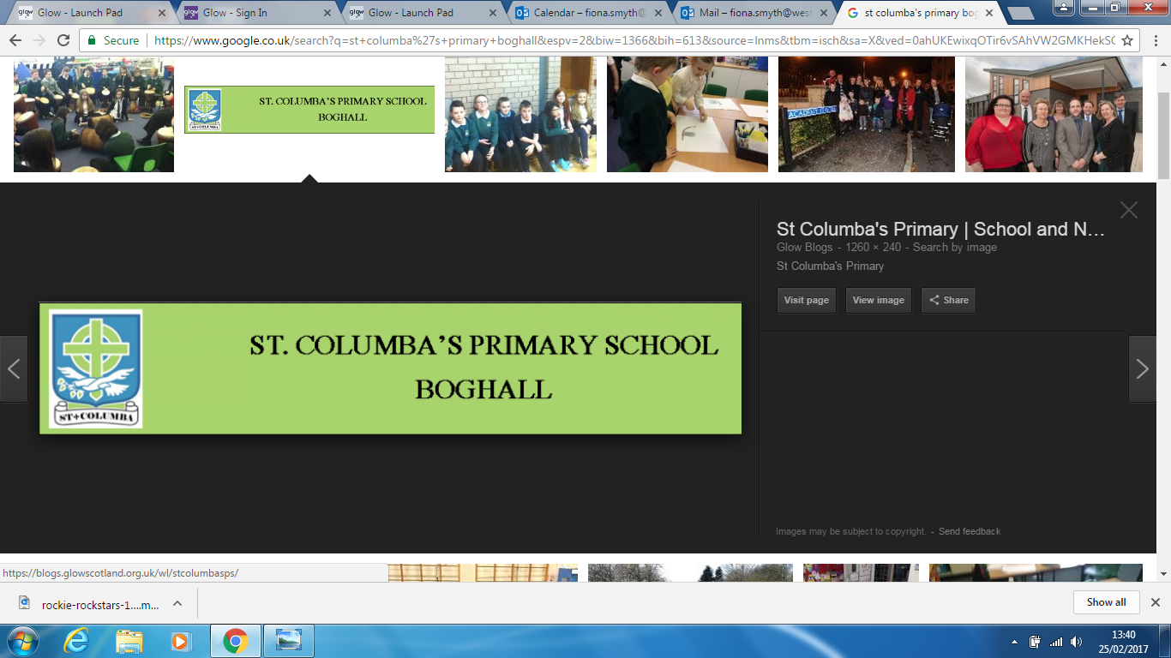 St. Columba’s Primary Promote Positive Behaviour 

St. Columba’s Primary Promote Positive Behaviour  St. Columba’s Primary Promote Positive Behaviour 

St. Columba’s Primary Promote Positive Behaviour  St. Columba’s Primary Promote Positive Behaviour  St. Columba’s Primary Promote Positive Behaviour 

St. St Columba’s Primary Promote Positive Behaviour  St. Columba’s Primary Promote Positive Behaviour  St. Columba’s Primary Promote Positive Behaviour 