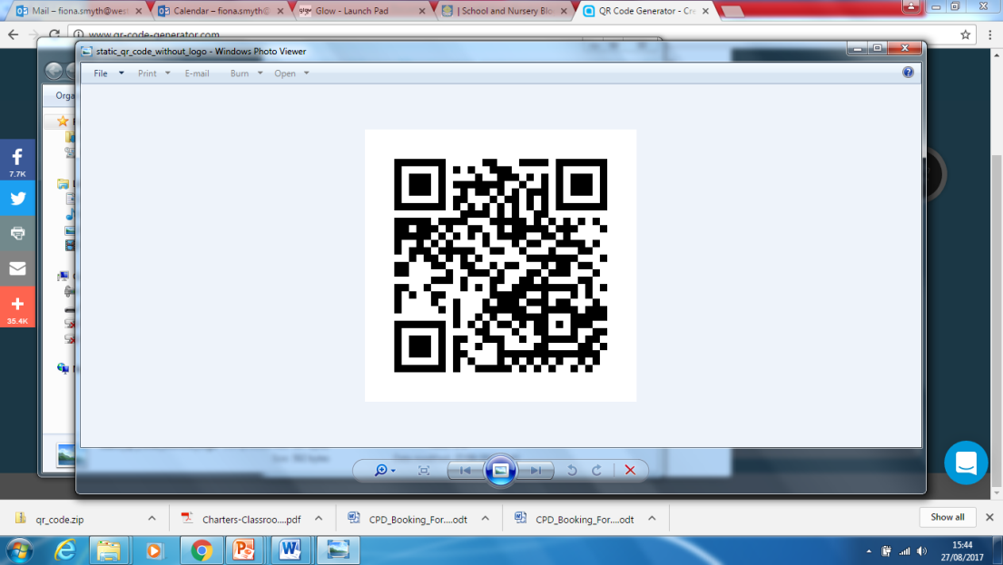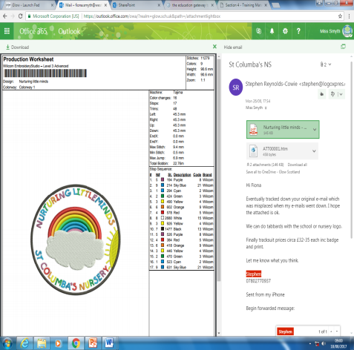

St. Columba’s Nursery

Week Beginning 28th August 2017

Nurturing Little Minds

**Welcome Back**

I am delighted to officially welcome you back for our new nursery session, which is shaping up to be a very exciting and busy one. We open our doors to our new nursery children this week, and we are very excited to meet them.

We have a very busy term ahead and I hope to capture some of the events through the weekly updates.

We were sad to see Mrs Sinnott go before the summer, but we will be keeping her up to date with all our exciting adventures!

Thank you for your continued support and I look forward to working with you and your children over the year!

Miss Smyth ☺

We welcome Mrs Connelly who joins the afternoon session in the nursery she will be working with the orange group, I know you will make her feel very welcome.

**Nursery Uniform**

We are in the process of changing our nursery logo after the competition run last session. We are waiting on the uniform supplier providing us with the sample before we go ahead with the order. I am sorry for any inconvenience this has caused. We will have it sorted as soon as possible

Keep up to date with all things St. Columba’s.

Follow us on twitter @StColumbas2016

Or blog

<https://blogs.glowscotland.org.uk/wl/stcolumbasps/>

**Early Years Officer**

As Mrs Sinnott is now in Australia, that makes way for an acting Early Years Officer post within our nursery. I am working with the authority to ensure this position is filled quickly and with the best interests of our children. I will be in touch with the appointed post!

Please ensure the nursery has the most up to date contact information so we can reach you quickly in an emergency. Please contact the school office to update your details

**Parents as Partners**

Following on from the parent survey sent our last session we are reviewing our current parental engagement strategy.

Throughout the week of the 11th of September, you will be invited at one point to join your child for a stay and play session.

You will be provided with a link to your child’s online journal details so you can get a snapshot of what happens whilst your child is at Nursery!

**Health Care Plans**

**It is so important if your child receives medication that the nursery have the correct plan in place.**

**Please speak to a member of nursery staff if this is the case.**