****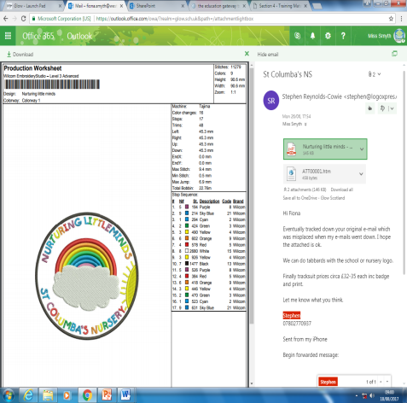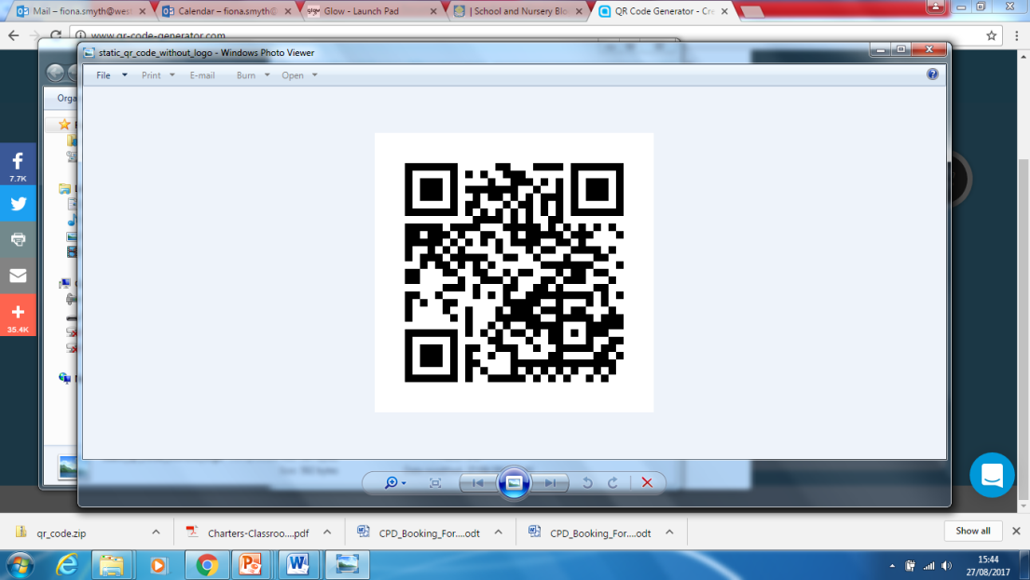

St. Columba’s Nursery

Week Beginning 10th September 2017

Nurturing Little Minds

Visitors

Please check your child’s hair regularly for unwanted visitors. We cannot contact parents directly about this so please be vigilant and check regularly.

**Snack Money**

**We require all children to pay £1.50 at the start of the week in order for snack to be provided for all children. This is the same across all West Lothian Nurseries. Please ensure you hand your money in at the start of the week.**

**Nursery Uniform**

Our nursery badge has now been approved and the ordering site will now be set up. I should be able to provide you with details next week!

It really does look fantastic!

An exciting discovery was made last week in the nursery garden…we found snail eggs!!

We all learned something new!

A snail lays its eggs from the side of its neck!

Please come and see our snail eggs, we would love to show them to you.

**Reminder:Parents as Partners**

Throughout the week of the 11th of September, you will be invited at one point to join your child for a stay and play session or a come back and play. You do not need to stay for the whole session you can stay for as little or as long as you wish.

You should visit your child:

Monday Am: Green Group Pm: Green Group

Tuesday Am: Orange Group Pm: Orange group

Wednesday: Am: Red group Pm: Red group

Thursday: Am Blue group Pm: Blue Group

Friday: Am Yellow Group

If the time does not suit please speak to your child’s key worker and we will arrange another time for you.