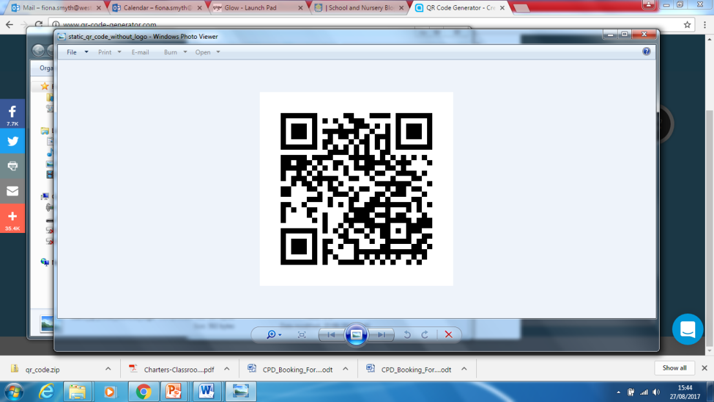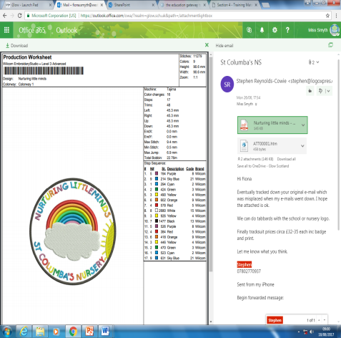

St. Columba’s Nursery

Week Beginning 4th September 2017

Nurturing Little Minds

Visitors

Please check your child’s hair regularly for unwanted visitors. We cannot contact parents directly about this so please be vigilant and check regularly.

**Health Care Plans**

**It is so important if your child receives medication that the nursery have the correct plan in place.**

**Please speak to a member of nursery staff if this is the case.**

**Nursery Uniform**

Our nursery badge has now been approved and the ordering site will now be set up. I should be able to provide you with details next week!

It really does look fantastic!

**Early Years Officer**

On Monday I interviewed for the position of acting Early Years Officer, I am delighted to share with you that Mrs Notman and Mrs Gouws will take up the acting post. We wish them well in their new post!

**Parents as Partners**

Throughout the week of the 11th of September, you will be invited at one point to join your child for a stay and play session or a come back and play.

You should visit your child:

Monday Am: Green Group Pm: Green Group

Tuesday Am: Orange Group Pm: Orange group

Wednesday: Am: Red group Pm: Red group

Thursday: Am Blue group Pm: Blue Group

Friday: Am Yellow Group

If the time does not suit please speak to your child’s key worker and we will arrange another time for you.