****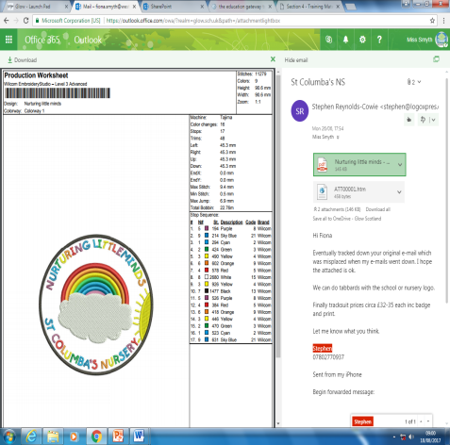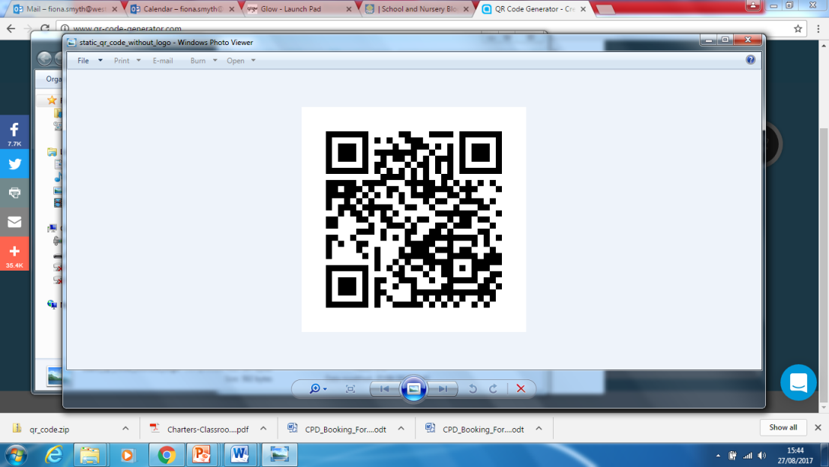

St. Columba’s Nursery

Week Beginning 2nd October 2017

Nurturing Little Minds

Headteacher: Miss Fiona Smyth

Medication

If your child requires medication this must be left in the nursery with a member of staff otherwise your child cannot attend nursery for insurance purposes. Thanks for your support!

**Snack Money**

**We require all children to pay £1.50 at the start of the week in order for snack to be provided for all children. This is the same across all West Lothian Nurseries. Please ensure you hand your money in at the start of the week or use the ipay impact login sent out last week. Can I ask that you check your envelope to ensure you received the correct details for your child**

**Nursery Uniform**

You can now buy the new nursery logo jumpers and polo shirts. Either use this web address or use the form which will be sent out to each of you.

<http://www.logoxpres-schoolwear.co.uk/St-Columbas-Nrs/>

Snacks

Some of our children are bringing snacks with them in their bags- Can we ask that if this is the case you let the keyworker know. Can you also ensure the snack **DOES NOT** contain peanuts as we have a large number of children with allergies

STV children appeal.

Sean Batty will visit the school and nursery on Wednesday at 2pm. We are looking forward to this. Please ensure you return the photograph permission form.



This week…

Water has been the topic of conversation with Lots of water play outdoors experimenting and exploring water…what do you use water for?

· The children have been exploring colour mixing. In the art area children are mixing paint to make colours, this was taken outside using powdered paint and experimenting with skittles-Make sure you come and have a wee look at our colour mixing wall in the nursery!