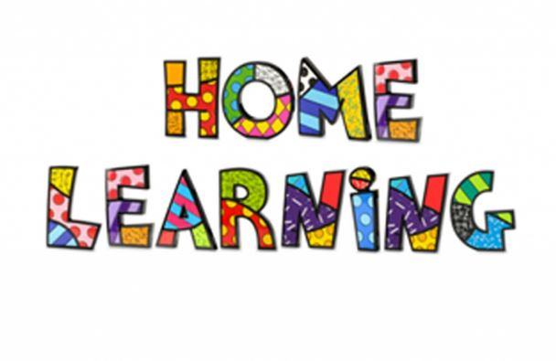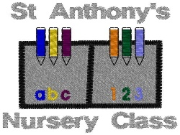

**Hello Everyone!**

The ladies at Saint Anthony’s hope that you are having fun at home and enjoying all of our lovely activities we have planned for you on the blog again this week. The ladies are loving seeing all of your photos your grown-ups have been emailing us. Your grown-ups can also leave some comments on the blog to tell us what you think. We look forward to hearing all about your week.

Stay Safe Everyone, We miss you lots.

|  |  |  |
| --- | --- | --- |
| **DAY** | **STAFF** | **ACTIVITY/LEARNING EXPERIENCE** |
| [Free Washing Hands Cliparts, Download Free Clip Art, Free Clip Art on  Clipart Library](https://www.google.co.uk/url?sa=i&url=http://clipart-library.com/washing-hands-cliparts.html&psig=AOvVaw18JF1PclN4uuCvhRgBy35u&ust=1612257512110000&source=images&cd=vfe&ved=0CAIQjRxqFwoTCPiXocOtyO4CFQAAAAAdAAAAABAR)Monday | Mrs Nicol will be reminding us about the importance of washing our hands. | Early years science is about exploring and investigating the world, and about having fun and playing. Today’s activity is an experiment and a song on washing our hands and getting rid of all of those nasty germs. |
| [Rainbow Noodles HD Stock Images | Shutterstock](https://www.google.co.uk/url?sa=i&url=https://www.shutterstock.com/search/rainbow%2Bnoodles&psig=AOvVaw1cJ9ykl-nOxa-l4fGgjjjW&ust=1612257567519000&source=images&cd=vfe&ved=0CAIQjRxqFwoTCLDKx92tyO4CFQAAAAAdAAAAABAE)Tuesday | Miss Taylor will be teaching us how to make rainbow spaghetti. | Playing with rainbow spaghetti is a great sensory experience for children of all ages. It will help children to understand their five senses and help them to learn their colours. |
| Wednesday[Nature Play Ideas: Land Art - Red Ted Art - Make crafting with kids easy &  fun](https://www.google.co.uk/url?sa=i&url=https://www.redtedart.com/nature-play-ideas-land-art/&psig=AOvVaw2fvHf6KHeI6NWoP3XYRi47&ust=1612258355101000&source=images&cd=vfe&ved=0CAIQjRxqFwoTCJDrhdWwyO4CFQAAAAAdAAAAABAE) | Mrs Bett will help us to create our own land art using natural materials | You and your family could collect some natural resources when out walking or playing in your garden and create some land art. You could use stones or sticks to make shapes or just use your imagination! |
| Thursday[Greenlands Community Primary School: Music](https://www.google.co.uk/url?sa=i&url=http://www.greenlands.lancsngfl.ac.uk/page/music/72198&psig=AOvVaw3OKSNC2DoJmiS-8AcPo1ov&ust=1612257747525000&source=images&cd=vfe&ved=0CAIQjRxqFwoTCKj0pLOuyO4CFQAAAAAdAAAAABAE) | Miss Curran will be teaching us to move our bodies to the rhythm of the music. | Today’s learning experience is all about moving our bodies to the rhythm of the music. This activity will also help children follow instructions and develop their motor skills. |