Primary 7 Final Week
FUN TASKS
Choose 2 tasks per day
Listen to an Author    Visit BBC Bitesize to listen to an author of your choice.  https://www.bbc.co.uk/events/rhvg9r | 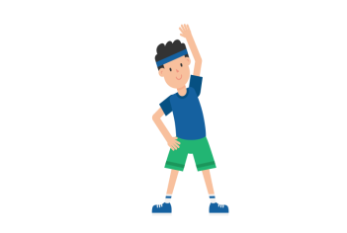  Exercise  Join the Body Coach for a workout.  https://www.youtube.com /channel/UCAxW1XT0iEJo0TYlRfn6rYQ
  Music  Click on the link to try the daily music activity posted by NYCoS  https://www.nycos.co.uk/daily-activities/ | Baking Activity  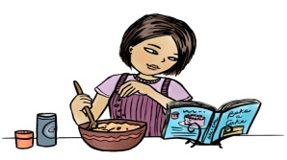  Choose one of the recipes attached or go online to select a recipe of your choice. Always ask an adult for help/permission.
Maths  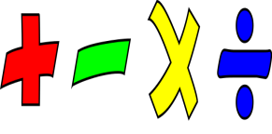  Test your Mathematical knowledge, speed and accuracy on Sumdog, Times Tables Rockstars and Hit the Button. | Art    Try one of these sites for inspiration  https://www.youtube.com/user/ArtforKidsHub  https://rapidfireart.com/
Quiz    Choose one of the quizzes attached. |   Mindfulness Task  Choose a relaxing, mindfulness task that you enjoy doing [no screens] or go on a nature scavenger hunt. Scavenger hunt lists are attached.
  Virtual School Trip  Choose a trip and explore  https://virtualschoolactivities.com/  https://www.weareteachers.com/best-virtual-field-trips/ |   Read a book  Choose a book, get comfy and enjoy reading!

