P7 General Knowledge Quiz Name:
Score:
- Who is the current Prime Minister of the U.K.?

- Who is the First Minister of Scotland?

- Dunfermline used to be the capital of Scotland? True or False?

- Name the capital city of the U.S.A.?

- Name 2 citrus fruits?

- Name 2 makes of cars made in Germany

- What is the main ingredient of porridge?

- Name the hard substance which makes up the outer surface of your teeth.

- Who invented the television?

- Which Scottish city is known as the capital of the highlands?

- Which planet is the closest to the sun?

- Which country is represented by this flag? 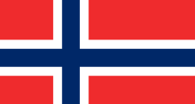

- Au is the scientific notation for which metal ?

- How many metres long is an Olympic swimming pool?
- What is the name of the church in the Vatican City in Rome?

