Wednesday 3rd June

House designs

**Directions:** you will become an architect for this task and design your dream home by creating a floor plan like we did the other week. A floor plan is a visual representation of what your house will look like. Builders use floor plans to know the layout of the house and how much they will need to buy in materials.

**Rules**

* **You must include a minimum of 7 rooms in your house. You need:**
* **1 bathroom**
* **1 kitchen**
* **1 master bedroom**
* **1 bedroom**
* **1 living room**
* **2 other rooms of your choice ( office, conservatory, dining room etc)**

**Number 2**

**You will find the perimeter and area of all rooms in your home so the builder will know how much materials they need. You will need a final perimeter and area of the entire house. You must add all the perimeters and areas together to get a total for each.**

* **A) perimeter of each room**
* **B) area of each room**
* **C) total perimeter – add all your perimeters up**
* **D) total area – add all your areas up.**

**When drawing your dream house make sure you label each room e.g. living room. I would suggest 1cm (box) equals 1m.**

**You can include all you’re working out on a separate piece of paper if you cannot fit it around your drawing.**

**Example:**

**To work out the perimeter = add up all the sides by counting the boxes or count each individual boxes in the room.**

**Bed 2 Perimeter = 11+11+5+5 = 32 cm**

**To work out the area we use the formula l x b = area**

**Bed 2 area = 5 x 11 52 cm2**

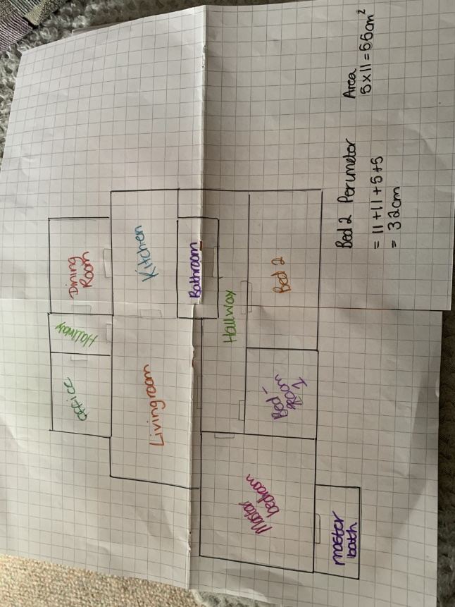

Created by : Aileas Liusaidh.