LO: To tell the time using the hour and minute hands.
Success Criteria:
1 – I can show different o’clock times on my clock.
2 – I can write what time is shown on the clock.
3 – I can draw different o’clock times using red for the hour hand and blue for the minute hand.
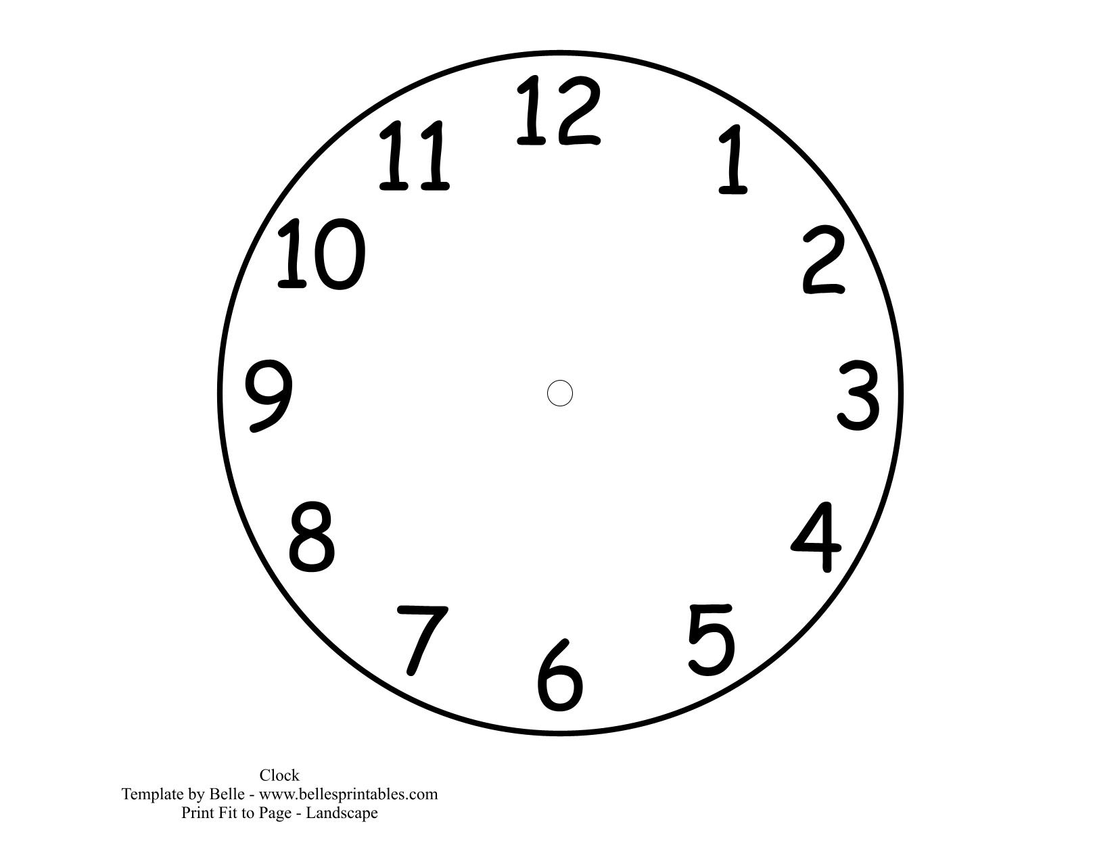
__ o’clock
__ o’clock
__ o’clock

1 o’clock
4 o’clock
8 o’clock

Extension: I can draw and write my own times on the clocks.

LO: To tell the time using the hour and minute hands.
Success Criteria:
1 – I can show different o’clock times on my clock.
2 – I can write what time is shown on the clock.
3 – I can draw different o’clock times using red for the hour hand and blue for the minute hand.
__ o’clock
Half past __
Half past __

Half past 2
4 o’clock
Half past 5

Extension: I can draw and write my own times on the clocks.

