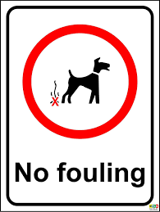

L.I – we are learning to use our notes to create an informative leaflet.

Primary 6, I was super impressed with your note taking skills last week. You had some very detailed notes. This week we are going to take the notes you gathered and the questions and put them into paragraphs for the leaflet. Remember you are trying to raise awareness to dog fouling going on in your own area. Think how the people of Armadale feel when they see it/walk in it.

Task

Arrange your 3 or 4 questions that you compiled last week in order. Think carefully about what you think should come first in the leaflet. Remember to include an introduction to why you are doing this leaflet.

Look closely at your notes and see how you can expand on this information to put under each of your questions.

Remember to include an introductory paragraph explaining why you are creating this leaflet and who or where it is based for.

Think of the layout:



Are you going to use pictures to explain your findings?

For Example;

Introduction –

Question 1 - What are the dangers of dog fouling?

Dog fouling is not only an unpleasant sight to see but it is very dangerous. Dog waste is known to contain lots of different kinds of bacteria which can cause you to become unwell. The symptoms are cramps, diarrhoea, intestinal illness, and serious kidney disorders in humans. It is also known to be toxic for you garden and cause stains and burns.

Question 2-

Question 3 -