Maths quiz – complete one column.

Green  - 46.2 x10  - 37.82 ÷ 10  - 123.4 ÷ 10  - How much of the circle is coloured in?  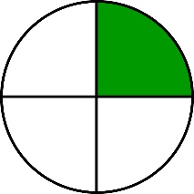  - £5.56 + £3.75  - James went to the shop with £20. He bought a magazine for £2.75 and a poster for £10.75. How much change will he get?  - 0.42 + 0.23  - 4.32 – 2.11  - Change 11.35pm into digital time.  - 42 ÷ 6 | Orange  - 34.4 x 100  - 321.3 ÷ 100  - 4.56 ÷ 100  - How much of the circle is coloured in?  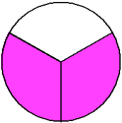  - £45.67 x 7  - Eric has a pet dog called Barney. He needs to buy him a special dog shampoo every 3 months. It costs £15.50 for a bottle each time. How much will it cost him a year?  - 34.76 + 56.89  - 89.76 – 53.21  - The bus leaves at 10:55 and takes 45 minutes to get to its next stop. What is the new time?  - 975 ÷ 5 | Red  - 0.34 x 1000  - 45.7 x 20  - 765.2 ÷ 1000  - 4. How much of the circle is coloured in?  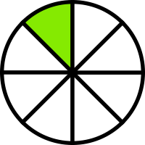  - £234.67 x 8  - John is a fitness fanatic. He pays £34.40 for a gym membership each month. He also buys a new pair of trainers each month costing £42.00. How much does he spend over 6 months?  - 1758.98 + 546.29  - 3542.23 – 219.21  - The train leaves at 10:52 and takes 56 minutes to reach its next destination. What time will it be?  - 976 ÷ 8

Answers
Green  462  3.782  12.34  ¼  £9.31  £6.50  0.65  2.21  23:35  7 | Orange  3440  3.213  0.0456  2/3  £319.69  £62.00  91.65  36.55  11:40  195 | Red  340  914  0.7652  1/8  £1877.36  £458.40  2305.27  3323.02  11:48  122

