An amazing assembly!
P7B’s assembly was great, everyone was amazing. The whole thing was brilliant so a big round of applause to them. The assembly was about confidence. At the start of the assembly you saw Gabriella. Her confidence was torn apart by the mean comments and the nice comments built her confidence back again. »
It was a five out of five assembly. Written by Jared King

2/11/2018 | Springfield Primary School | Issue One 2018-19

the springfield times

hello springfield!
  - This is Springfield News
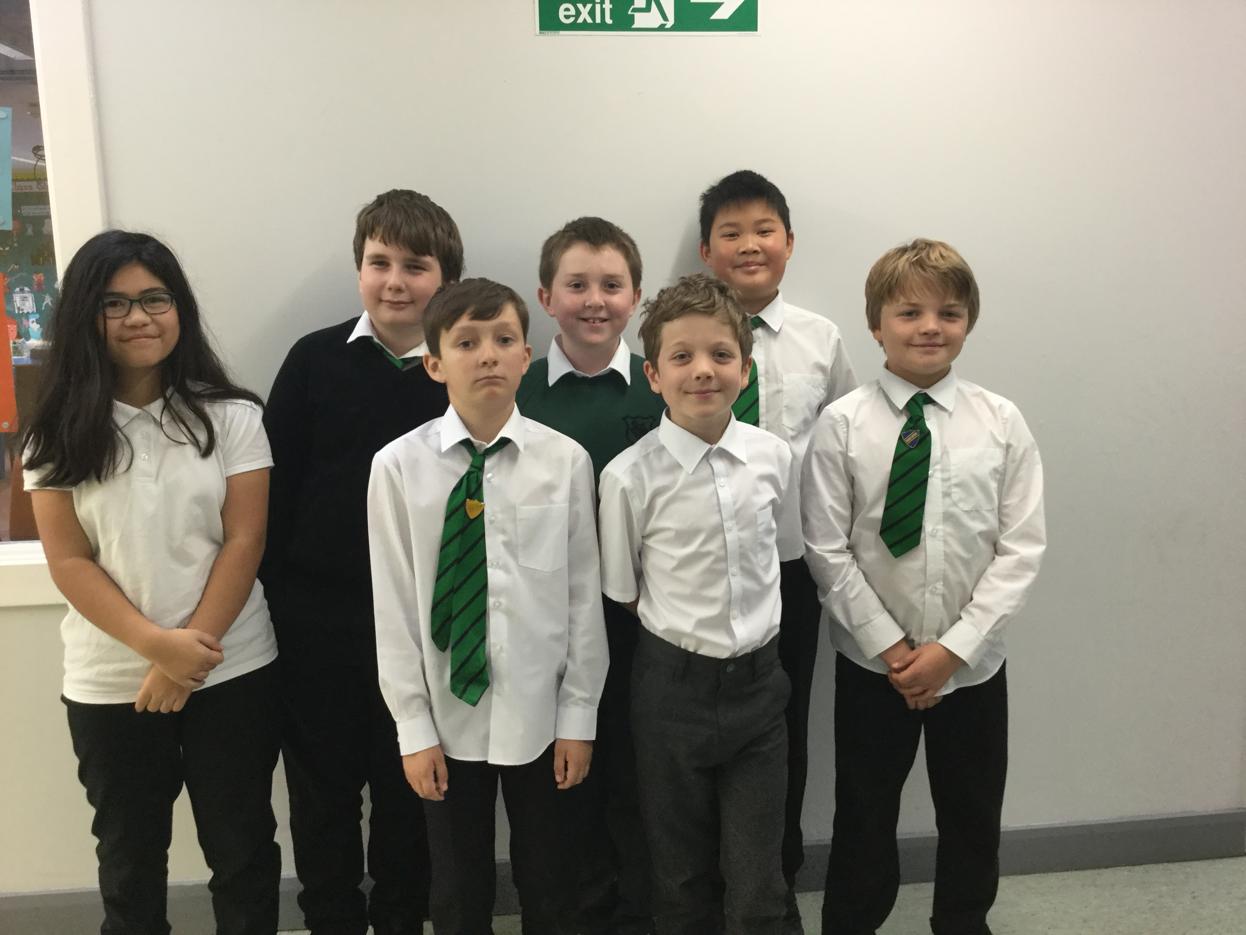
L-R – MH, JK, BR, JS, JM, JL, MH. (RG took it)
Hello, my name is Joseph Moon and I am the editor of the Springfield Newspaper. Each edition is released monthly, and each issue is jam-packed with amazing articles, sport pages, Achievements, comic, puzzles, class articles, club news, and more! We have a dedicated team of journalists, researchers, puzzle editors, comic illustrators, a photographer, and of course me, the editor of Springfield News. I’m now going to introduce the team.
Jayden Leung – A journalist
Jamie Sutcliffe – Another journalist
Ruairidh Gray – Our photographer
Mack Huxley – A comic illustrator/researcher
Millie Haokip – Another comic illustrator/puzzle editor
Jared King –A journalist
Beinn Robinson – Comic editor/journalist
Joseph Moon (me) – Editor! (Continued next)
I hope you are going to enjoy this issue and all the issues to come. We have all enjoyed writing issue and hope you will enjoy seeing what your class and other classes have done. Written by Joseph Moon »

What is The 10,000 book challenge?
  - Jared King finds out.
The 10000 book challenge has started. We need to read 10,000 books by the end of the year, and if we read those books, we win amazing books next year. We have read 1010 books so far and well done to everybody who has been taking part. »

a message from the sports leaders
  - Make sure to follow…
We have been spending an hour each week cleaning the PE cupboard. Please make sure this is tidy at all times as everyone has to be able to access sports equipment, and most importantly, we have to make sure that nothing is insecure as it could fall and injure someone. Thanks, and make sure to always keep the cupboard tidy! »

_______________________________________________________

achievements

Here is a selection of October’s achievements from around school. They are all amazing and everyone mentioned her should be very proud of themselves. If you had an achievement, but it’s not here, please do not hesitate to contact our team. Ask for Joseph M in P7A. Here you go…

P2: Gregor P – He won a rugby trophy! Well done! Also in P2, Gregor C won a football trophy and he did very well!
P3: A lot of achievements for P3. Take a deep breath; Ruairidh moved up a level in football; Mairi moved up a level in swimming; and surprisingly; so did Nico! Harrison won a football trophy and Ailith won a football trophy.
P4: Rebecca and Era got a higher grade in swimming; Marie got a higher group in gymnastics; Callin, Cali, Sofia, Anita, Olivia and Sarah took part in a gymnastics competition.
P5: Mark did the junior fun-run; Dean did judo silver; Rebecca achieved levels one and two of climbing; Hannah did the Aviemore fun-run and Euan got level one in fencing.
P6: Joanne did mermaids and sharks; Imogen won prizes for horse-riding; Euan, Isla and Cameron did a triathlon and Harry and Cameron competed in a football tournament.
Congratulations to everyone with an achievement in this article!

Puzzle page!

Riddles

What has 13 hearts but no other organs?
I’m everywhere and a part of everyone. I am the end of space, time and existence itself. What am I?
I’m 3/7 chicken, 2/3 cat and 1/2 goat. What am I?
What do you call a bee that eats other bees?
Compiled by Ruairidh Gray ~ Answers on back cover »

4 Panel comic

club articles!
In Springfield, we have a vast array of clubs, which include:
Our football team which is very successful, as we have won the George Allan 4 times and the Round Table 10 times! They practice on Monday.
Choir also practice on Monday, P4 and P5 are going to go to Edinburgh Airport to sing Christmas carols. Good luck! (cont. next page)
Our netball team practice every Wednesday, and last year we entered into the league for the first time and came second!
Our Quidditch team was set up last term, and hasn’t yet started up again, although Kieran would like to re-start it.
Chess Club is also on a Monday, and it is open to P4-7 pupils. No experience required.
Finally, Running Club is run by Mr. Wells and he has various meeting so it is still undecided as to which day it is on. All abilities can come, and if you can’t make afterschool, then there is also a lunchtime club on Thursdays.
By Ruairidh Gray »

Monthly recipe – captians fish pie
You will need: 3 spring onions, finely chopped; 1 x pack fish pie mix (cod, salmon, smoked haddock etc., weight around 320g-400g; 100ml milk; 450g potato, peeled, large ones cut in half; 75g frozen sweetcorn, defrosted; a handful of grated cheddar cheese; 1 large egg, beaten; flour, for dusting and olive oil, for frying.
- Cook the potatoes in boiling water until just tender. Drain well and return to the pan on a low heat. Heat for another minute or two to evaporate excess liquid. Mash the potato with a small knob of butter. Allow to cool.
- Put the fish spring onions and milk in a shallow dish, cover with cling film and cook in the microwave for 1 ½ - 2 mins until just cooked. If you don’t have a microwave, put everything in a saucepan and gently cook until just opaque and cooked through.
- Drain the fish and spring onions through a fine sieve. Gently mix through the potatoes, avoiding breaking up the fish too much, along with the sweetcorn, cheddar and a generous grind of black pepper. Form into 6 - 8 patties. The cooler the mash potato is when you do this; the easier it will be to form the patties as the mixture will be very soft when warm.
- Pour the egg on one plate and scatter flour on the other. Dip the patties in egg and then flour and arrange on a sheet of baking paper on a tray. Put the patties in the fridge for at least half an hour to firm up if the patties feel very soft. At this point you can freeze the patties, wrapped individually. Defrost thoroughly before moving onto the next stage.
- Heat a large frying pan with a generous glug of olive oil. When the oil is hot, carefully lower the fish cakes into the pan. Cook for 5 - 7 minutes or until golden brown underneath and then carefully flip them over. Fry for another 5 - 7 minutes or until golden on the bottom and heated all the way through.

Springfield’s sports pages

a quick sports overview
  - What activities happen in our school?
Basketball is a game where you shoot a ball at a hoop with five players on each team. In netball there is different positioning. There’s a scorer and they can’t move when holding the ball. They can turn but still can’t run and you score in a hoop. Well I think that everybody knows what football is, but football is a game where there are 2 goals and 11 people on each team. They kick the ball in the goal and get a point. You shoot the quaffle through the hoop for 10 points. If you catch the snitch, you get 30 points. By Jared King »

term 2 p.e – What’s going on?

Stage | Cluster Event | Activities Term 2
P1 | n/a | - Better Movers and Thinkers (Ball Skills)  - P1-3 Multisport programme
P2 | n/a | - P1-3 Multisport programme  - Better Movers and Thinkers (Ball Skills)
P3 | Benchball | - P1-3 Multisport programme  - Basic Moves
P4 | Racquet Sports | - Short tennis  - Basic Moves
P5 | Handball | - Handball
P6 | Cross Country | - Cricket
P7 | Sportshall Athletics | - Athletics

P7 Basketball
  - What activities happen in our school?
Last term P7a have been doing basketball. Basketball is a common sport in our school, as well as a lot of netball and bench ball. Every time when P7a go to the hall for basketball, we usually practice/warm up before we have a team game like a match. We also have been doing the remote control game. Instead of saying go you say play, and stop is pause. If you Mr. Logan says ‘home’ you go to the centre of the hall. We also have been practicing on communicating and passing. There are 3 moves that are useful for a basketball match. 1 is a bounce pass, 2 is an overhead pass and 3 is an underpass which is the most common one. When you’re in P7, you’ll learn these moves. If you have any other sports you would like us to write about, you can tell us and that will give us a guideline to go on.
By Jayden Leung »

sports hall athletics
  - An amazing achievement!
Both P7s are going to do the athletics at Linlithgow Academy Sports Hall which is very exciting and highly popular. The competition will be on Thursday 15th November 2018. They will leave at 12:45 and come back at 2:45pm. There can only be 15 girls and 15 boys. Don’t forget, good luck the people who have been chosen to go, because they’re playing for our school! The people who will be chosen might have a chance to complete a maximum of two tracks and field events. If we win the cluster we head to the regional event. And if we win the regional we head to the national competition! Good luck everyone!
By Jayden Leung »

the

Springfield

times

Contact Information
Joseph Moon P7A
Springfield Primary School
Linlithgow
(Otherwise contact Ruairidh Gray, P7A, SPS)
Please send in your keep warm recipies and if you are lucky enough to get your recipe in the newspaper you will recive a goodie bag.

