Five little leaves

5 little leaves so bright and gay,
Were dancing about on a tree one day
The wind came blowing through the town
Oooooooooooo…Ooooooooooooooooo
One little leaf came tumbling down

4 little leaves so bright and gay,
Were dancing about on a tree one day
The wind came blowing through the town
Oooooooooooo…Ooooooooooooooooo
One little leaf came tumbling down

3 little leaves so bright and gay,
Were dancing about on a tree one day
The wind came blowing through the town
Oooooooooooo…Ooooooooooooooooo
One little leaf came tumbling down

2 little leaves so bright and gay,
Were dancing about on a tree one day
The wind came blowing through the town
Oooooooooooo…Ooooooooooooooooo
One little leaf came tumbling down

1 little leaf so bright and gay,
Were dancing about on a tree one day
The wind came blowing through the town
Oooooooooooo…Ooooooooooooooooo
That little leaf came tumbling down

Five little sunflowers

Five little sunflowers grew in a row
One had no water so that didn’t grow.

Four little sunflowers grew in a row
One was too hot so that didn’t grow

Three little sunflowers grew in a row
A caterpillar ate one so that didn’t grow

Two little sunflowers grew in a row
The wind bent one so that didn’t grow

One little sunflower grew all alone
Soon she was the biggest little flower in town!



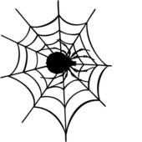

One elephant

1 elephant went out to play
On a spider’s web one day
He had such enormous fun
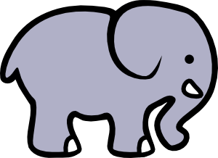
He asked another elephant to come.

2 elephants went out to play
On a spider’s web one day
He had such enormous fun
He asked another elephant to come.

3 elephants went out to play
On a spider’s web one day
He had such enormous fun
He asked another elephant to come.

4 elephants went out to play
On a spider’s web one day
He had such enormous fun
He asked another elephant to come.

5 elephants went out to play
On a spider’s web one day
He had such enormous fun
He asked another elephant to come.

Once I caught a fish alive

1,2,3,4,5, once I caught a fish alive, 6,7,8,9,10 then I let it go again.
Why did you let it go, because it bit my finger so which finger did it bite this little finger on my right.

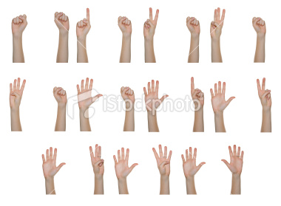

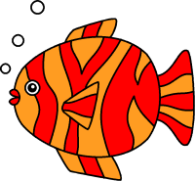

Five Easter eggs – (tune 5 current buns)

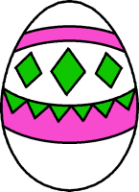
5 Easter eggs in the sweet shop
Round and fat with a ribbon on the top
Along came … with a penny one day
Bought an Easter egg and took it right away.
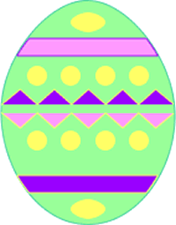
4 Easter eggs in the sweet shop
Round and fat with a ribbon on the top
Along came … with a penny one day
Bought an Easter egg and took it right away.
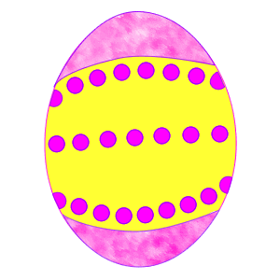
3 Easter eggs in the sweet shop
Round and fat with a ribbon on the top
Along came … with a penny one day
Bought an Easter egg and took it right away

2 Easter eggs in the sweet shop
Round and fat with a ribbon on the top
Along came … with a penny one day
Bought an Easter egg and took it right away.

1 Easter eggs in the sweet shop
Round and fat with a ribbon on the top
Along came … with a penny one day
Bought an Easter egg and took it right away.
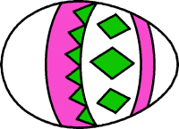

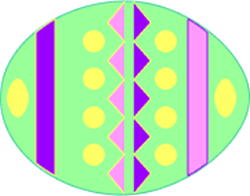

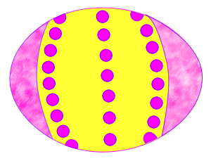

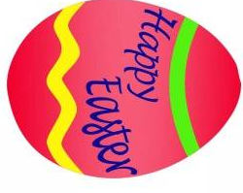



Five little speckled frogs

Five little speckled frogs,
Sat on a speckled log eating some most delicious grubs yum, yum,
One jumped it to the pool where it was nice and cool then there were four green speckled frogs glug, glug.
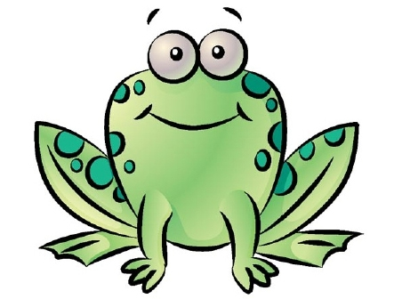
Four little speckled frogs,
Sat on a speckled log eating some most delicious grubs yum, yum,
One jumped it to the pool where it was nice and cool then there were three green speckled frogs glug, glug.

Three little speckled frogs,
Sat on a speckled log eating some most delicious grubs yum, yum,
One jumped it to the pool where it was nice and cool then there were two green speckled frogs glug, glug.

Two little speckled frogs,
Sat on a speckled log eating some most delicious grubs yum, yum,
One jumped it to the pool where it was nice and cool then there was one green speckled frog glug, glug.

One little speckled frog,
Sat on a speckled log eating some most delicious grubs yum, yum,
He jumped it to the pool where it was nice and cool then there were no green speckled frogs glug, glug.

Five little ducks

Five little ducks went out one day over the hills and far away,
Mother duck she said quack, quack, quack but only four little ducks came back.

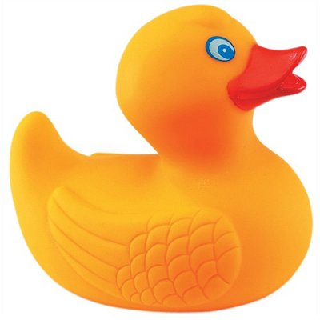
5

4

3

2

1

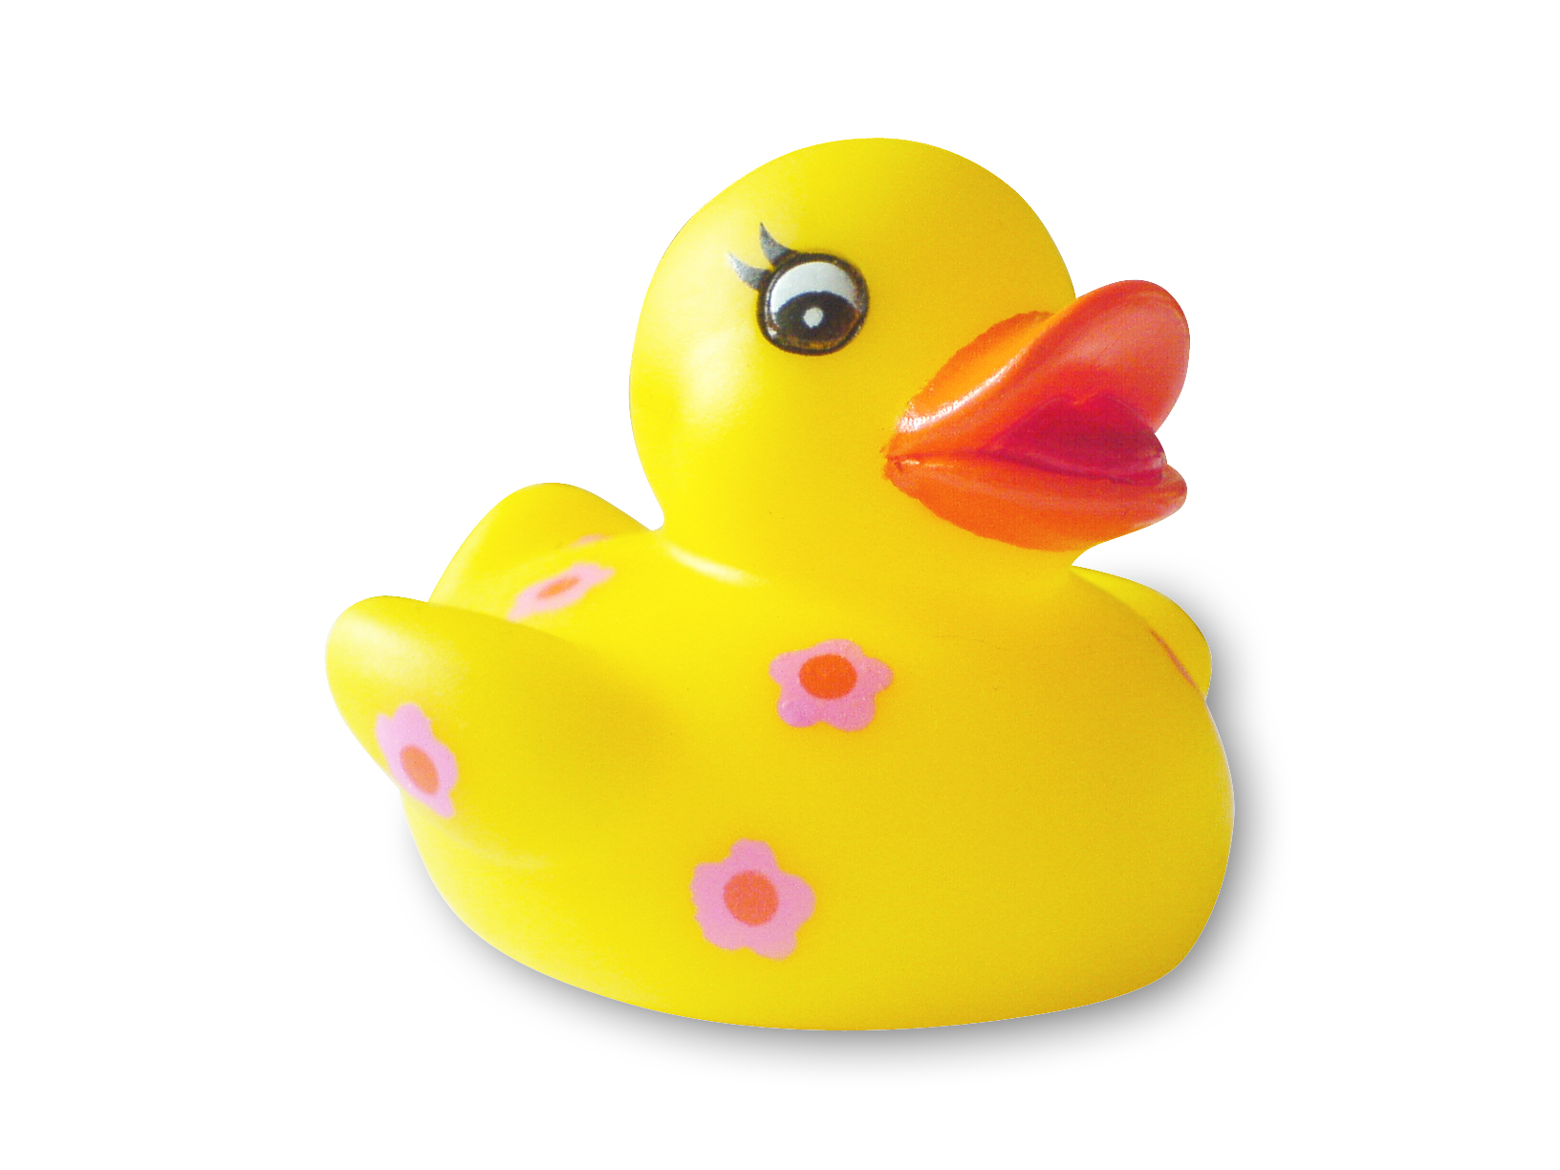

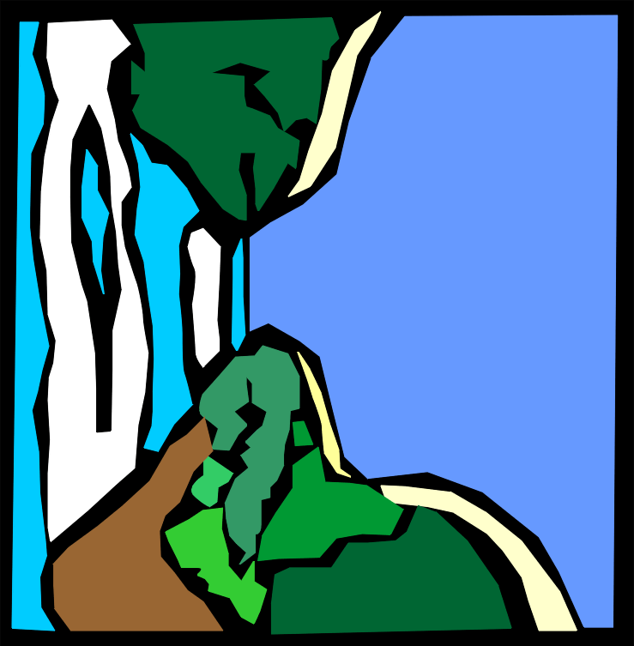

Lets do it again

1- Number one, touch your tongue.

2- Number two, touch your shoe

3- Number three, touch your knee

4- Number four, touch the floor.

5- Number five, do the jive.

6- Number six, pick- up sticks.

7- Number seven, point to heaven.

8- Number eight, close the gate.

9- Number nine, touch your spine.

10- Number ten, Lets do it again!



Pirate ship
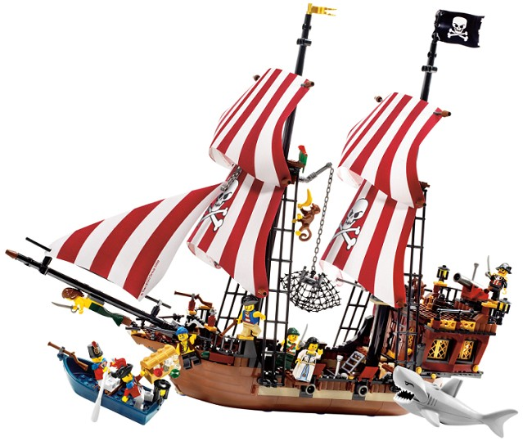
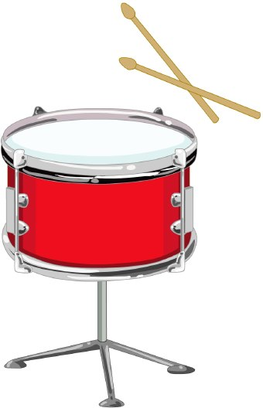

When I was one I banged my drum the day I went to sea,

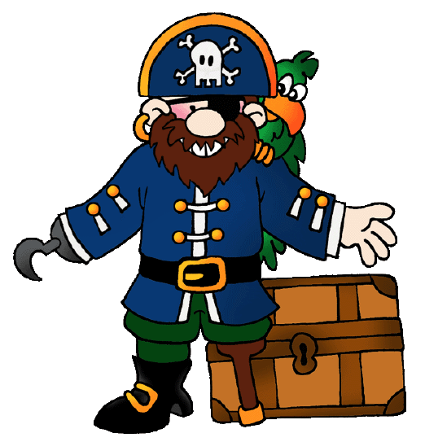
I jumped aboard a pirate ship and the captain said to me,
We’re going this way, that way, forwards, backwards over the Irish sea,
A bottle of rum to warm my tum and that’s the life for me.

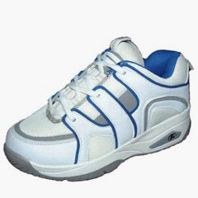
When I was two I lost my shoe the day I went to sea…

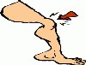
When I was three I banged my knee the day I went to sea…



When I was four I knocked the door the day I went to sea…

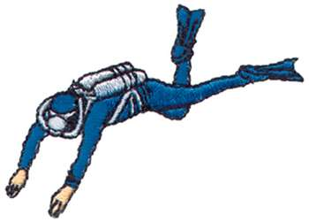

When I was five I learned to dive the day I went to sea…

5
4
3
2
1

Five Currant Buns

5 currant buns in a bakers shop,
Round and fat with sugar on the top.
Along came (choose a child),
With a penny one day.
Bought a currant bun and took it away.
4 currant buns in a bakers shop…
3 currant buns in a bakers shop…
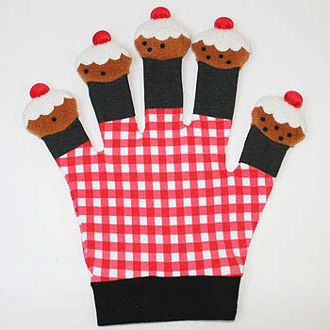
2 currant buns in a bakers shop…
1 currant buns in a bakers shop…
Ten Fat Sausages

10 fat sausages, sizzling in the pan,
All of a sudden one went Bang!
.
9 fat sausages, sizzling in the pan…
8.....etc

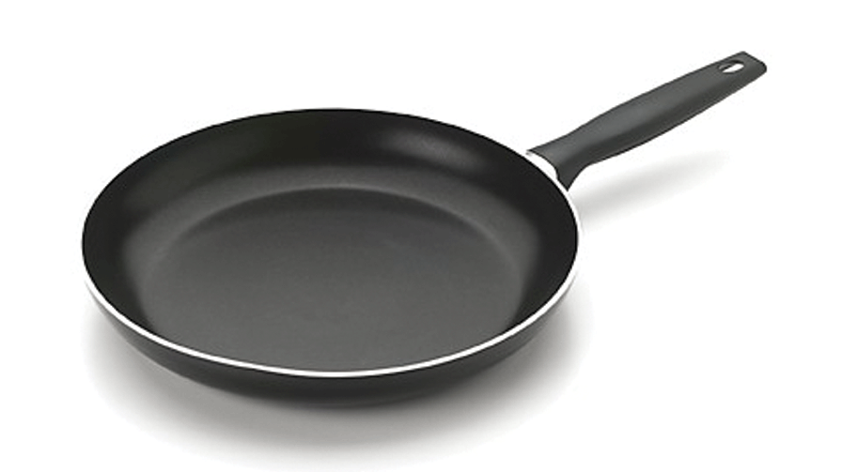
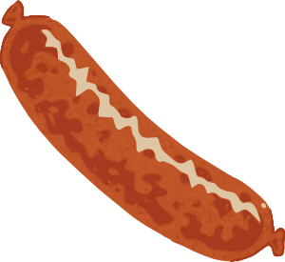

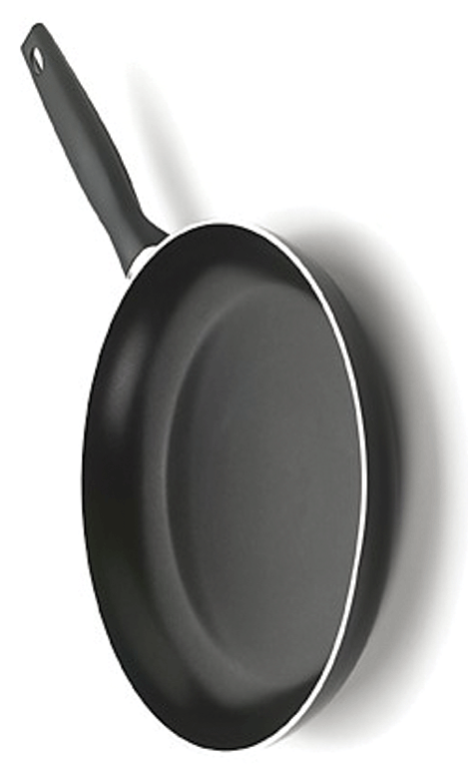

Ten Green Bottles
Ten green bottles, hanging on the wall,
Ten green bottles, hanging on the wall.
And if one green bottle,
Should accidentally fall.
There'll be, nine green bottles, hanging on the wall.

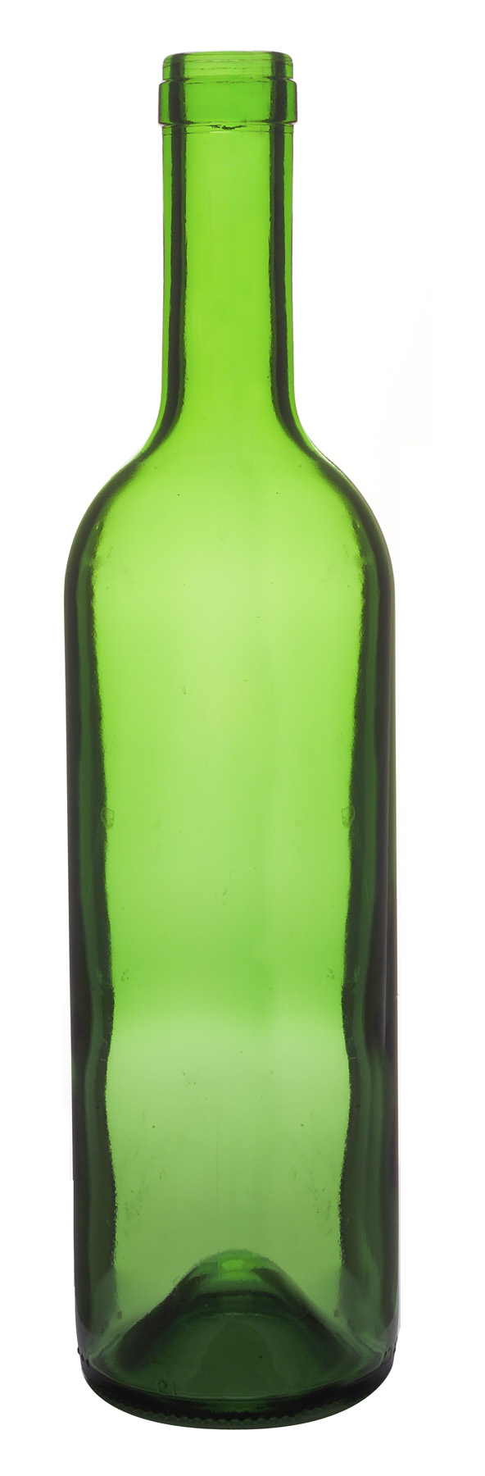

10 Little Indians

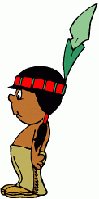

One little, two little, three little Indians

Four little, five little, six little Indians

Seven little, eight little, nine little Indians

Ten little Indian boys.

Ten little, nine little, eight little Indians
Seven little, six little, five little Indians
Four little, three little, two little Indians
One little Indian boy.

1 | 2 | 3 | 4 | 5
6 | 7 | 8 | 9 | 10

10 bottles of pop on the wall
10 bottles of pop
If one of those bottles should happen to fall,
9 bottles of pop on the wall.
10 bottles of pop on the wall
9 bottles of pop on the wall
9 bottles of pop
If one of those bottles should happen to fall,
8 bottles of pop on the wall.
8 bottles of pop on the wall
8 bottles of pop
If one of those bottles should happen to fall,
7 bottles of pop on the wall.
6 bottles of pop on the wall
6 bottles of pop
If one of those bottles should happen to fall,
5 bottles of pop on the wall.
5 bottles of pop on the wall
5 bottles of pop
If one of those bottles should happen to fall,
4 bottle of pop on the wall.
4 bottles of pop on the wall
4 bottles of pop
If one of those bottles should happen to fall,
3 bottle of pop on the wall.
3 bottles of pop on the wall
3 bottles of pop
If one of those bottles should happen to fall,
2 bottle of pop on the wall.
2 bottles of pop on the wall
2 bottles of pop
If one of those bottles should happen to fall,
1 bottle of pop on the wall.
1 bottle of pop on the wall
1 bottle of pop
If that bottles should happen to fall,
0 bottles of pop on the wall.

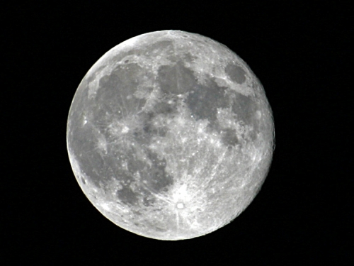
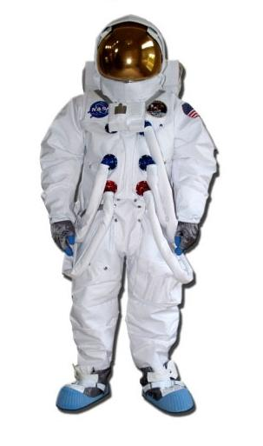


Five little Astronauts
There were five little astronauts
Going to the moon
One stayed to close the door
And that left only four
There were four little astronauts
Going to the moon
One stayed to make some tea
And that left only three
There were three little astronauts
Going to the moon
One couldn't find his shoe
And that left only two
There were two little astronauts
Going to the moon
One couldn't get her spacesuit on
And that left only one
One little astronaut
Did go to the moon
10, 9, 8, 7, 6, 5, 4, 3, 2, 1,
BLAST OFF!
But she didn't like it very much
So she came back home quite soon


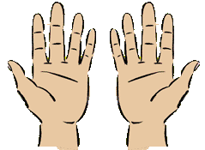

I have ten fingers
And they all belong to me,
I can make them do things-
Would you like to see?
I can shut them up tight
I can open them wide
I can put them together
I can make them all hide
I can make them jump high
I can make them jump low
I can fold them up quietly
And hold them just so.

Five little monkeys
Five little monkeys swinging from a tree,
Teasing Mr crocodile, "You can't catch me"
Along came the crocodile, as quiet as can be and SNAP!
went the crocodile, and then there were:
Four little monkeys swinging from a tree?

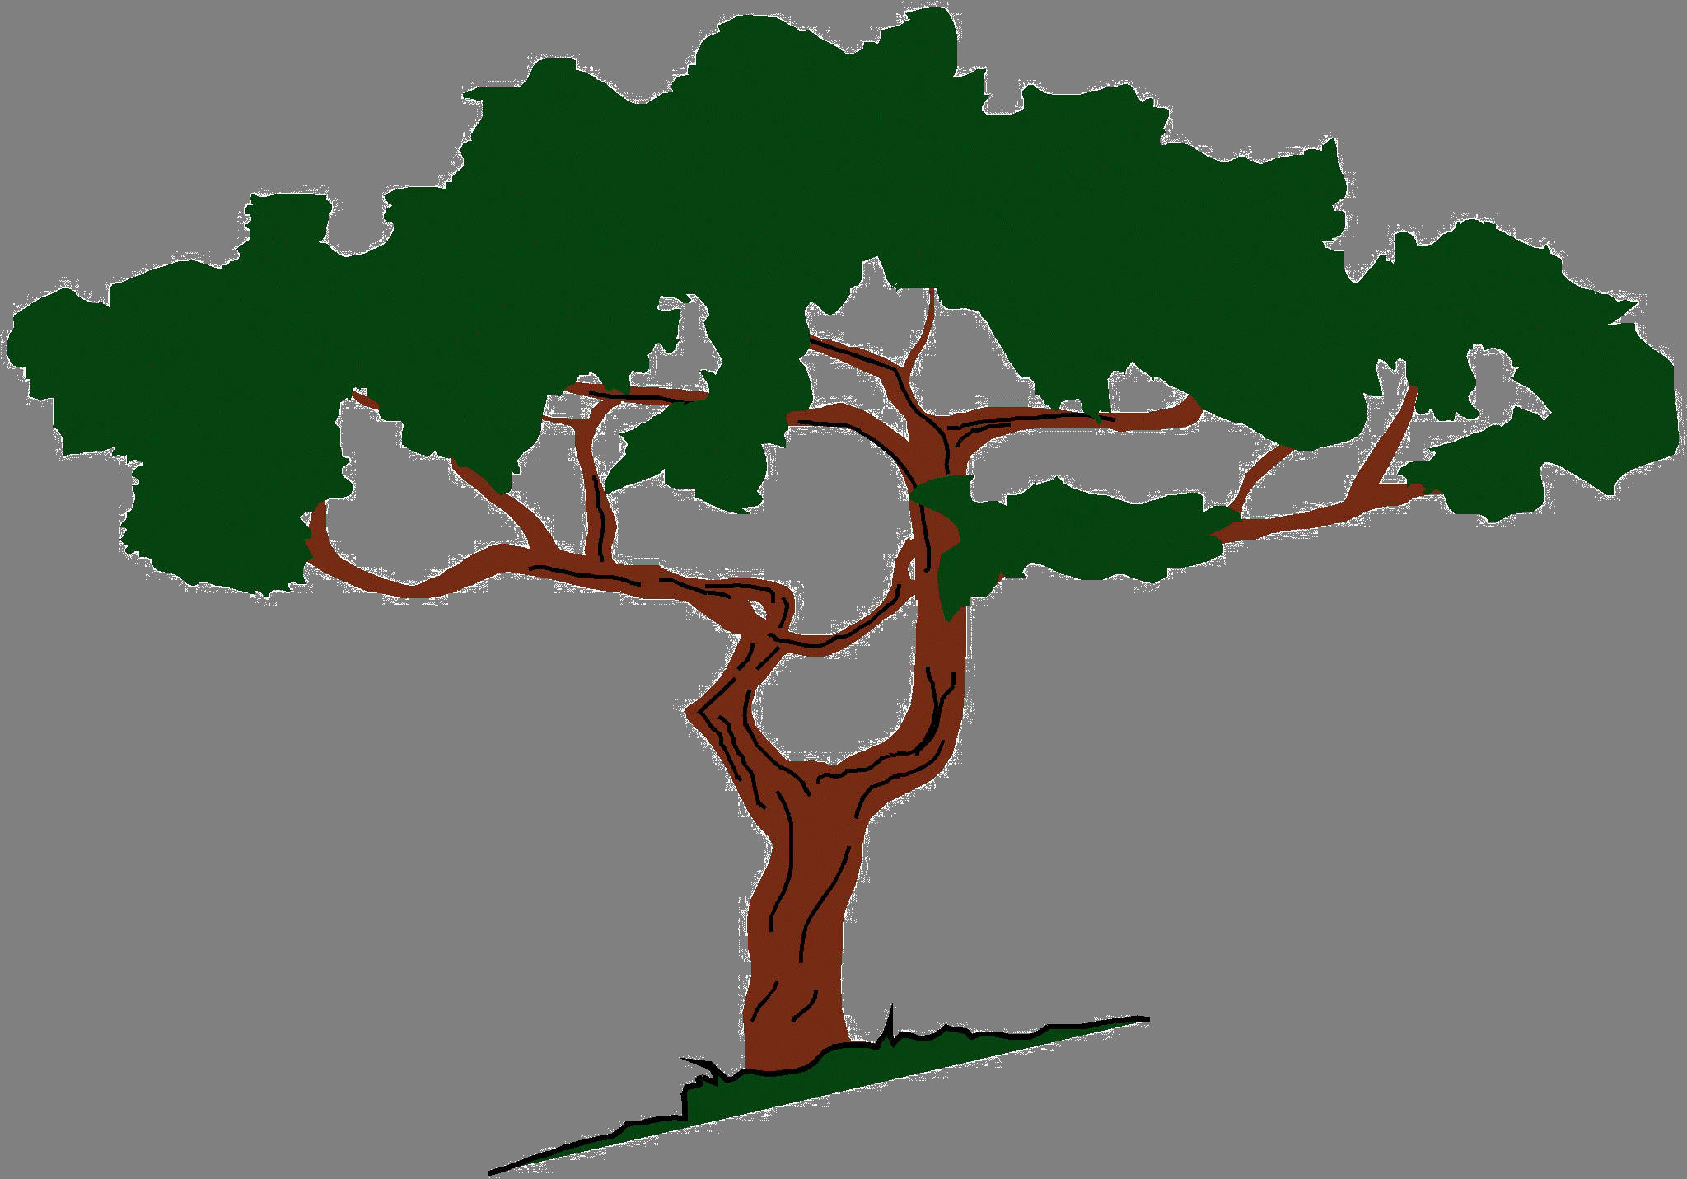

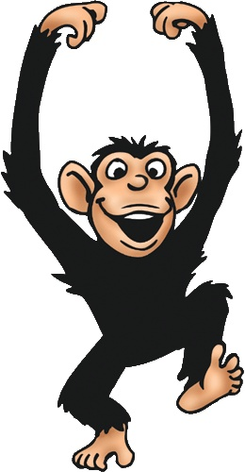

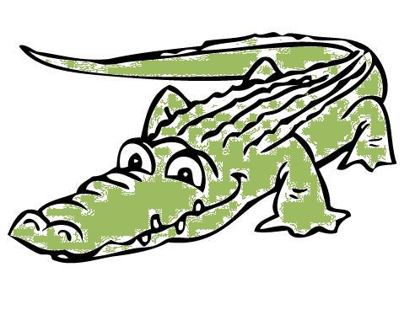

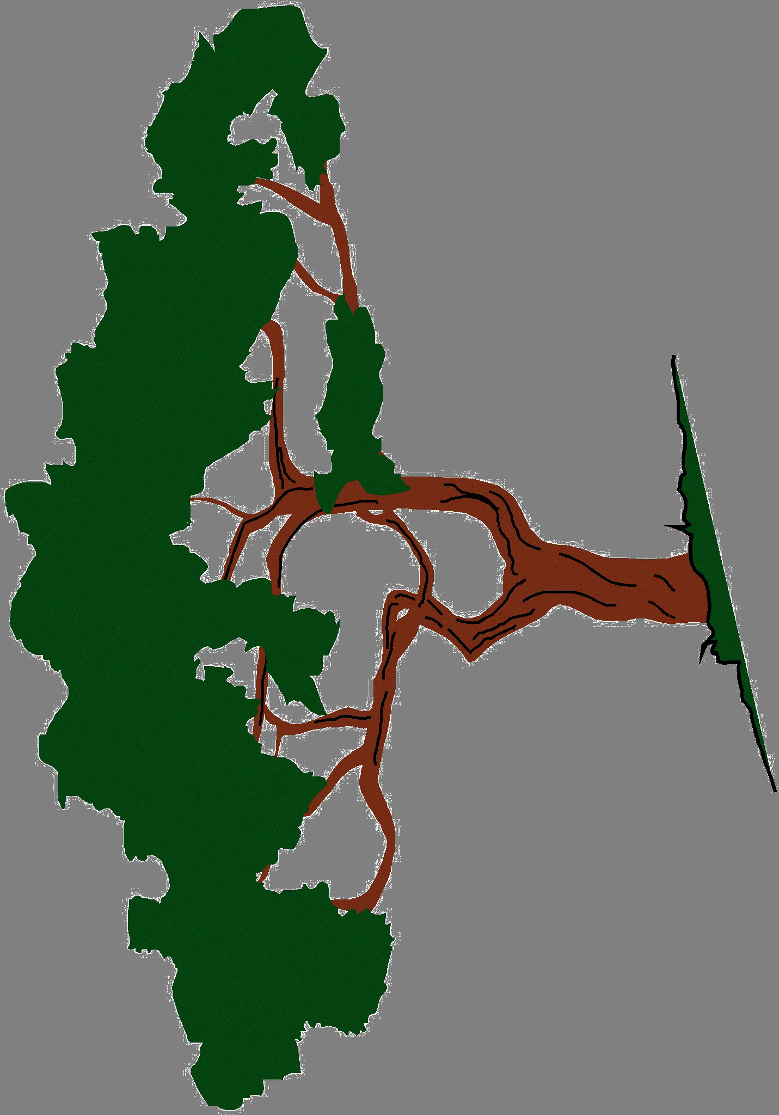

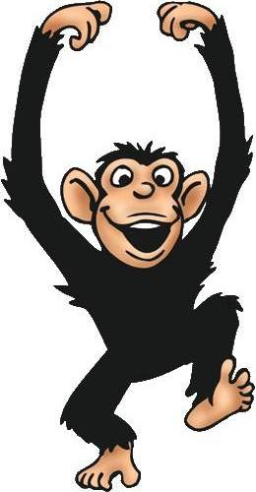

Five Little Monkeys
Five little monkeys jumping on the bed.
One fell off and bumped his head.
Mummy Called the doctor and the doctor said,
"No more monkeys jumping on the bed."
.
Four little monkeys jumping on the bed.
One fell off and bumped his head.
Mummy Called the doctor and the doctor said,
"No more monkeys jumping on the bed."

Three little monkeys jumping on the bed.
One fell off and bumped his head.
Mummy Called the doctor and the doctor said,
"No more monkeys jumping on the bed."

Two little monkeys jumping on the bed.
One fell off and bumped his head.
Mummy Called the doctor and the doctor said,
"No more monkeys jumping on the bed."
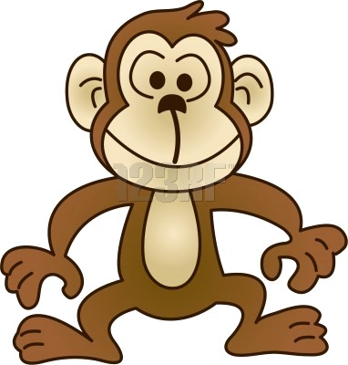
.
One little monkey jumping on the bed.
He fell off and bumped his head.
Mummy Called the doctor and the doctor said,
"No more monkeys jumping on the bed."

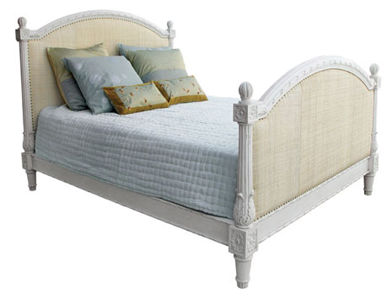

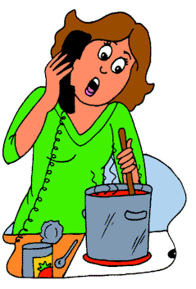

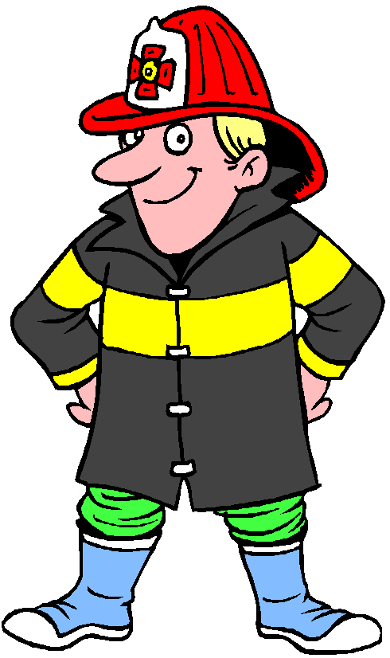
Little Firemen
Five little firemen standing in a row,
1 2 3 4 5 lets go.
Jump on the engine with a SHOUT,
As quick as a wink the fire is out.
Four little firemen standing in a row,
1 2 3 4 woosh lets go.
Jump on the engine with a Shout
As quick as a wink the fire is out.
Three little firemen standing in a row,
1 2 3 woosh woosh lets go.
Jump on the engine with a Shout
As quick as a wink the fire is out.
Two little firemen standing in a row,
1 2 woosh woosh woosh lets go.
Jump on the engine with a Shout
As quick as a wink the fire is out.
One little firemen standing in a row,
1 woosh woosh woosh woosh lets go.
Jump on the engine with a Shout
As quick as a wink the fire is out.
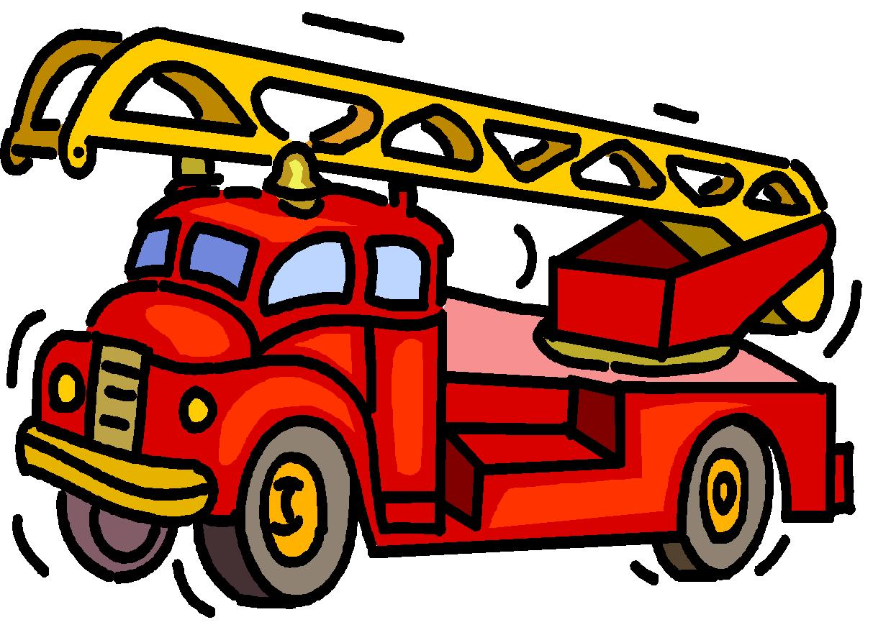

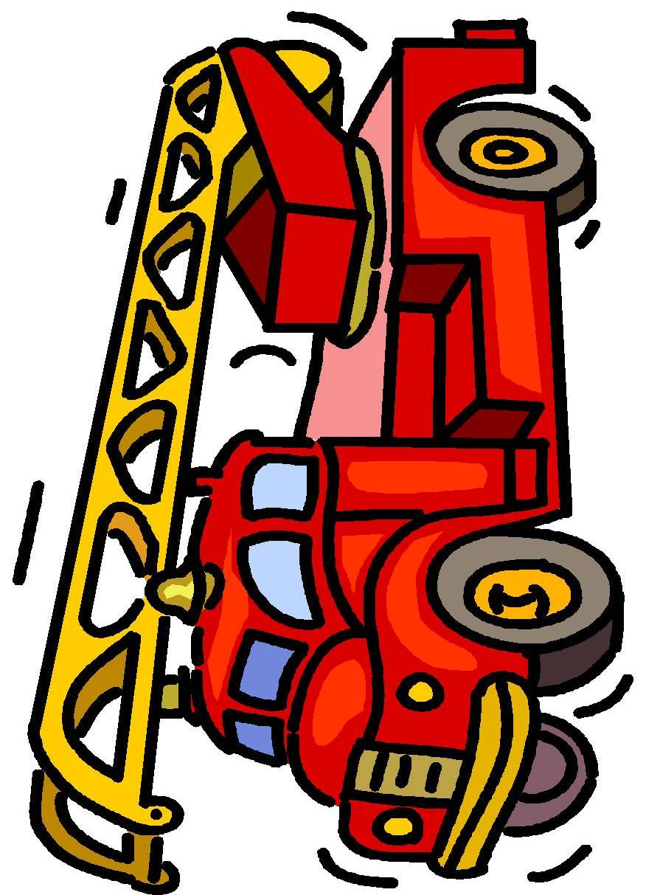
I have ten little fingers

I have ten little fingers and ten little toes,
Two little arms and one little nose,
One little mouth and two little ears,
Two little eyes for smiles and tears,
One little head and two little feet,
One little chin makes me all complete!



Five peas in a peapod
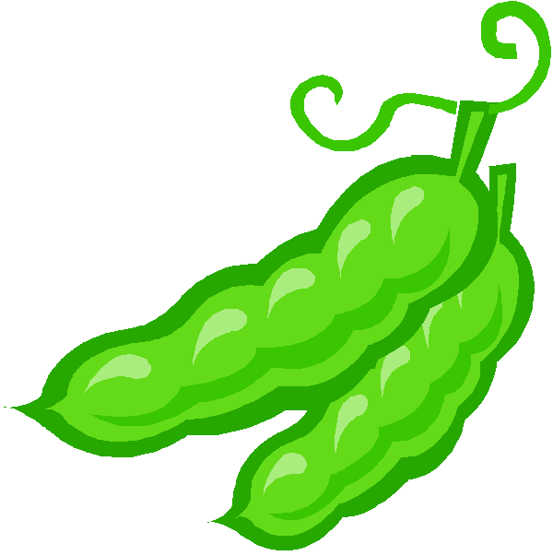
Five fat peas in a pea pod pressed
(children hold hand in a fist)
One grew, two grew, so did all the rest.
(put thumb and fingers up one by one)
They grew and grew
(raise hand in the air very slowly)
And did not stop,
Until one day
The pod went POP!
(children clap hands together)

Ten in the Bed

There were ten in the bed,
And the little one said, 'Roll over, roll over'.
So they all rolled over,
And one fell out,
There were nine in the bed…
8…..
7……
6……
5……
4…..
3…..
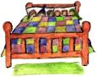
2…..
There was one in the bed,
And the little one said, 'Roll over, roll over'.
So he rolled over,
And he fell out,
There were none in the bed,
So no one said,
Roll over, Roll over.

5 Little Snowmen
Five little snowmen were very fat,
Each one wore a funny hat;
Out came the sun and melted one,
And four little snowmen stood in the sun.
(continue counting down to one)
One little snowman was very sad,
He still had his funny hat,
Down came the snow
and the children played,
And built four more snowmen on that winter’s day!

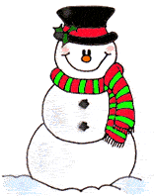
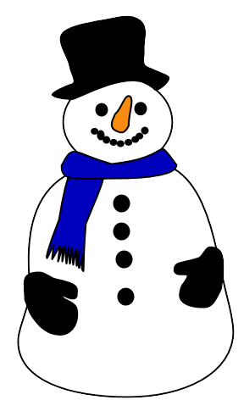
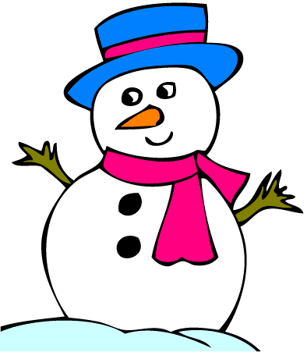
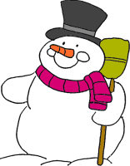
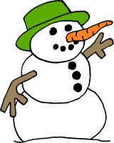

One Potato, Two Potato

One potato, two potato,
Three potato, four.
Five potato, six potato,
Seven potato more.
2
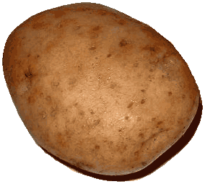
1
3
6
5
7
4

2

1

4
3

6
5

7

Five Little Men in a Flying Saucer

Five little men in a flying saucer,
Flew around the world one day.
They looked left and right,
But they didn't like the sight.
So one man flew away.
ZOOOOOOOOOM!
Four little men in a flying saucer......

Continue until they've all gone.

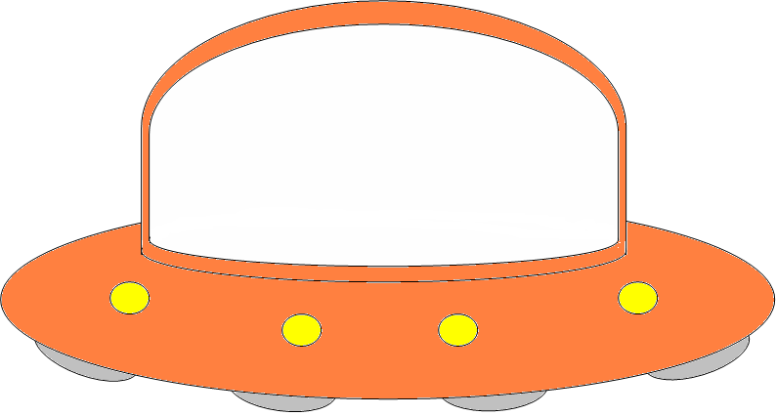
Five Crispy Pancakes
Five crispy pancakes in a frying pan,
Flip them , toss them and catch them if you can.
Along came (choose a child),
For a pancake one day
Sprinkled it with sugar and took it away.
Four crispy pancakes in a frying pan...

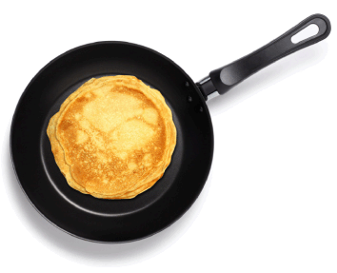

A Tall Silver Rocket
A tall silver rocket
Is standing on the ground,
Now it’s nearly ready
Here comes the sound.
10,9,8,7,6,5,4,3,2,1
BLAST OFF

Sing a Song of Numbers
Sung to: "Sing a Song of Sixpence"
Sing a song of numbers,
Count them one by one.
Sing a song of numbers,
We've only just begun.
One-two-three-four-five-six,
Seven-eight-nine-ten.
When we finish counting them,
We'll start them once again.

1 2 3 4 5 6 7 8 9 10

1 | 2
3 | 4
5 | 6
7 | 8
9 | 10

On the farmer’s apple tree

On the farmer’s apple tree
Five red apples I can see,
Some for you and some for me
Pick one apple from the tree.

On the farmer’s apple tree

Four red apples I can see…

Three big balloons

Three big balloons, yellow, green and blue
One went pop
And then there were two.

Two big balloons, ready for some fun
One went pop and then there was one.

One big balloon, playing in the sun
It went pop and then there were none.
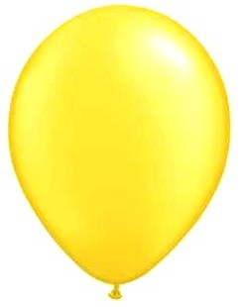

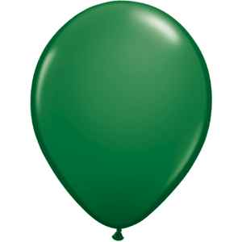


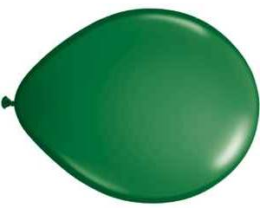
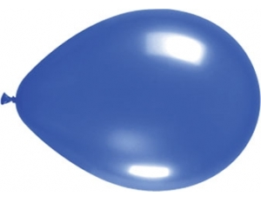
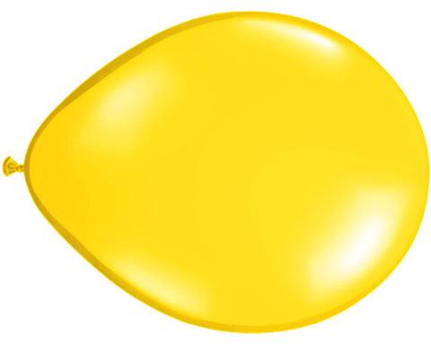
Five little woolly lambs

Five little woolly lambs in a field one day
One little woolly lamb wandered far away
Don’t wander woolly lamb, don’t wander far
Mother sheep is calling Baa Baa Baa.

Four little woolly lambs…
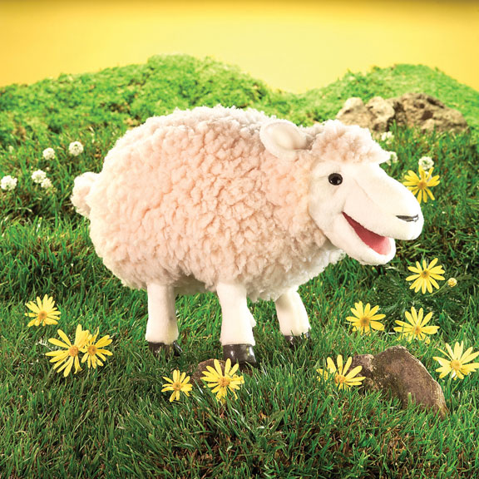

Johnny taps with one hammer

Johnny taps with one hammer,
One hammer, one hammer,
Johnny taps with one hammer,
Then he taps with 2

Johnny taps with two hammers,
two hammers, two hammers,
Then he taps with 3

Johnny taps with three hammers,
three hammers, three hammers,
Johnny taps with three hammers,
Then he taps with 4
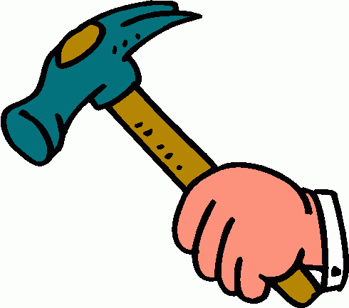

Alice the Camel
Alice the camel has five humps.
Alice the camel has five humps.
Alice the camel has five humps.
So go, Alice, go.
Alice the camel has four humps.
Alice the camel has four humps.
Alice the camel has four humps.
So go, Alice, go.
Continue counting down
Alice the camel has no humps.
Alice the camel has no humps.
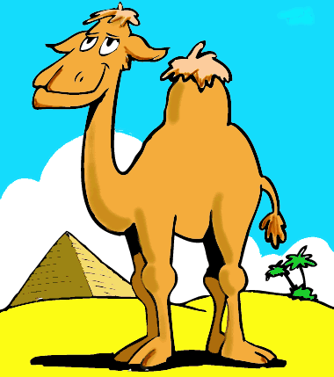
Alice the camel has no humps.
Now Alice is a horse

Five Little Birdies
Five little birdies, flying around our door,
The blue one flew away and then there were four.
Four little birdies sitting in a tree,
The yellow one flew away and then there were three.
The little birdies didn't know what to do,
So the red one flew away, and then there were two.
Two little birdies sitting in the sun,
The Brown one flew away, and there was one.
The little green birdie felt so all alone,
He/she flew away and then there was none


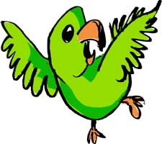

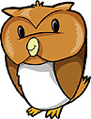

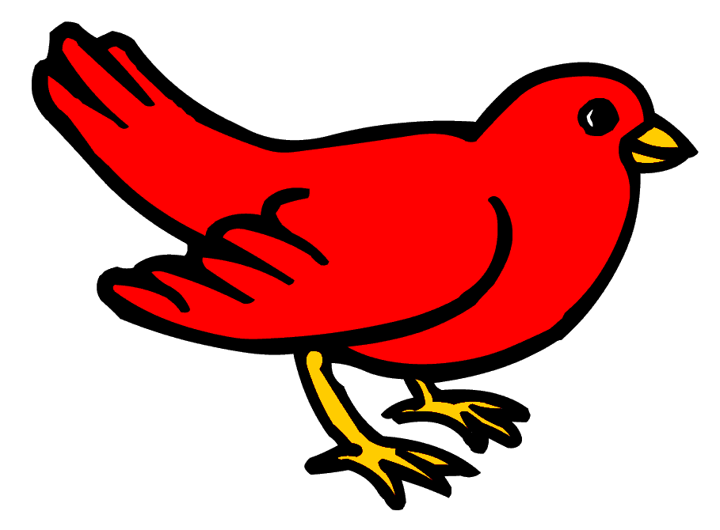
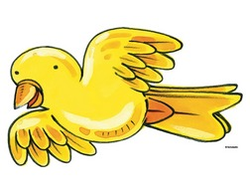

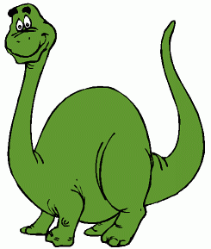
Dinosaurs
Five enormous dinosaurs
Letting out a roar--
One went away, and
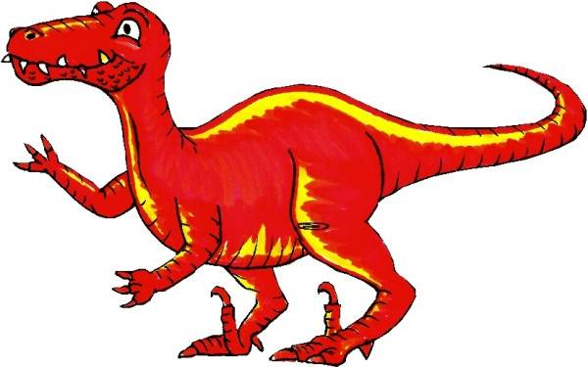
Then there were four.
Four enormous dinosaurs
Crashing down a tree--
One went away, and
Then there were three.
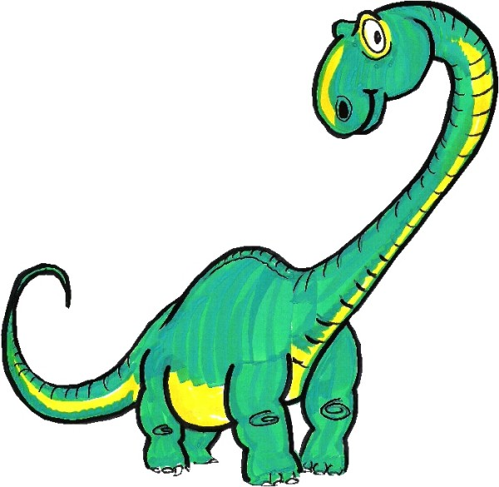
Three enormous dinosaurs
Eating tiger stew--
One went away, and
Then there were two.
Two enormous dinosaurs
Trying to run--
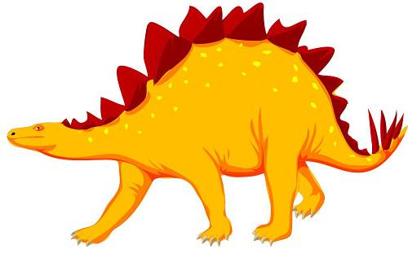
One ran away, and
Then there was one.
One enormous dinosaur,
Afraid to be a hero--
He went away, and
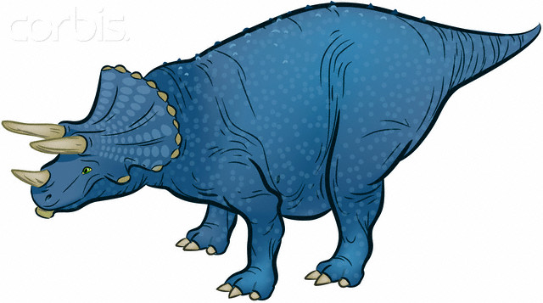
Then there was zero

Five Little Mice
Five little mice came out to play
Gathering crumbs along the way
Out came pussycat sleek and fat
Four little mice go scampering back
…
One little mouse came out to play
Gathering crumbs along the way
Out came pussycat sleek and fat
No little mice go scampering back
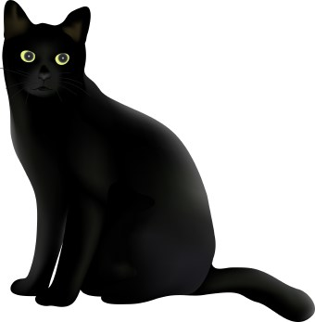

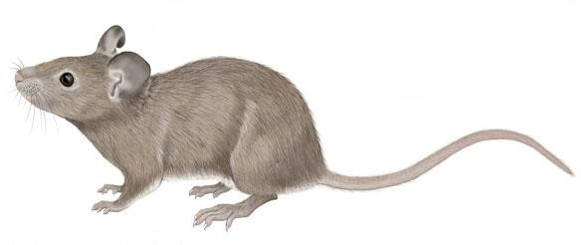

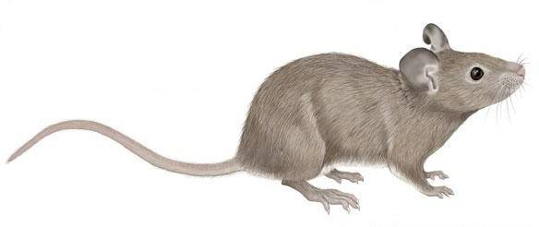

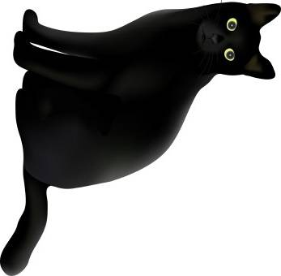

Five big ice-creams

Five big ice-creams
With sprinkles on the top
Five big ice-creams
With sprinkles on the top
And if …………. comes and takes one
And gobbles it all up
There’ll be how many ice-creams standing in the shop

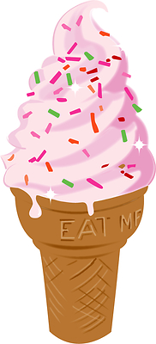

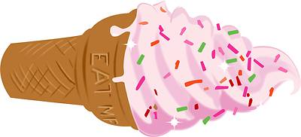

Five little froggies

Five little froggies sitting on a well
One looked up and down he fell
Froggy jumped high
And froggy jumped low
Four little froggies dancing to and fro
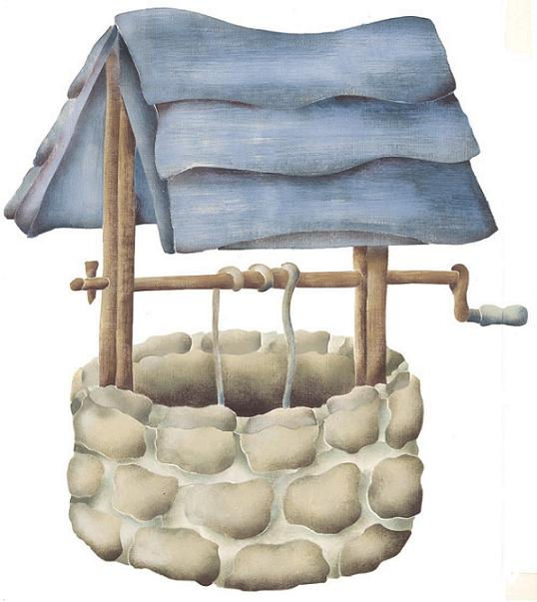
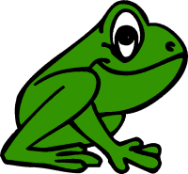
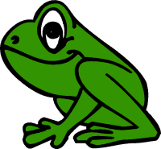

Ten Little Children
One little, two little, three little children.
Four little, five little, six little children.
Seven little, eight little, nine little children.
Ten children in the room.
Ten little, nine little, eight little children.
Seven little, six little, five little children.
Four little, three little, two little children.
One child in the room.

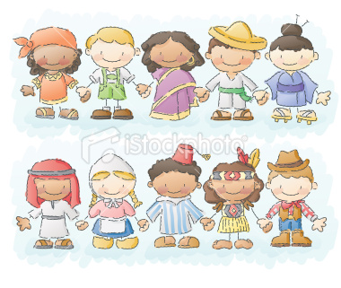

Five Little Pigs
(Tune is "Five Little Ducks Went Out to Play")
Five little pigs rolled in the mud-
Squishy, squashy felt so good.
The farmer took one piggy out.
"Oink, oink, oink" the pig did shout!
Count down until-
No little pigs rolled in the mud.
They all looked so clean and good.
The farmer turned his back and then,
Those pigs rolled in the mud again.



