My Family  Draw a picture of your family.  Add as much detail as you would like including if you have any pets.  Remember to label your picture with each person’s name.  If you can, bring your picture in on Friday to share during circle time.  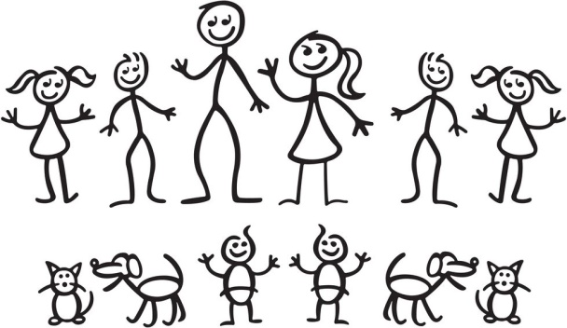 | My Feelings  Choose and read your favourite book with a parent, carer or older sibling.  See if you can pick out some feelings words from the book, for example: sad, happy, excited.  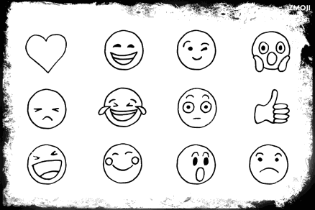  Think about your first day in Primary 2. What feelings words could you use to describe how you felt before, during and after school? | My Skills and Talents  Have a discussion with a parent, carer or older sibling about your skills and talents.  Do you attend any after school clubs or sports clubs? For example: judo, dancing, gymnastics.  What skills do you have? For example: organising things, running fast, being a good friend to others.
P2 Home Learning – Thursday 13.08.20

