Name_________________________ Date___________________
LI: to write all about myself

Name_________________________ Date___________________
LI: to write all about myself
Item 1:

Item 2:

Item 3:

Item 4:

Item 5:

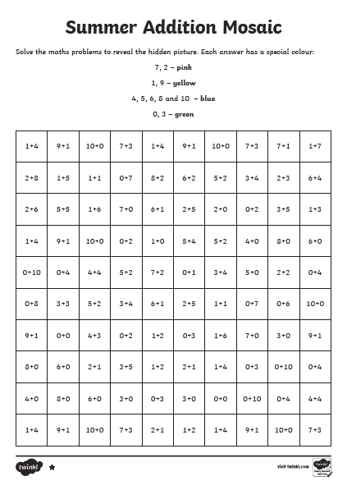

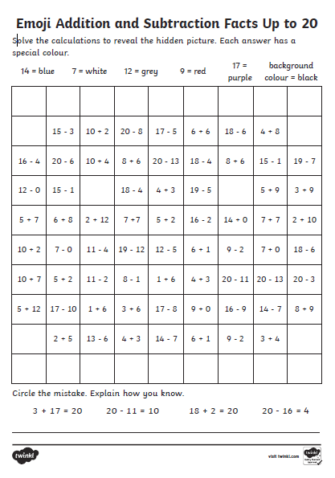
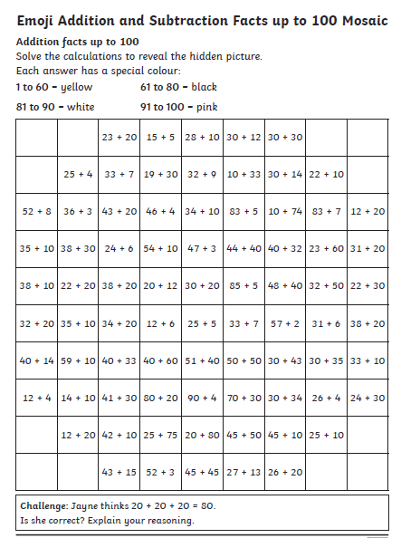

Blank Grid for Numeracy extension Task

