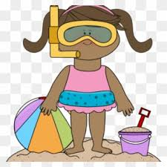
Summer Holiday Activities

Things to do when it is sunny | Sunshine Checklist  Make a checklist to make sure that everyone is following the Sun Safety Rules, including drinking plenty of water and going in the shade  https://www.youtube.com/watch?v=EwyqaLnsi5Q | Bee and Butterfly Spot  Keep track of how many butterflies or bees that you see. Remember if you see a bee in need, you can ask an adult to help you make a small sugary drink to help them. This can just be a small tub with some water and sugar. | 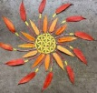  Nature art  Make a picture  using twigs, pebbles,  leaves and flower petals. Your picture could be an abstract  design or a self-portrait. | 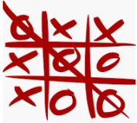  Water writing.  You will need a  container of water  and a paint brush  or stick. Draw pictures,  play noughts and crosses, or write your name on concrete paths.
Things to do when it is raining | 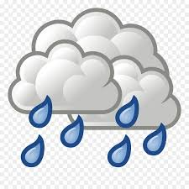Rain Gauge  Make a rain gauge to measure how much rain water has fallen  Here is a link to help you  https://www.youtube.com/watch?v=QOzdcM-YZ2U | 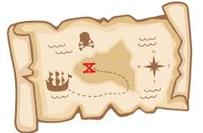Indoor Treasure Hunt  Set up an indoor treasure hunt at home. Ask your adults to hide some items and you can design a map of your house. Your adult can mark off where to find the treasure with an X. | Memory game  You will need10 small objects from around the house. Lay out the objects on a table or tray. Ask your partner to close their eyes. Take away an object. Your partner opens their eyes and has to guess what is missing. | Help around the house.  Tidy your room.  Plump the cushions  on the sofa, dust and  vacuum. Help make  lunch and clear the dishes. Put your feet up and enjoy reading your favourite book when everything is lovely and tidy.
Things to do when it is windy | 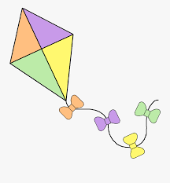Make a Kite  Make a kite from recycled materials. When it is dry, go outside and fly it!  https://www.youtube.com/watch?v=mc3AUuuj9_I | Wind Chime Music  Create a wind chime  and listen to all of the  different sounds that it makes.  https://www.youtube.com/watch?v=QRgum3KzfLo | Make a windmill  Make a pinwheel  windmill to decorate  the garden. Adult supervision required.  https://www.youtube.com/watch?v=xUpCuwf3JEg | Blow bubbles  Make bubble mixture  using washing up  liquid and water.  https://www.bbcgoodfood.com/howto/guide/how-make-bubble-mixture

Things to do when you are bored  (these tasks are longer projects which will take more than just a day!) | Home Library  Create an at home  library. Remember  everyone in your house  will need a library card and you will need a list of books to keep track of which books are being borrowed and returned. | Home Cinema  Create an at home cinema. Everyone in your house will need tickets and also a timetable of which films will show and when they will be on. Everyone will need comfortable seating and maybe some snacks too! | Reading den  Build a reading den using a blanket or two, sofa cushions and pillows.  https://home.oxfordowl.co.uk/blog/building-reading-dens/ | Learn a poem  Choose a poem  and practise it. When  you know it by heart, recite it to  the people at home.  https://childrens.poetryarchive.org/explore/?key=&type=poems&poet=&theme=&form=&age=251
Things to do if you are missing someone | Pick up the phone  Call someone that  are missing and ask  them how they are doing. | Write a Letter  Write a letter for  someone who you miss  and post it to them. | Create a memory poster  Draw or write about your favourite memory with the person, then take a picture and send it to them! | Become a photographer  Take pictures with a phone or tablet of the people who are with you! Share those new memories with the people you are missing next time you see them.
Things to do if you are missing school | Play Classrooms  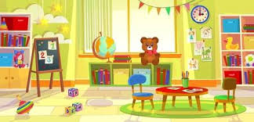  Set up a classroom at home and set tasks for the people in your house. | Online Games  Go on to the P3 blog and look through the online game links that we have posted  https://blogs.glowscotland.org.uk/wl/simpsonps/category/primary-3/ | Create some goals  Think about something you could get better at, create a plan of action and try and improve your skill. | List it  Make a list of all of the things that you will need to pack in your school bag for P4.  