Themed activities for the last week in Primary 1

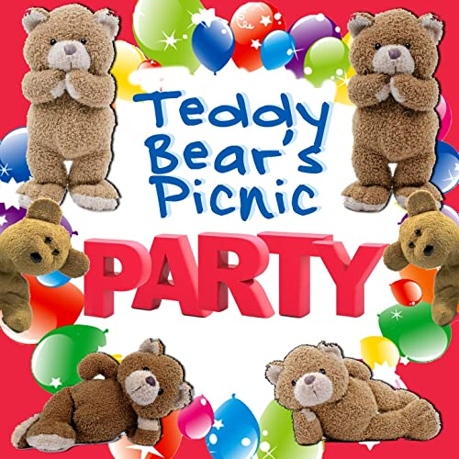  Choose your favourite toys to attend and begin to plan your teddy bears picnic.  Can you sort your toys? (e.g. brown, big or small)  Can you order the according to size? | Create an invitation and send it to those who you want to attend your party.  Remember to include, date, time, venue and who it is to and from.  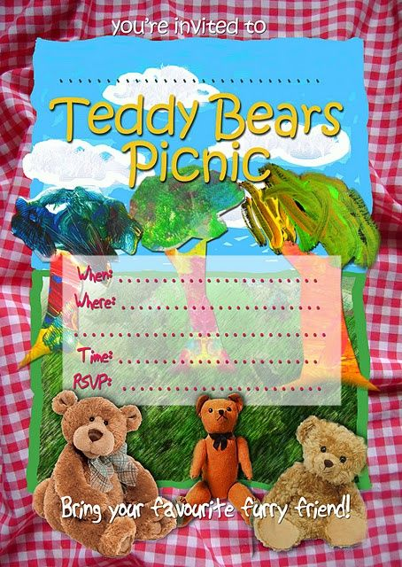 | 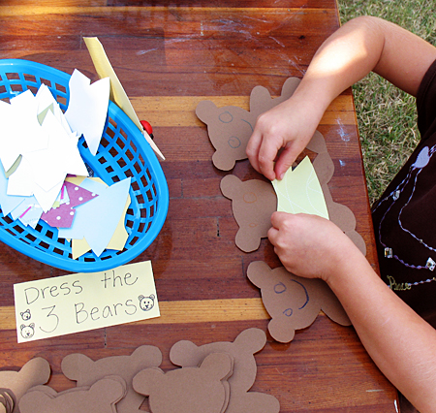  Get creative and make yourself or your teddy a new outfit to wear to the teddy bears picnic. | Plan your party menu try to get a good balance and of food.  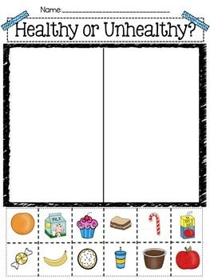  We should try to eat 10 pieces of fruit and veg a day.
EXPLORING FAIRNESS  Using raisins or grapes can you share an amount equally among your picnic guest.  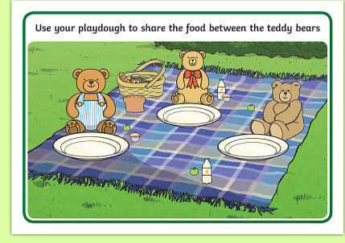 | P.E. / Physical Activity  1, Toss the bees into the honey pots (throwing to a target)  2, Teddy Bear Relay Races  3, Toss the Bear – measure who can throw it the furthest | 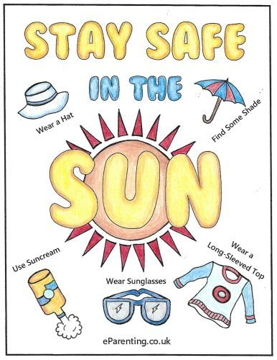  If you have planned an outdoor picnic think about the things you will need to keep yourself safe whilst out in the sun. | Enjoy your teddy bears picnic.  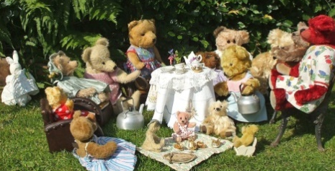
Go outside and act out the story ‘We are Going on a Bear Hunt.’  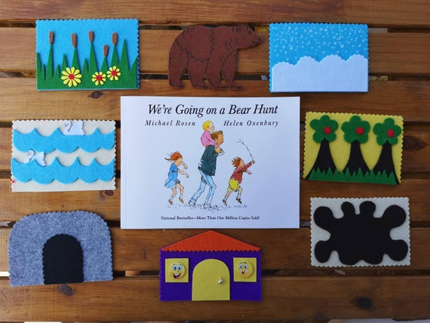 | ICT – using the internet complete a research project.  This could be about how many different kinds of bears there are.  Or  You may want to choose one type of bear and draw and write some facts about that bear. | 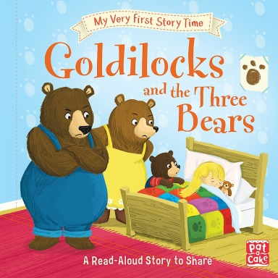  Can you make a change to the story of Goldilocks? Create a new page to add to the book.  Will you change the start middle or end?  Draw a picture and write a sentence. Remember to include capital letters, full stops and finger spaces. | Explore and discuss the different emotions of each character. Think about how you might feel if you were one of the bears or if you were Goldilocks. 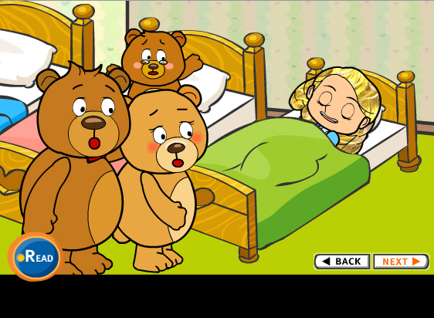
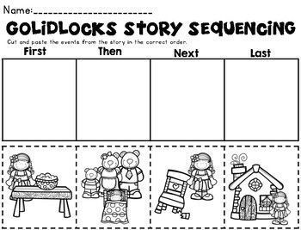 | STEM  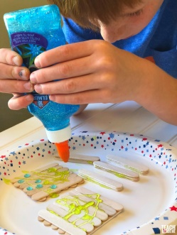  Can you use materials to help make baby bear a new seat? | Can you help make porridge?  What do you like to add to your porridge? | The Three Bears are keen to find Goldilocks. Can you make a wanted poster to help them find her?

