Primary 3’s Virtual Trip to an Aquarium!
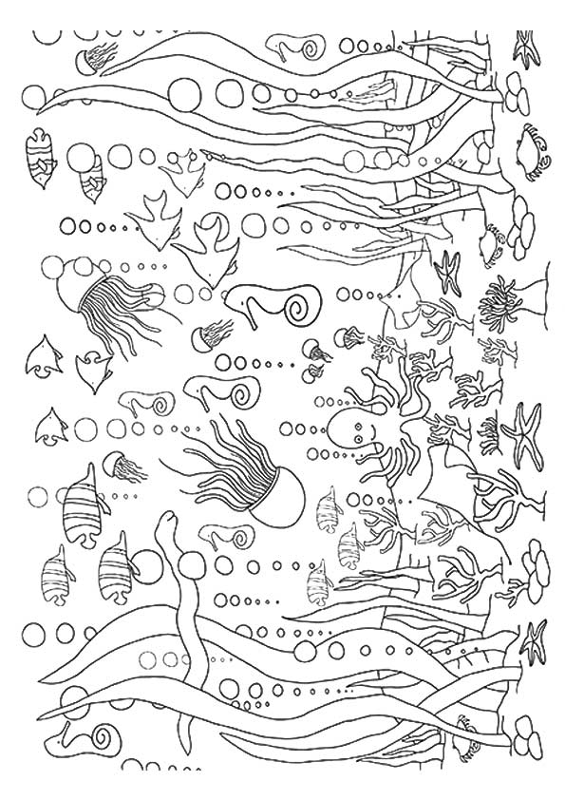
Name:_________
Date:_________
Instructions: Use the Powerpoint on the school blog to take your virtual school trip. The pages in this book are to support the activities in the presentation. The numbers inside a coloured box match up with the slides in the presentation – just look for the same number and same colour!
There is no pressure to complete all of the activities – pick and choose which ones you are the most interested in!
1
Part 1: Checklist (Planning and Organisation)
You’ll need to remember a lot of things on the school trip. Why not draw a picture of yourself holding everything you need?

Part 2: Tickets
2

To get into the aquarium, we need a ticket. The cashier has asked you to design your own!​
•Checklist for success:​
- the name of the aquarium (be creative)​
- the price of the ticket (not too expensive!)​
- the date of your trip
Front:

Back:

Part 3: Design your own coral reef
3

Take a look at the coral reef camera and think about everything you’ve learned about the ocean. What kind of creatures would live on your coral reef?

Part 4: Penguins
4
Choose the correct habitat for the penguins. Think about everything you’ve learned about these animals and why the habitat you choose is the most suitable.
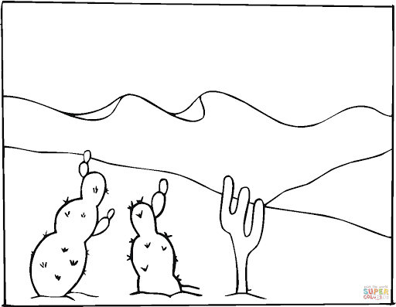 | 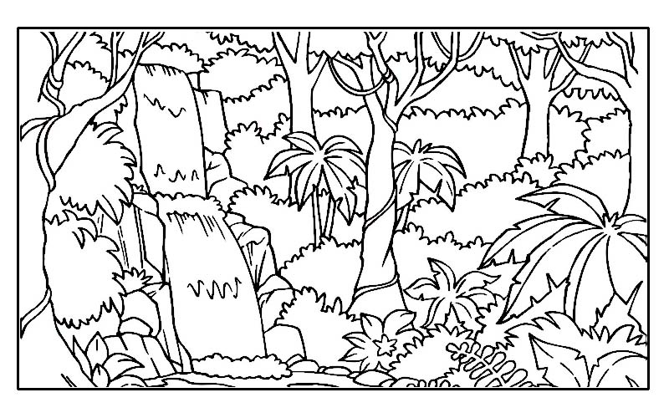
Habitat 1:  Lots of sand  Not very much rain or water  Very hot | Habitat 2:  Lots of trees  Rains every day of the year  Can be hot
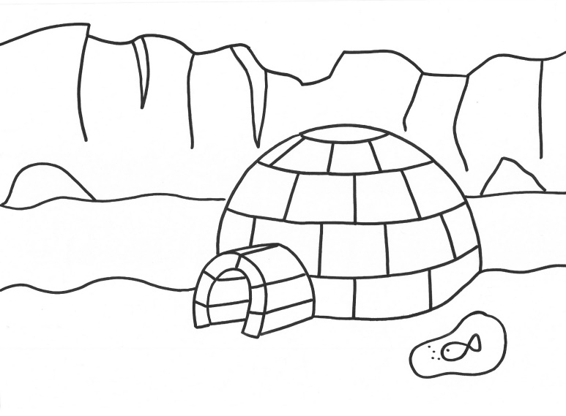 | 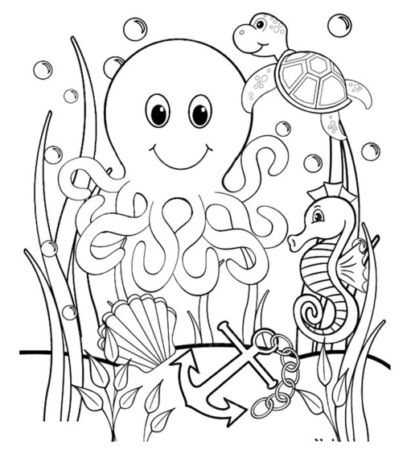
Habitat 3:  Lots of ice and snow  Water nearby with fish  Cold | Habitat 4:  Under the water  Lots of big predators  Sandy ocean floor
Can you think of animals that could live in the other habitats?
Plastic in the Ocean
5
Use the link below to answer the questions:
https://www.deepseaworld.com/blog/deepseaworld/conservation-in-scotland/
- Roughly how many years does it take plastic to decompose?

__________________________________________________
- What kind of things can have a devastating impact on ocean pollution?

- How much plastic is found in the ocean each year?

- What are some things people think you can recycle? Can you recycle these things?

Gift Shop
6
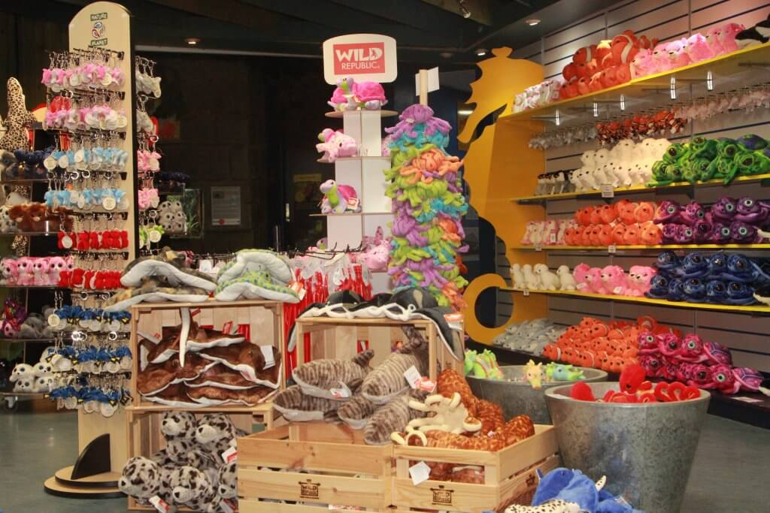
Look at the prices below and add up the prices of the items you would like to buy.

Shark snapper stick - £3.45
Keyring - £1.50
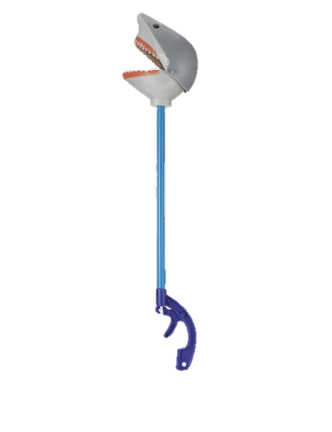
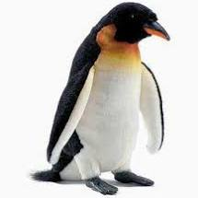
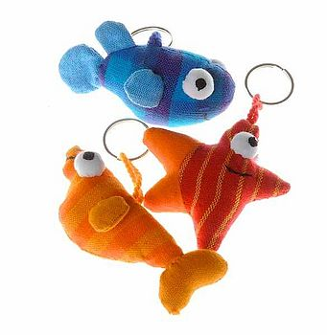

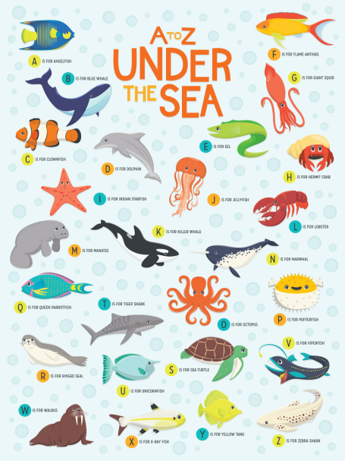
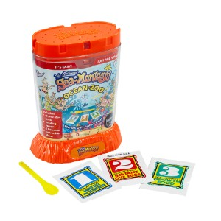
Cuddly toy - £5.53

Grow your own sea monkeys kit - £6.99

Poster - £3 OR 2 for £5
Report Writing
7
Now we're back from our trip, it's time to present what we learned!​ You can do this in any way you like – it could be a report, newspaper article, comic strip, poster.​
Checklist for success: ​
- a fun title​
- your favourite part of the virtual trip​
- two facts you learned​
- pictures of some things you saw​

Extra room for report writing if needed!

