P3 Week 10 Home Learning: Science, Social Science, RME and French. 22.06.2020
Science

Revision of food chains.

Activity 1: Sort the images into the correct order to create food chains.

- 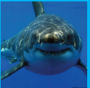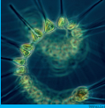

- 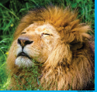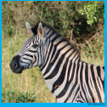

- 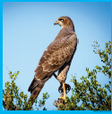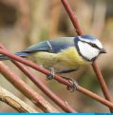

- 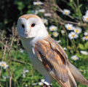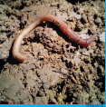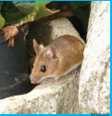

Activity 2: food chain vocabulary. Draw a line to match each key word to its definition.
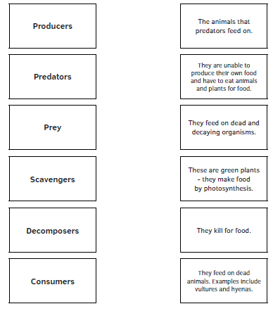

Social Science

Revision of Sea animals and plastic in the ocean

RECAP. Last week’s theme was dolphins. Here are the answers to the quiz:
- True or false – dolphins are herbivores. False. Dolphins are carnivores.
- Do dolphins have a nose? No, they have a beak.
- How do they breathe? Dolphins breathe through a blow hole. They breathe above the water, then close the blow hole to keep water out of their lungs when they dive under the sea.
- True or false – dolphins can hold their breath under water for 25 minutes. True!
- How do dolphins locate objects under water? Dolphins send out sound waves which come back to the dolphin when the waves bounce of other objects. This is called echolocation.
- Dolphins live in groups. Why is this useful? The greater numbers in the group gives them protection from predators.
- How are people harming dolphins? Like other sea creatures, dolphins are being harmed as a result of getting tangled in plastic.

Social Science
Activity 1: here is a chance for you to show how much you have discovered about ocean creatures and plastics.
Quiz.
- How does plastic get into the oceans?
- What is the name for the tiny pellets of plastic used to make larger plastic objects? It sounds a bit like hurdle.
- Can you describe one or two ways in which plastic is harmful to ocean life?
- What do penguins eat?
- Are penguins better at flying or swimming? Can you explain why?
- True or false, sharks have about 3,000 teeth.
- What is a shark skeleton made of? Clue: it is not made up of bone.
- How long can dolphins hold their breath under water?
- What do dolphins eat?

Activity 2: Imagine you are going to give a talk on plastic in the ocean to the Primary 2 classes. Design a poster to illustrate your talk. Here is an example to help you. You will see that it has a title, key facts and illustrations. Once your poster is finished, give your talk to someone at home. Make time at the end for them to ask questions. If possible, ask someone to take a picture of your poster and post it to the blog comments, or tag @missblyth1 and @MrsLDee on Twitter.
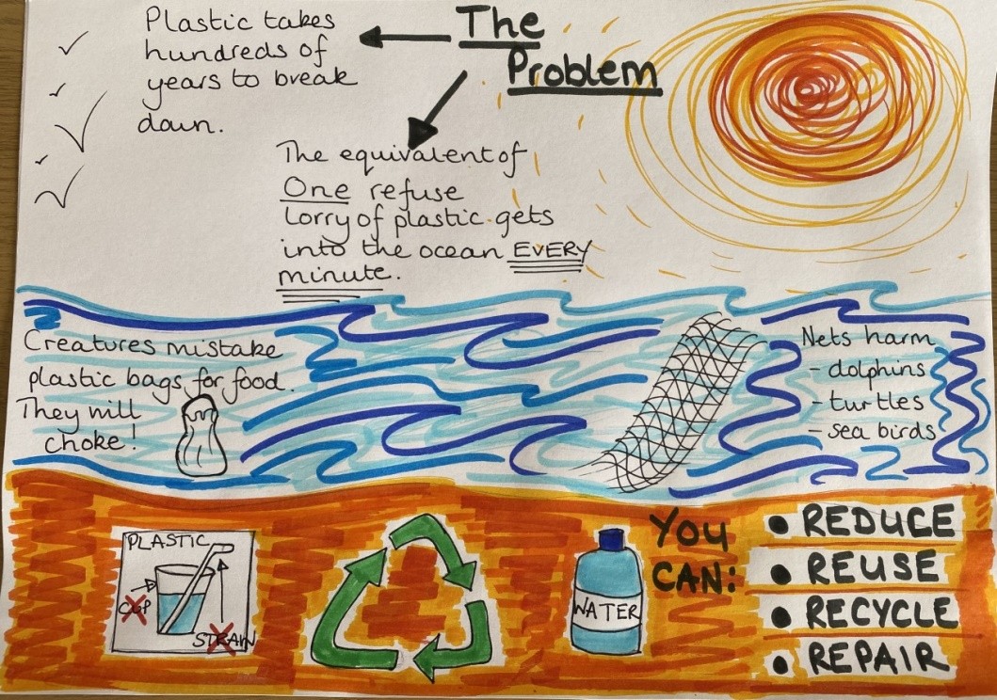

RME
Places of Worship
RECAP: Churches: did you manage to label the important features found in a church? Here are the answers below.
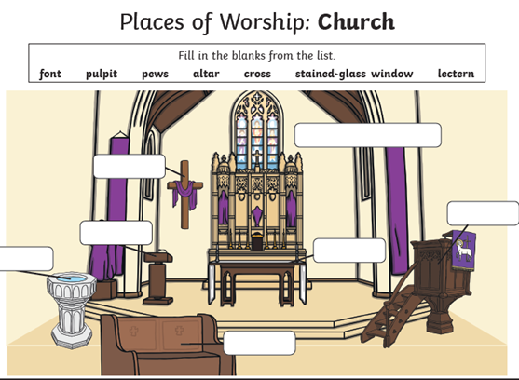

stained glass window
cross
lectern
pulpit
font
altar

pew

Activity 1: Thinking about the places of worship you have studied, what do they have in common? What differences were there?
Things in common | Differences

Activity 1: can you complete this true or false quiz on the places of worship you have been learning about?
Mosques:  - There are no pictures on the walls.  - People keep their shoes on inside a mosque.  - Worshippers sit on benches to pray. | Synagogues  - Worship is led by the Rabbi.  - The holy book is written in English.  - Men and women sit together in the synagogue.
Gurdwara  - You don’t need to cover your head in the gurdwara.  - People sit on the floor to pray.  - The room where people pray is called the Langar Hall. | Churches  - Stained glass windows show different saints.  - The font is where babies are christened.  - The holy book is kept on the altar.

Match the holy books: draw a line to match up each holy book to the correct faith.
Islam – Mosque | Bible
Judaism – Synagogue | Guru Granth Sahib
Sikh – Gurdwara | Torah
Christianity – Church | Qu’ran

Activity 2: Imagine you are part of the welcome team for a place of worship. You can choose a mosque, synagogue, gurdwara or church. You are getting ready to show a group of children around the building. Which three parts of the building are you going to take your tour group to? Why these parts? What do you want to tell the children about these features?
Optional: design an information leaflet for your tour group. It will need to include some illustrations and a sentence or two on the three features you want to talk to them about in your chosen place of worship.
French
Food vocabulary revision: Can you match each picture to the correct label?
