P3 Week 10 Blog (wc 22nd June 2020) – Literacy Activities
Spelling
Purple/Orange | Blue | Yellow | Green
sentence  separate  special  straight  strange  strength  suppose  surprise  therefore  though  thought  through  that’s  there’s | say  school  sea  small  snow  something  still  stop  stopped  suddenly  take  tell  than  these  thing  things  think  thought  through | say  school  sea  small  snow  still  stop  that  the  their  them  then  there  they  this  time  to  too | saw  said  same  she  see  so  some  that  the  their  them  then  there  they  this  time  to  too

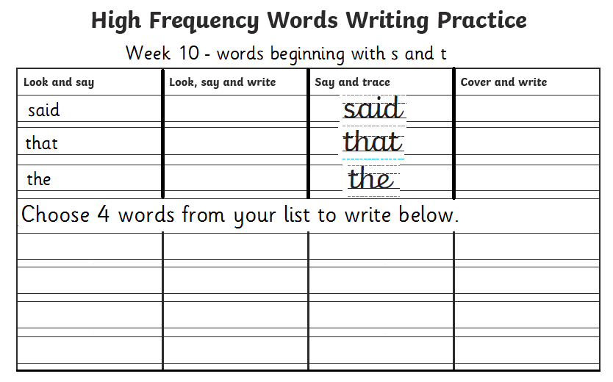
Handwriting Activity

Name: Date:
Story of common words which start with ‘s and t’
Read the silly story and highlight the common words. Highlight all the common words every time you see them!
say school sea small snow

still stop that the their them

then there they this time

to too

There was a little school which was by the sea. People would say that it was quite small. In the winter, when it began to snow, the children would stop what they were doing and stand still by the window just watching it fall into the sea. It was their favourite thing to do. Their teacher was happy to let them do this for a little while.
Then, one day something strange happened! There was something in the water! They could see it shining in the light of the morning sun. They kept it a secret from their teacher. They thought that if they told her this secret, she might not let them look out the window anymore. They came up with a plan instead …
Time seemed to go forever that day as they waited for the bell to say it was the end of the school day.
‘When the bell goes, run home to get a backpack with supplies’, said Jim.
‘I want to come too’, said Penny.
The children were so excited to find out the secret of the sea …
Write what you think happens next, including 3 of the common words at the top of the page.

Correct the spelling mistakes that are circled below then re-write the sentences below with all the correct spellings.
Sentence | Correct spelling
‘I like your pencil case’, sed Cara.

Not all big cats have the saim markings.
I have sum friends in different classes from me.
Ther are lots of things to explore in the jungle.

Lis Friday I am going to read my favourite book.

I can tell the tyme.

1.______________________________________________________________________________________________________________
2.______________________________________________________________________________________________________________
3.______________________________________________________________________________________________________________
4.______________________________________________________________________________________________________________
5.______________________________________________________________________________________________________________
6.______________________________________________________________________________________________________________

Wordsearch
Find the common words in the wordsearch. Remember they all start with s and t!
say school sea small snow

still stop that the their them

then there they this time

to too

s | a | y | a | b | t | c | t | a | h | t
c | a | b | c | d | h | a | h | b | c | h
h | a | b | l | c | e | d | e | a | b | e
o | t | q | l | w | m | e | r | t | y | u
o | h | i | i | o | p | a | e | s | d | f
l | e | g | t | h | e | i | r | h | j | e
k | y | l | s | z | x | c | v | b | m | n
p | r | s | t | n | l | m | n | i | o | l
p | q | r | o | s | o | t | t | u | v | l
n | e | h | t | x | y | w | z | h | x | a
x | y | z | x | y | z | x | y | z | i | m
s | t | o | p | w | t | o | o | a | e | s

What word did you find first?
What word did you find last?

Reading
Go on to https://www.booktrust.org.uk/books-and-reading/have-some-fun/storybooks-and-games/hairy-maclary/ to read ‘Hairy MaClary.

After you have read it through you can write a short list of about 5 words (or you can just discuss them) that you are unsure of and discuss them with someone at home to find out what they mean.

Here are some questions to answer about the story. You might want to read through the story again to help you find the answers

- Who is the Author of ‘Hairy MaClary?
- Who is the main character?
- What is the number of Hairy MaClary’s home?
- Who did Hairy meet first?
- Name the dog, who was covered in spots.
- Find all the rhyming words when Hairy meets Muffin McLay.
- How many dogs did Hairy meet altogether?
- Who was hiding in the shadows?
- How did the dogs react to who was hiding in the shadows? Do you think all dogs would normally react in this way?
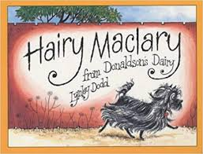

Writing
Let’s think about all of the wonderful memories that we have made together in P3, as well as all of the amazing learning that you achieved!
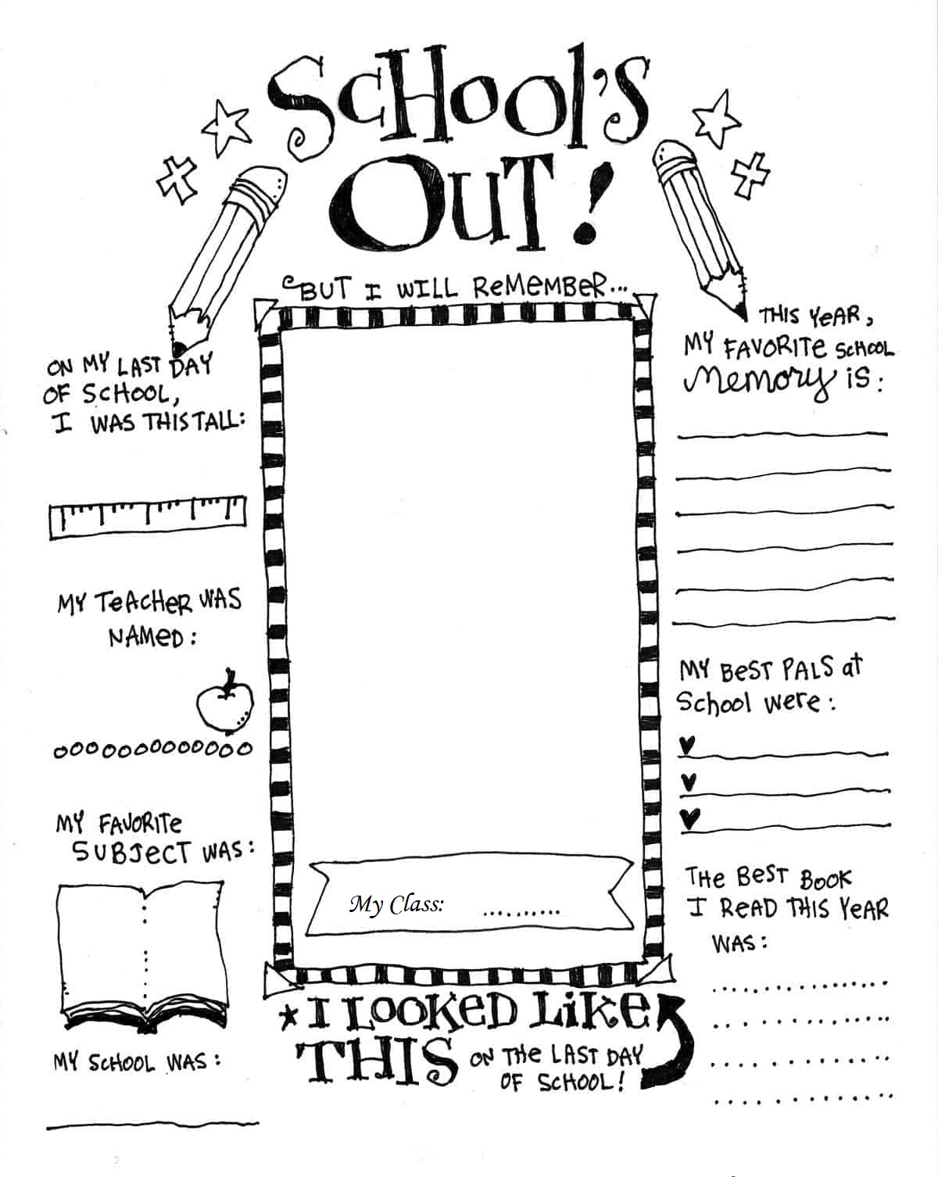
You could record this on a piece of paper and keep it somewhere safe to look back on over the summer holidays Here’s an example of some things that you could include…

Let’s set a list of goals that you aim to achieve over the Summer Holidays. Maybe you’d like to read more books, get better at a sport or riding your bike, or you might want to teach someone a new skill.
Here is an example to help you
