P2 Home Learning Grid 2020 Week 11
We are introducing a new format of grid to better support your child and you in your daily learning routines.
Each grid will contain 1 Literacy, 1 Numeracy and 2 other Curriculum-based activities per day.
These can be done whenever suits you and your family. Please see suggestions of supporting websites and resources.
For the last week in school we would usually be doing fun, team building activities so we have tried to include active activities for you to try at home for your last week in Primary 2.
Literacy and English | Numeracy and Maths | Cross-Curricular Activities
Writing  Write a letter to your teacher for Primary 3. Have a think about what you would like to tell your new teacher about yourself.  You can use the template below to help with the layout of a letter. | Numeracy- Place Value  Use the below online games to practice place value. We have been thinking about thousands, hundreds, tens and ones.  https://www.topmarks.co.uk/learning-to-count/place-value-basketball  https://www.topmarks.co.uk/place-value/place-value-charts | Activity 1- Dance  Choose one of your favourite songs and make up a short dance routine to it.  Perform your short routine to someone in your household.  Activity 2: Health and Wellbeing  Follow the simple recipe below to make bread.
Reading  Visit https://home.oxfordowl.co.uk/books/free-ebooks/  Go to 'Oxford level' and this will show the books covering the stage you were reading in school or search for books by age. | Maths- The Maths Factor  Choose an activity to try from “The Maths Factor”: https://www.themathsfactor.com/  Have a think about different strategies you can use. | Activity 1-Health and Wellbeing  Meditation is a great way to help relax and look after our mental health. Have a go at the following Cosmic Yoga video: https://www.youtube.com/watch?v=K1SVHDcQH7o  Activity 2-Science  Try to plant a flower and make sure it has everything it needs to live.
Writing- Film Review  Watch your favourite film and write a book review.  Tell us why you enjoy the film.  You can use the template below to help. | Numeracy  For this activity you are going to be the teacher.  Try to teach someone in your house how to solve some of the following questions. You could use counters, toys, number lines etc to help teach them.  1a). 22 + 5 b) 6 + 7  2a) 9-3 b) 26 – 4  3a) What is double 3? b) What is double 8?  4. I have 8 sweets. How do I share them equally between me and my friend? | Activity 1- French  Practise saying numbers to 20 in French. https://www.youtube.com/watch?v=UsEz58BblMY  Activity 2- PE  Challenge time! See how many of the following activities you can complete in 30 seconds or a minute:  star jumps, squats, toe touches, lunges and sit ups.
Phonics  Get an adult to make up 5 non-sense words and 5 real words. Can you figure out which are the non-sense words and which are the real?  For example:  non-sense word- zog real word- log | Maths- Shapes  Have a go at drawing the following 2D shapes:  triangle, square, rectangle, hexagon.  Now have a go at drawing the following 3D shapes:  cube, cone, cylinder, sphere  Check your shapes by watching the following videos: https://www.youtube.com/watch?v=svrkthG2950 https://www.youtube.com/watch?v=guNdJ5MtX1A | Activity 1-Art  Draw a bucket and inside include pictures of things you would like to do and learn about in Primary 3. Think about different colours you can use to make the picture bright and colourful.  Activity 2- Science  Have a search around your house for things you can push and pull and create a list for them.  For example, I can push the buttons on my TV remote. I can pull my door open.
Talking and Listening  Talk to an adult about what you are looking forward to in Primary 3. This may help with your letter writing task.  For example, perhaps something you would like to learn about or making new friends. | Numeracy- Times Tables  Have a look at the following videos to practise your times tables.  2x: https://www.youtube.com/watch?v=BGWMPqh04o4  5x: https://www.youtube.com/watch?v=gfRVYPcfecE  10x: https://www.youtube.com/watch?v=8yxMJUHBslY | Activity 1 – French  Practice saying days of the week in French: https://www.youtube.com/watch?v=Lpwf5N0rfVE  Activity 2: Just Dance  Have a go at the following Just Dance videos.  https://www.youtube.com/watch?v=gCzgc_RelBA  https://www.youtube.com/watch?v=6Q7-tzCCh3w
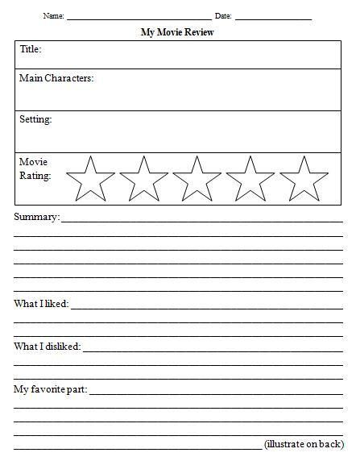
Resources and Examples
Writing Templates:

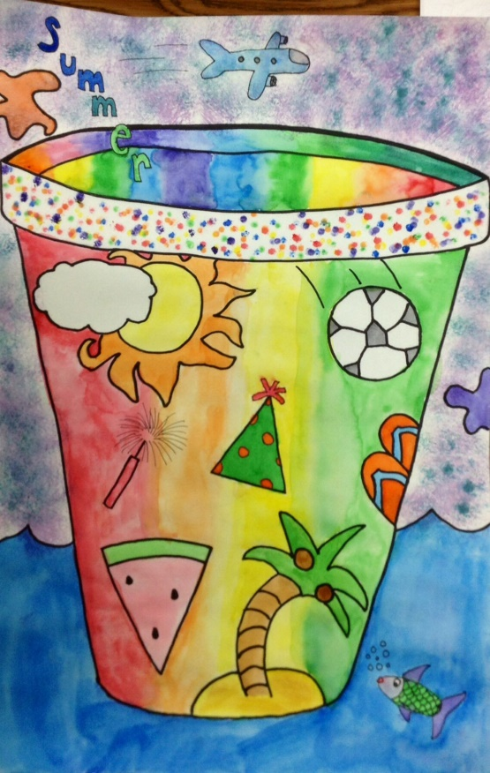
Health and Wellbeing: Bread Recipe Art: Bucket list

