P3 Week 9 Blog (wc 15th June 2020) – Numeracy Activities
Numeracy

Play 100 Square Connect 4 with 2 players. You will need a 100 square (like the one below). Don’t worry if you can’t print this out, it is easy to make – just go and grab a bit of paper, a ruler and pencil
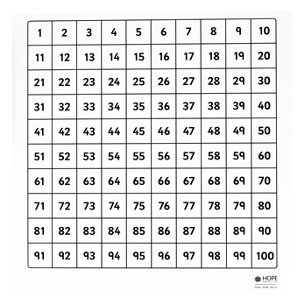
Then open the attached Powerpoint and follow the questions. Your adult could give you extra ones for more challenge, for example multiplication and division!

Addition and Subtraction Online Challenge
How far can you get on our challenge chart? Play these online games and see how far you can move down the table.
Challenge/Skill level | Website links
- Number bonds to 10 | http://www.ictgames.com/saveTheWhale/
- Doubles Addition | http://www.maths-games.org/ladybird-doubles.html
- Addition to 20 | https://www.ictgames.com/mobilePage/funkyMummy/index.html
- Add 10 more | https://www.ictgames.com/mobilePage/depthCharger/index.html
- 2 digit addition | https://www.mathplayground.com/ASB_Canoe_Puppies.html
- Addition to 100 | https://www.topmarks.co.uk/maths-games/hit-the-button  select number bonds option then add to 100

Challenge/Skill level | Website links
- Subtraction within 10 | https://www.mathplayground.com/ASB_IslandChaseSubtraction.html
2. Subtraction within 20 | https://www.mathplayground.com/superhero_subtraction.html
3. Subtract 10 from a number | https://www.mathplayground.com/math_monster_subtraction.html  select 10 and click enter
4. Subtract a 1 digit number from a 2 digit number | http://www.sheppardsoftware.com/mathgames/fruitshoot/fruitshoot_subtraction.htm  select level 2
5. Subtract a tens number from a 2 digit number | https://www.splashlearn.com/subtraction-games  you can do this by counting backwards in tens off the decuple
6.Subtraction within 100 – missing number | https://www.mathplayground.com/puzzle_pics_subtraction.html

