P3 Week 9 Home Learning: Science, Social Science, RME and French. 15.06.2020
Science
Theme: I Spy Nature!
Lesson: Trees

Activity 1: Why are trees important?
When I was little, there were some lovely trees in our garden: a lilac tree, a willow tree and a crab apple tree. Birds would sing in them, the lilac flowers looked pretty and had a lovely smell and the apples were made into yummy crab apple jelly. Trees are important for living things. Find out more: https://www.youtube.com/watch?v=D7dKRBZVLvI and https://www.youtube.com/watch?v=5I7u5FMQxHA

Trees are important because:
- Other creatures make their homes in trees.
- Tree roots stop soil blowing away. Healthy, deep soil makes it easier for other plants to grow, and a lot of living things need the plants for food.

Can you come up with two more reasons why trees are important?
1.
2.

Activity 2: Can you spot any of these leaves from trees in your surroundings? Are there any birds or insects on the tree? Does the tree have any flowers or fruits? When do you think we might start to see more seeds? Clue – CONKERS.
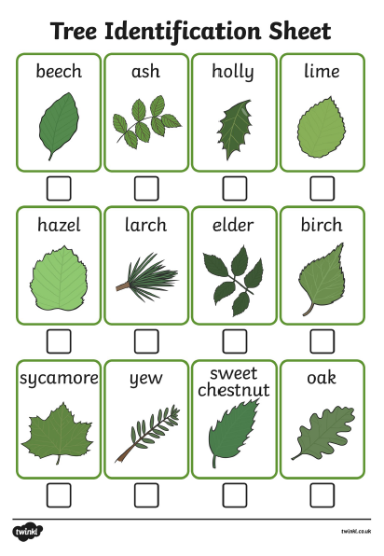

Other resources for identifying trees – ASK AN ADULT TO HELP YOU FIRST

* Scan a photo of a tree using Google Lens. This also works for plants and insects.
* The Woodland Trust has produced a free tree identification app. Search by features such as the bark, leaves, flowers, seeds and fruits. The app also has interesting tree facts, describes the tree’s value to wildlife, and includes folklore and symbolism. For details go to:
https://www.woodlandtrust.org.uk/trees-woods-and-wildlife/british-trees/how-to-identify-trees/
Activity 3: Acrostic Poem. Write an acrostic poem – it does not have to rhyme – and illustrate your work. Here is my poem.

Tall and proud,
Reaching that cloud.
Every creature needs your air.
Everyone is glad you’re there.
Social Science

Sea animals and plastic in the ocean

RECAP: Sharks were our sea creatures in focus last week. Were you able to find answers to the questions?
- True or false: sharks never sleep. They don’t sleep in the sense that humans do. They have rest and active periods. Some need to keep moving to breathe.
- True or false all shark species will attack humans. False. It is unusual for sharks to attack humans. People are a bigger threat to sharks than they are to us.
- True or false: sharks can have up to 3,000 teeth. True.
- What is cartilage? Cartilage is a tough and flexible substance that is not as hard as bone. It makes up the shark’s skeleton. Humans have cartilage in their ears and the tips of their noses.
- How many types of shark are there? 500 known species.
- Which species of shark is the largest? The whale shark. It can be 5 to 10 metres long.
- How does their shape help sharks to swim? The shark’s torpedo shape helps it to glide through the water.
This week, we are going to look at dolphins. Facts in the film will help you with this quiz:
- True or false – dolphins are herbivores.
- Do dolphins have a nose?
- How do they breathe?
- True or false – dolphins can hold their breath under water for 25 minutes.
- How do dolphins locate objects under water?
- Dolphins live in groups called pods. Why is this useful?
Link to the film: https://www.youtube.com/watch?v=2776_ah7qb0

Activity 2: leaping dolphins.
You will need:
- One sheet of A4 paper
- Scrap of paper – an old envelope will do
- Thin strip of cardboard (I used an empty cereal packet) or a clean lolly stick.
- Colouring pencils or felt tipped pens.
Step 1 | Step 2 | Step 3 | Step 4 | Step 5
Turn your A4 paper so it is landscape, then draw and colour a picture of the surface of the sea. Make sure the sky takes up at least half the picture. | Cut a slit in the paper – measure in 5cm from the left side. Make your cut about 18-20cm long. | On the scrap paper, draw and colour your dolphin. Cut it out and glue it to the top of the cardboard strip or lolly stick. | Tuck the lower part of the cardboard inside the slit in the paper. | Your dolphin can leap out of the sea and make graceful arcs, just like real dophins.

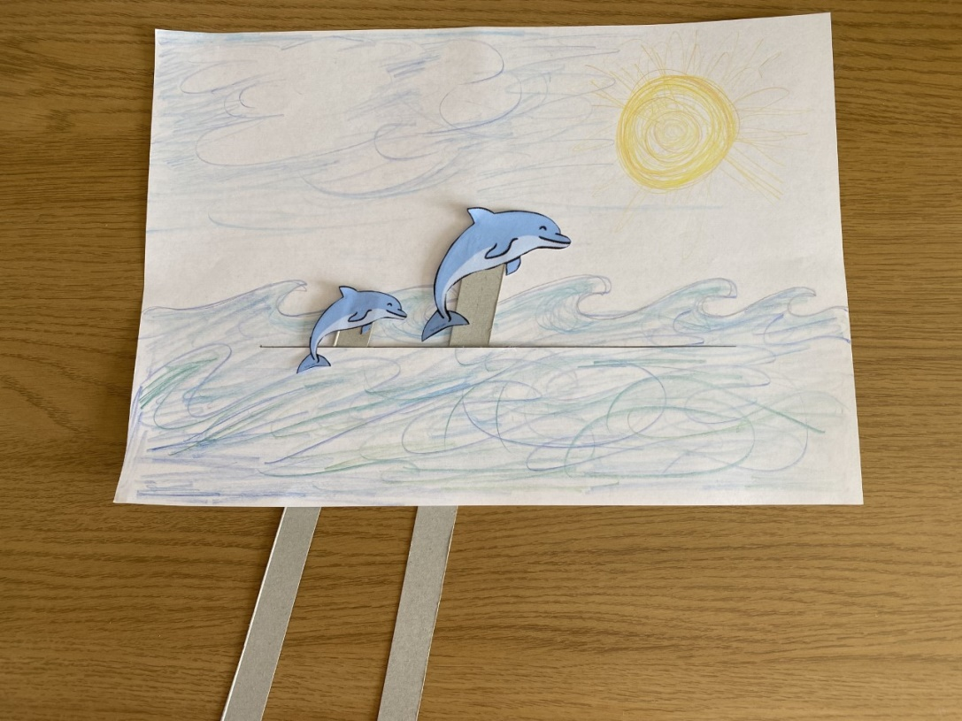

RME
Places of Worship
Last week we learned about a place of worship called a Gurdwara, where Sikhs go to pray and meet friends. Did you manage to tell someone about these facts about the Gurdwara?
- Are there any special rules about what people wear? Yes, people take off their shoes to show respect. Head coverings are worn to show people are humble – the opposite of pride, thinking a lot of yourself – when coming to pray to God.
- Where do people sit to pray? People sit on the floor.
- Is there a holy book? Yes, the holy book is called the Guru Granth Sahib. It sits above the people to show its importance.
- Are there any other interesting rooms in the Gurdwara? The Langar Hall is a room in the Gurdwara where people gather to share a meal. It is eaten on the floor, showing that everyone is the same before God. It also shows the importance of sharing to Sikhs.
This week we will study churches.
Activity 1: Listen out for these terms being mentioned in the films:
Lectern, Pulpit, Bible, Font, Bred, Wine, Tabarnacle.
Church of Scotland https://www.bbc.co.uk/programmes/p0115c21
Catholic church https://www.bbc.co.uk/programmes/p0113v3t

Activity 2: label the important objects shown in the diagram below.
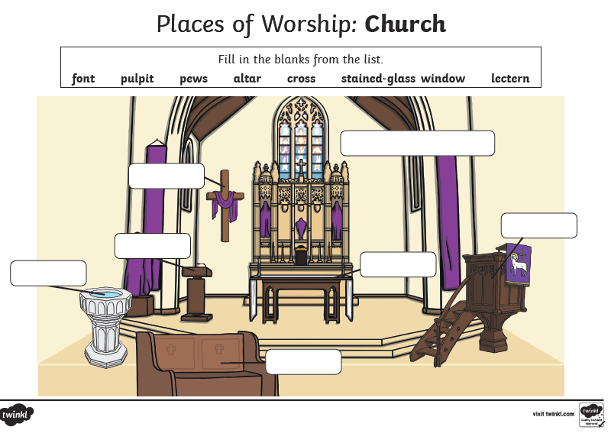

French
Week 9 Revision of colours, greetings and numbers.
Les couleurs treasure hunt.
Search around indoors/outdoors, and see if you can find one object in each colour below. Too easy? Try two/three/four objects in each colour:
- Rouge – red
- Orange – orange
- Jaune – yellow
- Vert – green
- Bleu – blue
- Violet – purple
- Rose - pink
- Marron – brown
- Gris – grey
- Noir – black
- Blanc - white
Bonjour mes amis! Practise your French greetings and phrases: https://www.youtube.com/watch?v=NXkJ88ygPY0
Counting songs – pick and mix to improve your counting fluency:
- 1-20 https://www.youtube.com/watch?v=UsEz58BblMY
- 20-50 https://www.youtube.com/watch?v=wlYqz2unHKc
- 50-70 https://www.youtube.com/watch?v=oIYvC7r05mU
- 1-100! https://www.youtube.com/watch?v=DnrTrbJ6mYs

