P3 Week 9 Blog (wc 15th June 2020) – Literacy Activities
Spelling
Purple/Orange | Blue | Yellow | Green
occasion  occasionally  often  opposite  ordinary  particular  peculiar  perhaps  popular  position  possess  possession  promise  potatoes | only  or  our  over  park  place  plants  pulled  play  please | of  off  on  one  out  our  people  put  park  plants | of  off  old  on  one  out  people  put

Handwriting Activity
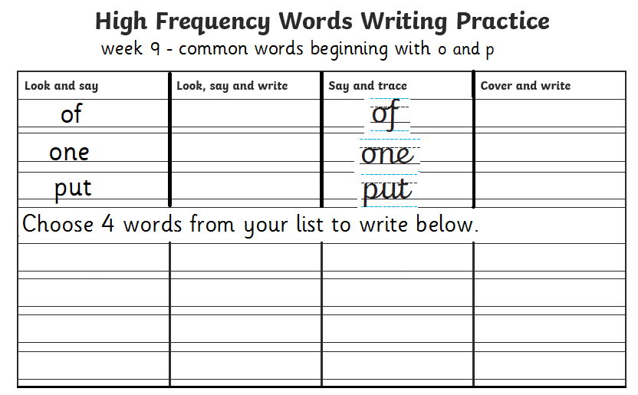
Name: Date:
Story of common words which start with ‘p and o’
Read the silly story and highlight the common words. Highlight all the common words every time you see them!
of off on one out

our people put park plants

One day, our dog escaped out into our garden and started digging up the plants! After he got a telling off, he ran away to the park. People had to move out of the way as he was running so fast! Luckily one of our neighbours stood in front of him and we managed to put his lead on.

Write what you think happens next, including 3 of the common words at the top of the page.

Correct the Spelling Mistake (on next page)

Sentence | Correct spelling
‘Can I have won of those cookies, please?’asked Jess.

I took my home learning owt my book bag.
How many peeple live in your house?
I poot a birthday card in my friend’s tray.

I like to go to the purk.

I need to water my plans.

Correct the spelling mistakes that are circled below then re-write the sentences below with all the correct spellings.

1.______________________________________________________________________________________________________________
2.______________________________________________________________________________________________________________
3.______________________________________________________________________________________________________________
4.______________________________________________________________________________________________________________
5.______________________________________________________________________________________________________________
6.______________________________________________________________________________________________________________

Wordsearch
Find the common words in the wordsearch. Remember they all start with o and p!
of off on one out our

people put park plants

o | f | a | b | c | d | e | f | g | h | i
m | n | o | p | m | o | n | o | p | m | n
a | b | c | a | b | n | c | a | p | b | c
p | l | a | n | t | s | x | y | u | z | z
x | y | z | x | y | z | x | y | t | u | o
m | n | o | p | m | n | o | p | m | n | u
z | z | q | n | w | e | r | t | y | u | r
q | r | s | t | e | u | v | w | x | y | z
k | i | e | l | p | o | e | p | a | s | d
r | f | g | h | j | k | l | z | x | c | v
a | b | n | m | q | w | e | r | t | y | u
p | j | k | l | n | m | o | p | f | f | o

What word did you find first?
What word did you find last?

Reading
Go on to https://www.youtube.com/watch?v=zs_8W-lvo0Y to read along with ‘Greta and the Giants’.
The font is not clear so you may have to treat this as an audio book this time

After you have read it through you can write a short list of about 5 words (or you can just discuss them) that you are unsure of and discuss them with someone at home to find out what they mean.

Here are some questions to answer about the story. You might want to read through the story again to help you find the answers

- Who is the Author of ‘Greta and the Giants’?
- Who is the main character?
- What happened when she stepped out in to the garden?
- Who do you think the giants are?
- Name 2 things that the giants did.
- Why do you think that the animals looked tired and sad?
- What did Greta do? Did it work at first?
- What happened that helped Greta to get noticed by the giants?
- Do you think it’s important to always do things alone or ask for help sometimes?
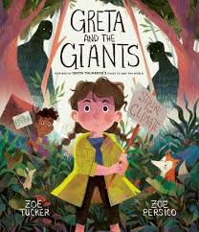

Writing
Let’s think about going back to school and seeing our friends again. Think about someone you like to play with, someone you like to read with, someone you like to work with …
Make a plan of how you aim to be a good friend to someone in P4 and write it down
Here are some ideas to start you off …
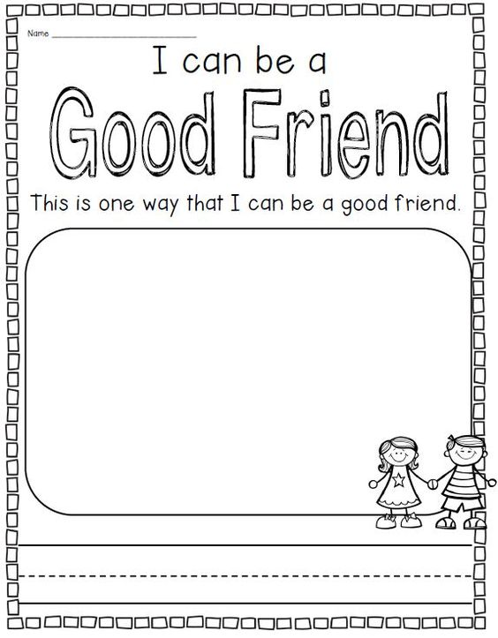

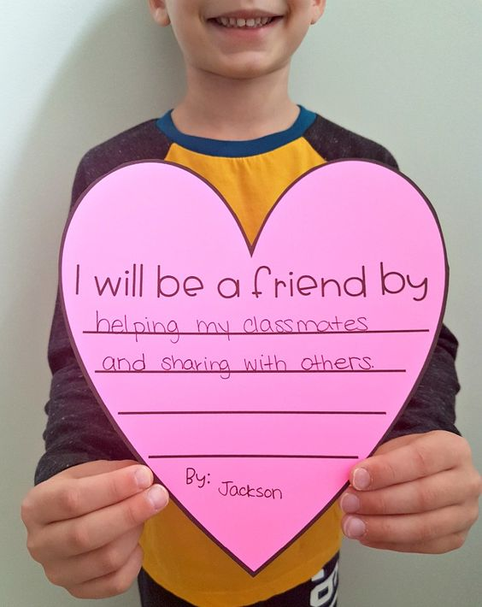

Now you have thought about how to be a good friend, let’s think about how we can show kindness to everyone in our P4 class! We are going to write a list of the ways that we can be kind to your classmates.
Here is something to get you started on your writing task …
