P3 Other Curricular Areas Activities – Week beginning 15th June
PE
This week, I would like you to start making plans for the summer holidays – how are you going to keep fit over the summer, what activities would you like to try out? In the blank grid below, create your own fitness grid – you can start some of the activities this week to test them out! I’ve also created an example in case you need some inspiration.
Do twenty star jumps every morning for a week. | Try to beat my personal best time running a lap of the garden. | Go out for a walk and try to spot as many types of birds as I can.
Dance to my favourite song before I go to bed. | Create an obstacle course. | Create a dance routine and teach it to a partner.
Throw ten teddies into a basket from 5 paces away. | Learn to do a cartwheel. | Do mindfulness yoga every evening for a week.

Health and Wellbeing
Following on from our discussions about skills and goal setting, we are going to think about future careers. Of course, you don’t need to decide what job you would like right now, but it can be really fun to look at different jobs and see the kinds of things you might do. Just like we use our success criteria in school to be successful in our lessons, in the world of work you will use a set of skills to be successful.
Think about a job you might like. What kind of skills will you need to get that job? What kind of skills will you use in the job? What kind of tasks might you have to complete day-to-day?
Here is an example about being a teacher:
To get the job, I had to go to university and learn all about being a teacher. I had to read lots of books about teaching (research skills) and learn how to plan lessons (time management, planning).
In my job as a teacher I have to work with other members of staff (teamwork) and deliver lessons to the class (communication).
Tasks I have to complete day-to-day are planning lessons, teaching the class, printing and filing papers and making up timetables
Think about a job you are interested in and see if you can answer the questions above.
Expressive Arts
Art and Design
Portrait drawing
This activity will help you learn about shape, tone and line. You can do this with a partner or by yourself, you will just need slightly different equipment for each. We are going to be drawing portraits. A portrait is a picture of a person. We will be doing single colour portraits today – you only need one colour to draw with.
You will need:
Something to draw on
Something to draw with
A partner OR a mirror
Start by folding your paper in half one way and then the other way – this will give you a guide to make sure your drawing doesn’t fly off the edge! The point where the folds meet is the centre of your drawing. If you are drawing a partner, ask them to sit in front of you and stay very still. If you are drawing yourself, prop the mirror up in front of you so you can see your whole face at once.
Start by drawing the bottom of the nose on the point where the folds meet. Think about areas that touch that point – the nostrils will go out to the sides and the bridge of the nose will go up.
Keep your lines light and soft as you sketch in the features of the face, and then when you are confident you have them in the right place, you can press your pen or pencil a little harder to create a darker line.
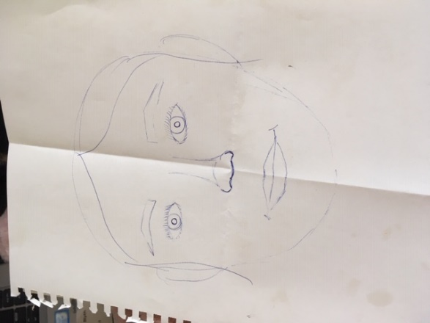
Once you have the features drawn in, you can add some tone to your drawing. Tone is how light or dark something is. Look again at your model’s face and notice where the darkest areas are – it’s probably under the chin, nose and eyebrows. With a light stroke, colour those areas to create a shadow. This will help your drawing look more 3D. 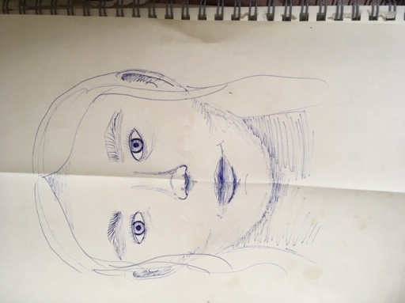
Music
For music this week, we will be thinking about tone in music. Below are three clips from movies. I would like you to listen to each one but don’t watch the video – close your eyes while it plays. Then, I would like you to write down how you felt while listening to each clip. Have a think about why that might have been. Was it the tempo (speed) of the music? Was it the instruments they were using? Composers use lots of different tricks to make you feel certain ways when listening to their music.
After you have listened to the clip, play it again, but this time watch the video at the same time and see if you felt the same way.
1 https://www.youtube.com/watch?v=vofCeiD3nrc
How I felt while listening: | How I felt while watching:
2 https://youtu.be/BV6EN4cm3UE?list=PLL_AvPc4DQ_xBac4iNYk4jbS9kP6GKujX
How I felt while listening: | How I felt while watching:
3 https://www.youtube.com/watch?v=lIzRa3DZf6A
How I felt while listening: | How I felt while watching:

