P3 Maths Week Beginning 15th June - Skills Focus: Measure
Have a go at this measure quiz below. The first one is done for you – remember to write the unit of measurement after the number, otherwise you could get confused!
- How long is the caterpillar?

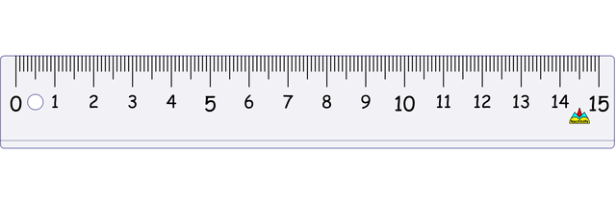

10cm

- How wide is the butterfly in cm?

- How long is the line in millimetres? (There are 10mm in a centimetre, so you can multiply the number of centimetres by 10 to find how many millimetres it is).

- Estimate (guess) how wide the door is, then measure it in centimetres and see how close you were.

- Measure the height of one of your books in centimetres. If there were three of those books stacked on top of each other, what would the total height be?

- Fill in the blanks in the sentences below:
I am going to measure my _______________.
First, I will estimate how long it is – I think it is ___________cm long.
Now I will measure it using a ____________________.
It is ___________cm long, which means that it is __________mm long.

