Growing Up and Moving On

Next year I’d like to be..

When I was a baby I…

In Primary 1 was good at…

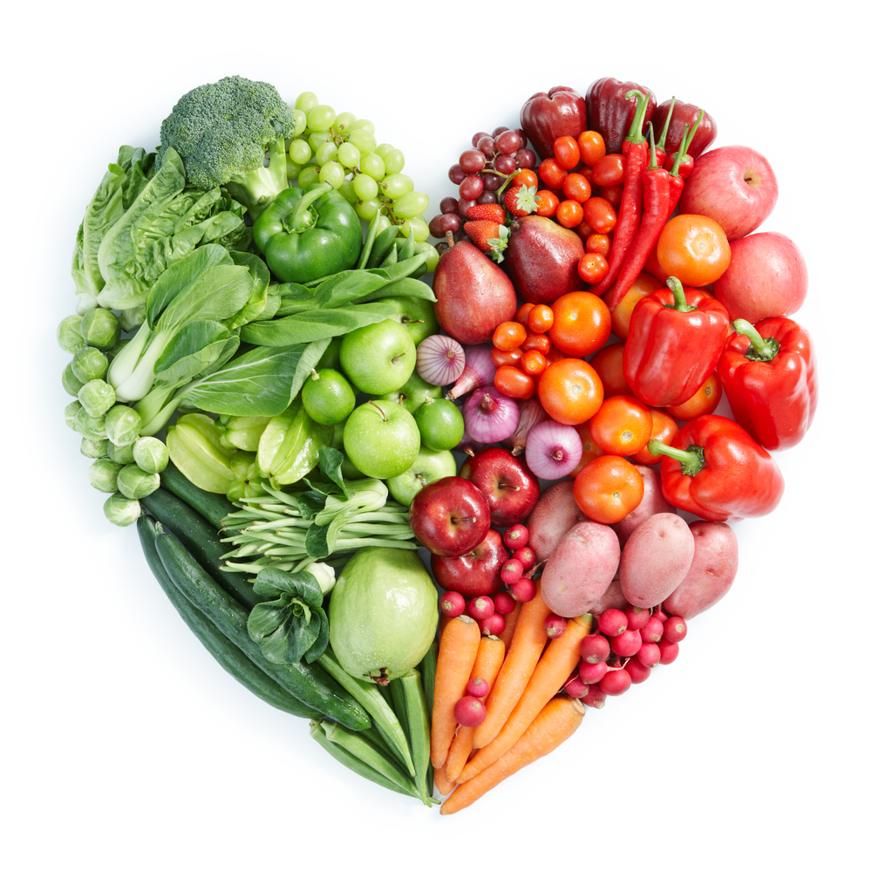

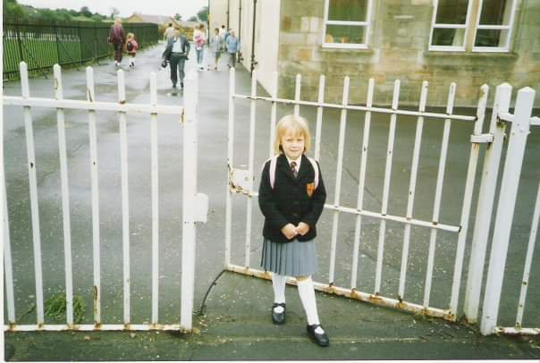

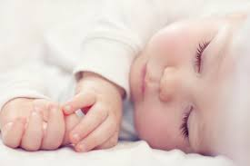

When I was in Primary 1 I was good at learning my keywords.

Next Year I’d like to be better at eating healthy and keeping fit.

When I was a baby I slept in a cot.

________________________________________________________________________________________________________