Welcome Back Activities!
Good Morning Everyone and welcome to Summer Term! Here are some Monday activities to get your term started. Your teachers are all looking forward to seeing you back on Teams tomorrow (P4-7) or interacting with you and your parents on the Blog.

P1-3 Literacy/RME/Maths/Art/STEM
Let’s think about Noah.
Can you remember the story of Noah’s Ark? Here it is, have a watch and listen https://www.youtube.com/watch?v=_vjjhMWJ2wE
- Can you write a summary of the story?
- Can you write 3 quiz questions for your teacher (or 5 or 7, if you are feeling very hardworking!) based on the story. Here’s a question to get you started: ‘What is the name of the main character in the story?’
Here’s some problem solving relating to Noah https://nrich.maths.org/136
Things to think about:
- Which animals will you choose?
- Could you choose a whole new set after this one? And another?
- What’s the greatest number of creatures Noah might have seen?
- What’s the smallest number of creatures Noah might have seen?
- What if Noah saw 18 legs, or 24 legs? What creatures might he see then?
- What if Noah saw 12 creatures, not 12 legs? What would be in the group then?

- Can you draw a picture of one of the groups of animals Noah might have seen? Can you draw your picture in the style of the famous painter Gauguin? He like to use very bold and bright colours. Here’s one of his paintings. It’s called Tahitian Landscape.
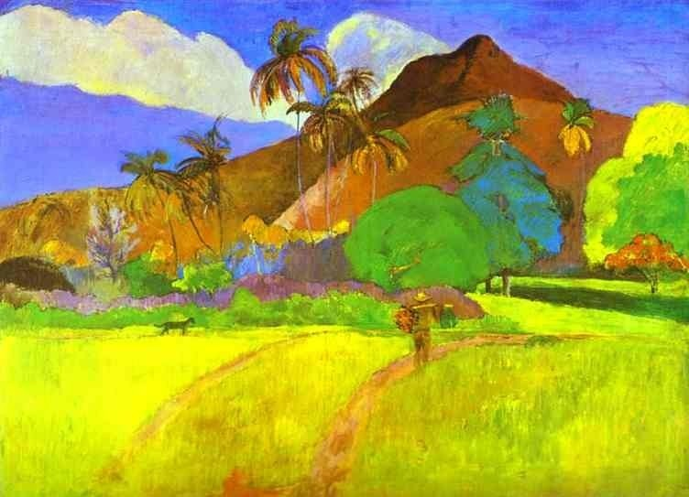
Now, the important thing about Noah’s ark was that it floated very well. Build something that floats, from things you find in the house.
Experiment with your Ark!
- How far can it float? Can you estimate and measure the distance?
- How much can it carry before it sinks? How could you make it float further or carry more cargo?
Write a set of instructions describing how you built your Ark, or tell another person in your household about how you did it.

P4-7 Maths/Literacy/HWB/STEM

Let’s think about 100. ‘Reach 100’ https://nrich.maths.org/1130
Things to think about:

- Where could you start?
- How do the four digits you choose contribute to the zero in the units column of 100?
- What can you say about the size of the digit in the top left cell?
- What is the smallest total you can make? What is the largest? Can you make all the totals in between?

- Listen to this extract from David Walliams ‘Gangsta Granny’…..she’s not quite 100 but she’s old! https://www.youtube.com/watch?v=Zm1P0l8OpHQ

Using the information contained within the extract, draw and label a picture of one or more of the characters mentioned. For example, you might draw Ben, and label him as kind, supportive, young. Evidence your answer, so, if you write ‘kind’, you might want to add something like, ‘because he stands up for his Gran against Mr Parker’.

- ‘The story of the theft of the Crown Jewels would be on the TV for weeks, on every website, and emblazoned across every front page of every newspaper in every country in the world. However, no one, but no one, would suspect the thieves were in fact a little old lady and an eleven-year old boy. They were going to get away with the crime of the century!’

Imagine that Ben and his Granny had got away with the Crown Jewels. Can you write the article for the front page of the next morning’s newspapers? Don’t forget to include a headline, description of the theft and maybe a picture of the suspects. The article could include an interview
with one of the Beefeaters. Did they hear or smell anything suspicious?

- Ben’s Granny needs a new getaway scooter for her heists. Can you design one for her? Either make one from bits and pieces you have in the house or draw the design for one, labelling all its special features.

- Have you heard about Major Tom on the news? Find out 10 facts about him. It’s his 100th birthday on 30th April. Please make a card for him and we will try to send them all to him.

