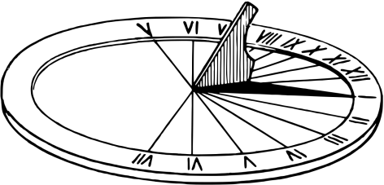
Let’s Make a Sundial
Design and create a sundial from readily available materials.

Challenge | Learning Intentions | Success Criteria | Skills
Each team will be given materials to make their sundial.  We then need to chunk the challenge.  Each group must then give out task roles.  Each team will design and present their model for display.  Each team will share how their Sundial meets the criteria with the class. | To construct a model of a sundial. (Sundial, a device used to tell time by the sun.)  To create a presentation to explain how it meets the design challenge success criteria.  To work effectively in a team.  To develop our thinking skills.  To take on task roles. | A successful sundial will:  - have a pointer, called a style or gnomon, which casts a shadow  - have a numbered dial on which the shadow falls to show the hour.  A successful presentation will:  - Explain how the sundial was made  - Explain how it will work. | Skills:  - Creativity  - Communication  - Organisation  Specific Observable Behaviours:  I can see:  - Planning  - An organised group using task roles.  - Groups of children working together.  I can hear:  - Brainstorming ideas  - Everyone’s ideas being discussed.

