Pre-School Home Teaching Service
Christmas Activity Pack

Contents
Christmas Sensory Tubs
Sensory Boards
Christmas Song Bags
Christmas Treasure Trail
Decorate your own Christmas Tee
Make your own Gingerbread Playdough
Make you own Snow Globe
Make you own Snow
Make your own Snow Dough
Smell Pots

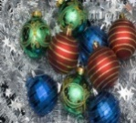
Christmas Sensory Tray
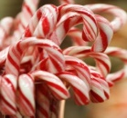
This is a fun activity which provides the opportunity for children to learn about Christmas at their own pace through exploration. (To ensure safety however, children should be supported in play and supervised at all times.)
Learning Opportunities:
Creativity: Freedom to choose, explore and developing imaginative use of the resources.
Sensory: Using all of the senses to explore resources, helping to make connections in their brain to learn about their world.
Motor skills (Movements of the fingers and body): Scooping, Pouring, Lifting, Stretching, Using pincer (finger) grips to pick up small objects.
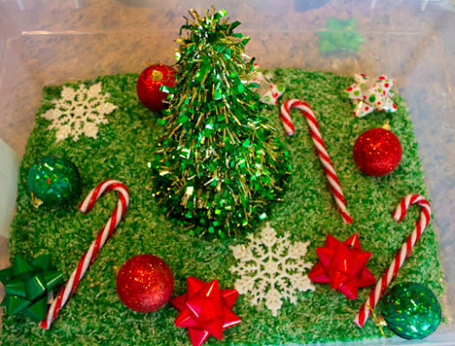
Literacy: Hearing lots of ‘names’ of objects and ‘descriptive’ words to label items in the box for your child
Maths: Exploring colour, shape, weight, size, counting etc.

How to make a sensory tray:
1. Find a large box, tub or tray. An under bed storage box is really good as it helps to restrict the amount of mess and is easy for your child to access. (Don’t go to any expense, make use of what you have at hand - a cardboard box can be just as good!)
2. Fill the box with anything you like. The idea is that your child will have to search through the box to find the items hidden inside.
For the sensory filling you could use: Cotton wool, bubble wrap (used for packaging) Shredded paper, tinsel, odd socks or anything else you have lying around the house that you can hide the objects in and your child can rummage through.
3. Then add different Christmas themed items. Ideally you would like items that stimulate all the different senses i.e. different textures, smells, sounds, tastes and sights.
Here are a few suggestions to get you started: Stars, Baubles (or any other decorations), Candy Canes, Light Up Toys, Beaded Garlands, Bells, some bits cut off your Christmas Tree or other Christmas scents: cinnamon sticks, dried orange, peppermint etc.
4. Then let your child explore the box and have fun. Play alongside them, talking about the different items they find and commenting on what they are doing with it.

A Christmas Themed Sensory Board
A sensory board works in a similar way to a sensory tray…but makes play more visual!
It offers little ones a range of sensory experiences in a simple, easy to access way.
This is particularly important for little ones who have not yet learned to look for things, as they are still developing ‘object permanence’.
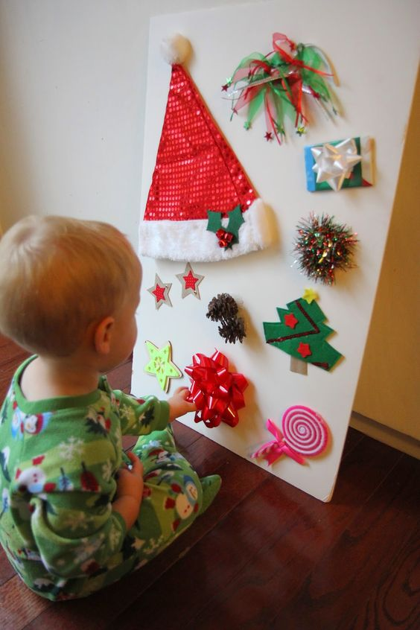
(Object Permanence -When something is out of sight but still there! E.g. Like a rattle falling from the pram. When the little has no awareness of object permanence the object is out of sight, ‘gone’: when they have learned object permanence, the child recognises it hasn’t gone -it is just out of sight and they look over the side of the pram for it to be returned.)
Learning Opportunities:
By placing a limited number of items on a board it helps to:
-focus attention and build increased concentration.
-build opportunities to ‘choice make’.

How to make a Christmas Themed Sensory Board:
- All you need is a piece of strong card, board, back of a dinner tray etc.

- Collect a range of between 3-5 Christmas items for your child to explore. (The items can be anything that is of interest to you child but again, try to have a mix of textures/sensory experiences).

- Items can be attached using sticky Velcro, so you can easily change items to keep the play motivating for you child, or stick them onto the board with glue for a more permanent result.

- Again, this activity should always be supervised to ensure your child remains safe.

Christmas Song Bag’s
Christmas songs and rhymes are a great way to engage you child in the Christmas Season. The repetitive and rhythmic aspect of music generally offers reassurance and is inviting to little ones.
In addition to this, Christmas songs are particularly good at supporting little ones socially as they tend to played continually during the Christmas season, universally across communities and generations making them hugely inclusive.
Learning Opportunities:
-Offer consistency and reassurance across many contexts, at a busy time of year: home, -nursery, shops etc.
-Builds opportunities to learn about Christmas events
-Learn new Christmas words and/or sign’s
-Teaches “cause and effect” -they give you an item and that makes you sing!
- With regular use your child will learn they can choose the songs, helping to build ‘choice making’ skills.

What you will need:
A bag, stocking or box
A collection of Christmas objects to represent Christmas Songs (e.g. A star shaped dough cutter for ‘Twinkle, Twinkle’; Wrist bells for ‘Jingle Bells’; Soft Toy Santa; When Santa got Stuck up the Chimney’ A branch for ‘Incy Spider’ and white pompom for ‘I’m a little snowman’, Angel Decoration for ‘Row the Boat’
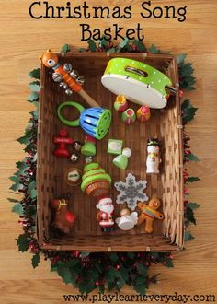
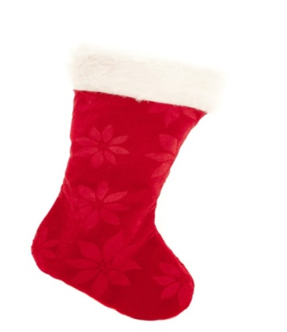
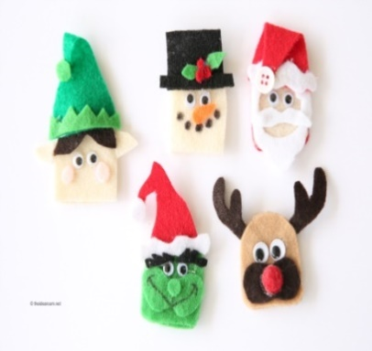
(Or you could choose own songs and use puppets, photos, PEC’S signs or drawings in the bag)

Song Lyrics for your Song Bag

Twinkle, Twinkle  Twinkle, Twinkle little star,  How I wonder what you are?  Up above the world so high  Like a diamond in the sky,  Twinkle, twinkle, little star,  How I wonder what you are? | Jingle Bells  Jingle bells, jingle bells  Jingle all the way  Oh, what fun it is to ride  In a one horse open sleigh  Hey, jingle bells, jingle bells  Jingle all the way  Oh, what fun it is to ride  In a one horse open sleigh | When Santa got stuck up the chimney  When Santa got stuck the chimney he began to shout,  "You girls and boys won't get any toys  If you don't pull me out,  My beard is black  There's soot in my sack  My nose is tickling too!"  When Santa got stuck up the chimney  A-choo, a-choo, a-choo!
Incy Wincy  Incy Wincy spider climbed up the winter tree,  Down came the snow and made poor Incy freeze.  Out came the sun and dried up all the Snow  So, Incy Wincy spider had another go! | I’m a Little Snowman (I’m a little teapot tune)  I’m a little snowman short and fat,  Here is my scarf and here is my hat,  When the snow is falling come and play  Quick before I melt away!  (National Youth Choir – Mini Music Makers)  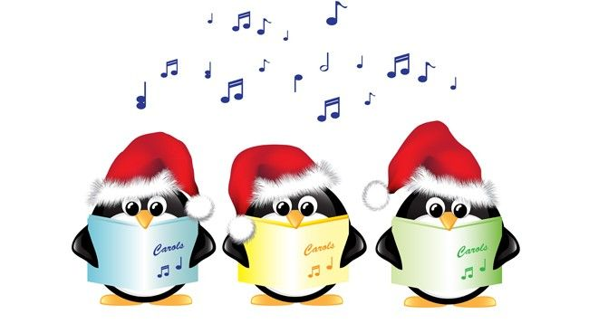  https://www.minimusicmakers.org.uk/resources/e-news/doc_download/26-christmas-songs.html | Row your boat  Row, row, row your boat  to the North Pole,  Wave your hand to Santa  and make angels in the snow!

Christmas Treasure Trail
Wrap up warm and go for an adventure!
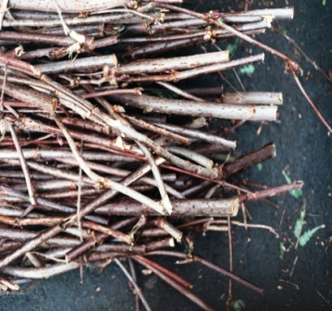
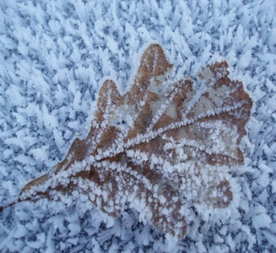
There are lots of things you can find on your doorstep; acorns, pinecones, leaves, holly, sticks, stones, snow. Take a bucket along with you and you can take them home to use them in play: Line, Stack, Tower, Cover, Roll, Make etc.

Children often stop and notice all the small things that often go unnoticed in a busy adult world. Stop and notice with them, as if for the first time. Give your child time to explore the things that interest them. Talk to them about the experience.
- Feeling the wind/rain on their face.
- Looking at frost glistening on spiders webs.
- Watching the movement of water in puddles or leaves on trees.
- Listening to twigs snap or leaves rustle as you stand on them.
- The squishy feeling of standing in mud or walking though wavy grass.
- Walk: in the dark, over pebbled surfaces, over stones, on wet grass, heather etc.

You could take a camera and put photographs of your experiences into an album to share another day.
Learning Opportunities:
-Learning about the world!
-Good for Health and Wellbeing

What you will need:
-Warm clothes
-A bit of time

Decorate your own Christamas Tree
If your child can’t resist touching your tree, give them one of their own that they are allowed to touch!
You can buy a mini one and decorations quite inexpensively or you can easily make one yourself out of card or cut one out of material.
Stick your tree to a wall or door, and then all you need is some decorations
Learning Opportunities:
-‘Cause and Effect’ – they can do things for themselves

What you will need:
-A tree or pre-cut tree from cad o material
-Decorations -Bought homemade or cut out of a magazine, homemade (for safety, make sure they are lightweight and unbreakable)
-Sticky Velcro or Blu Tac, then just let your child decorate, remove and redecorate as often as they like.
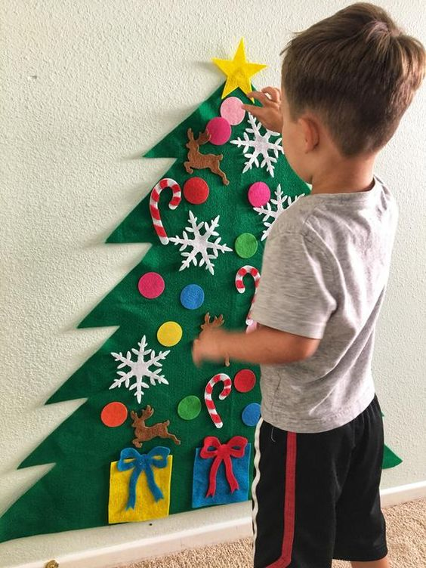

Make your own Gingerbread Playdough.

Simple and easy to make and fun for everyone.

Learning Opportunities:
-Playdough can be very calming. It is also very good for developing fine motor control of the fingers and hands. It helps strengthen muscles; teaches how to manipulate and control finger movements; develops bilateral integration (how to coordinate use of two hands together) and allows children to experience forces- pushing and pulling, developing the proprioceptive senses.

What you will need:
All you need is:
1 cup of flour
½ cup of salt
½ tbsp. ground ginger
½ tbsp. ground cinnamon
1 tbsp. vegetable oil
½ cup of water
Then just mix it together and knead it until smooth. To make it even more Christmassy and to add different textures you could add some glitter, little stars, buttons, different scents or food colouring. You can use cookie cutters, rolling pins, your hands and your imagination.

Make your own Snow Globe!
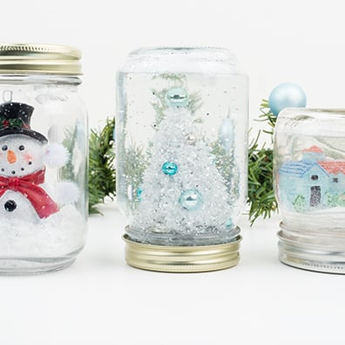
Need a bit of a break from the busy Christmas Season?
Take some time out with a Snow Globe.

Learning Opportunities:
-Gentle and Calming to watch
-Encouages focus and attention
-Builds awareness of ‘Cause and Effect’

What you will need:
- Clean, empty plastic jars or juice bottles with lids. These can be any size or shape as long as you can screw the cap on firmly.
- Glitter, Coloured beads or Party Confetti.
- Glue (This needs to be waterproof, superglue is ideal but needs to be used with caution by an adult, and kept away from children).
- Small toys, decorations, a laminated photo of someone your child will recognise or a favourite cartoon character.
- Glycerine
- Water
How to make it:
- Glue the toy or decoration to the lid and put it aside to dry, making sure the toys are tall enough to be seen inside the jar. You should also check that the toys fit the height and width of the jar with space around the sides so that the glitter can move around.
- Add water to the jar, up to the point where the lid screws on (Leaving space for the Sparkles!)
- Add some glycerine.
- Add the glitter, sparkles or confetti.
- Screw the lid on firmly, turn the jar upside down and give it a good shake. If some of the decorative items become dislodged in the process, you can easily open the jar again and remove them from the water, then glue them back down.

Sensory Ice blocks Bring the chill indoors with some fun ice activities
Make your own iced snow
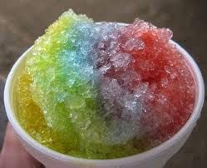
What you will need:
-basin or tub
-A grater
-Ice
-Colouring (Optional)

Grate some ice into the basin and you have snow! (It does melt pretty quickly but for a quick fun activity this is very simple.) You can play with it just as it is or introduce spoons, cups, or ladles, to extend the play.
Make your own iced building blocks
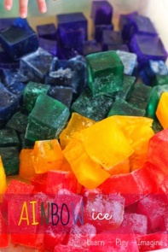
What you will need:
-Ice Cube Trays
-Tray
-Ice
-Colouring (Optional)

Tower, line, build, spin coloured ice cubes!

Make your own ‘hide and find’ Ice Cube Blocks
What you will need:
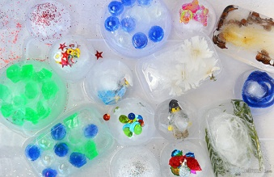
-Ice cubes or smalls yoghurt pots
-Fun figures or toys of interest
-Warm Water, Scoochie bottle (to help to melt the ice)
-Small wooden hammer (optional)

Freeze objects in plain clear water. Put in a tray to explore.
Have fun releasing the figures with warm water or a hammering action.
Sensory Snow Dough

A fun way to explore “snow” without having to wrap up warm! This is a nice light, fluffy, easy to make activity that can be shaped and moulded to make “snow” balls.

What you will need:
-Bicarbonate Soda (Found at the Baking Isle in the Shops)
-Water
-Glitter (Optional)

Add the Bicarbonate Soda to a bowl.
Add spoonful’s of water gradually while mixing with your fingers.
When it is ready, it will be light and fluffy to touch but come together when squeezed.

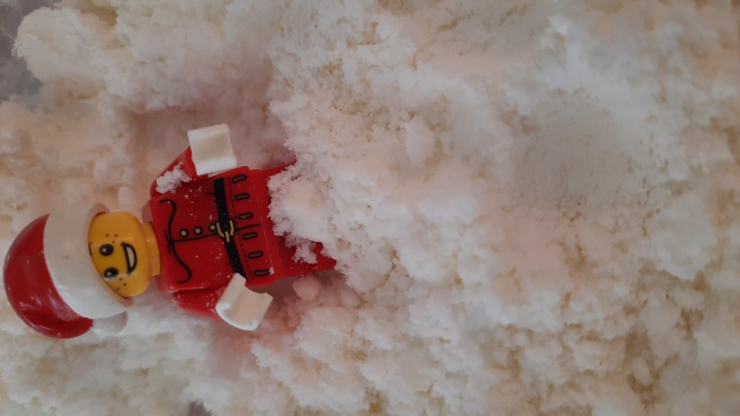

Smell pots!
This is a nice simple way to gently introduce new smells to your child helping to desensitise your child to the many Christmas scents they may be exposed to at Christmas.

What you will need:
-Small tubs, boxes, or empty spice jars with lids. (These can be homemade from an empty box or bottle with a lid or with tin foil secured with an elastic band.)

-Then just pop some “Christmas” scents inside and let your child to smell them one at a time. (Never make a child smell the tubs, allow them to explore them in their own time.)
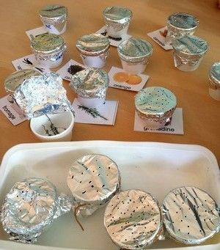
Some ideas you could try:
- cinnamon sticks
- ginger
- pine cones
- orange
- candy canes
- mint
- chocolate
- chestnuts
- cloves
- fruit cake
…or anything else that you like. This is a nice way

For more Christmas ideas visit:

Mini Music Makers
https://www.minimusicmakers.org.uk/resources/e-news/doc_download/26-christmas-songs.html

Pinterest
https://www.pinterest.co.uk/pin/91972017370638446/

Craft Ideas
https://www.thechaosandtheclutter.com/archives/christmas-sensory-activities

Pre-School Home Teaching Service
Beatlie School Campus
The Mall
Livingston
EH48 5EJ

