Pre-School Home Teaching Service Top 15 Gift Ideas
Yvonne’s Top 5  Gift Ideas | 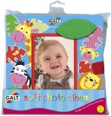  Photo Albums | 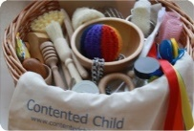  Treasure Baskets | 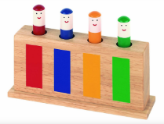  Pop Up Toys | 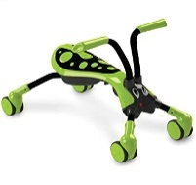  Wheely Toys | 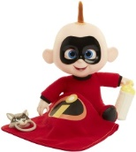  Imaginative/Dolly
Diane’s Top 5  Gift Ideas | 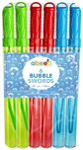  Bubble Wands | 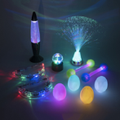  Dark Tent with Light Up Toys | 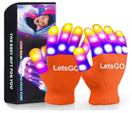  Light Up Gloves | 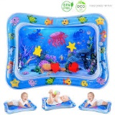  Water Mat | 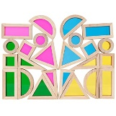  Perspex Coloured  Blocks / Squares
Gill’s Top 5  Gift Ideas | 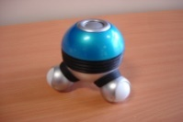  Massage Toy | 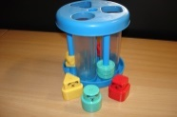  Noisy Shape Sorter | 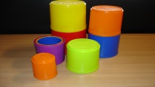  Stacking Cups | 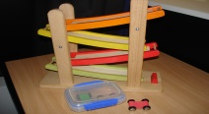  Car Run | 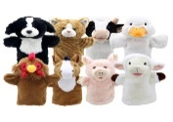  Animal Puppets

