Pre-School Home Teaching Gift Ideas
…with suggestions on why you might find these types of toys useful!

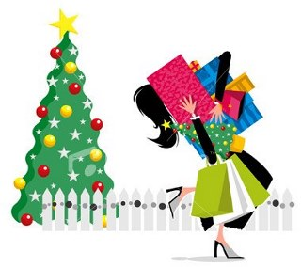

Please note
The following toys are only suggestions of the TYPES of toys that might be beneficial as a gift idea, if you are stuck for ideas, and not a recommendation to purchase any or all of these toys, or any specific brands.
You will know your child best – aim to purchase toys or resources that will be of most interest to them.
Happy Shopping!
Yvonne, Diane and Gill

Yvonne’s TOP 5 GIFT Suggestions
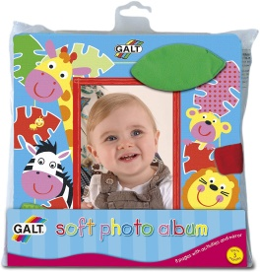 | Photo Album | Photo albums can small children learn about their world.  Fill a small photo album with either:  -Family Photos with Important People in your Childs life  -Photos of your child doing everyday routines: Eating Dinner, Bed Time, Going to nursery, Shoes on, etc.  -Photos of Important things in your child’s life: Toy’s, Pets, Foods, Places  -Fill with a variety of different coloured and textured papers or a selection of tactile materials.  They can also, offer comfort and reassurance. Can help with developing an awareness of routines. Can promote sharing attention and building relationships as you talk about the pictures together. Helps to develop an interest in books. Builds Fine motor control of the fingers to turn pages.
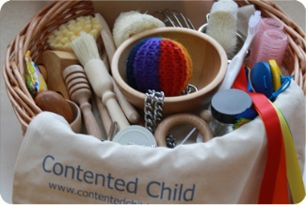 | Treasure Baskets | Treasure Baskets can build interest and curiosity  Fill a basket with a range of items that can be found around the  home: Moulding Tins, Keys, Wooden Spoons, Chains, Samples of Paper, Brushes, Mirrors, Small Scarves, Pegs, Pinecones, Jar Lids, Pom Poms, etc.  Treasure Baskets provide a huge range of sensory experiences stimulating: Touch, Taste, Smell, Hearing, Sight. Encourage the child to select and choice making. Develops imaginative use of objects. Builds confidence as there is no right or wrong way to play.  N.B - Treasure baskets should only be used with adults and removed after use.
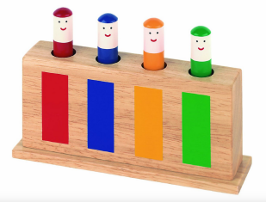 | Pop up Toys | Pop up toys are great for engaging your child in play and helping them to share attention due to the element of SURPRISE!!!  This particular little toy offers lots of learning opportunities: helps to develop hand/eye co-ordination-(looking at where the pieces fit and attempting to put them in the slots). With a little help, the child can learn to use a ‘pointy’ finger to push the figurers down. They can learn about ‘cause and effect’ as they bounce out the slots (recognising if they do something, they can make something happen). They will learn anticipation (waiting for and expecting something to happen). Your child might also use it to help with learning colours and practising how to match.
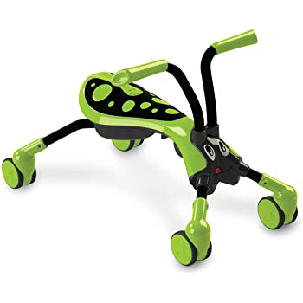 | Wheely Toys | Small Wheely Toys are great for developing physical skills including: body awareness, movement and balance.  It can also help with spatial awareness (being aware of space around the child and how to navigate obstacles that are in the in the way); making connections in the brain (having to co-ordinate many movements at the same time) and learning about safety and building confidence in learning (fall off, try again).
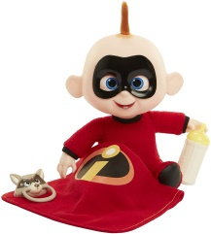 | Imaginative/Dolly Play | Toys based on Real Life objects help children to learn about all aspects of life (Doll’s, Tea Sets, Cleaning Utensils, Toy Kitchens)  Pretend play with you little one can encouraging children to practise what they see help them to learn: Communication and Vocabulary Skills (Taking turns in conversations and the names of things), Social and Emotional Skills (Sharing & Caring), Learning how to do things for themselves (Brush hair, hold a spoon, use a cup).
TOP TIP – Remember every parent wants to give their child the world! Birthdays and Christmases spans many years… so don’t feel the need to buy everything in the shop at once. Sometimes less is more! Try to aim for toys or activities that suit, interest and engage, your child now. Other gifts can wait for another Christmas or Birthday.
Diane’s Top...6 Gift Ideas

Gills’ Top 5 Gift Ideas
Massage toy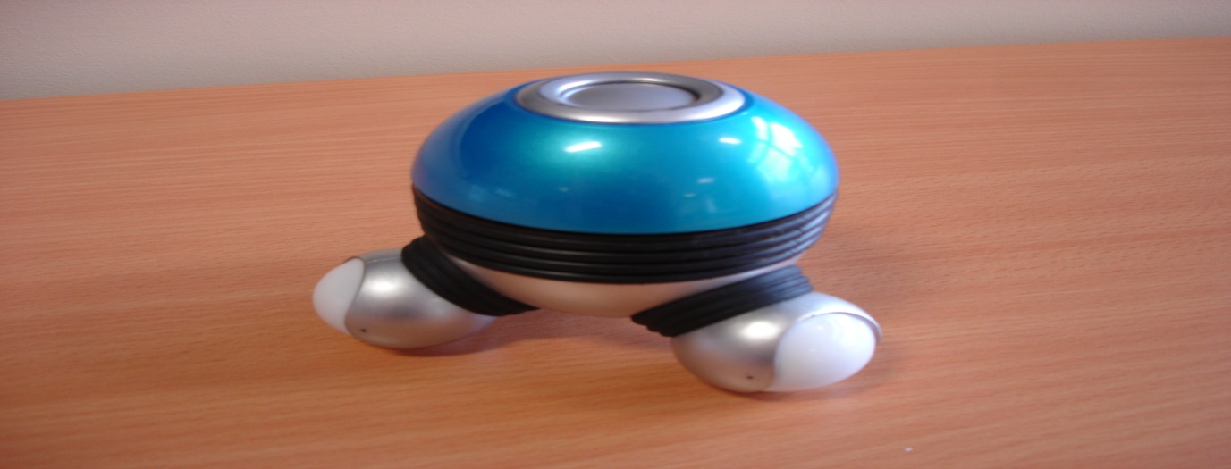
This is a nice simple toy which can be used in different ways. It can teach cause and effect. Your child will learn that in order to get it to vibrate and light up they have to press the button. Also to turn it off they need to press the button. It can be used to relax, by running it gently up and down their legs and arms or over their body. We have even found that for some children who find a haircut very stressful that gently using the massager on their head, gradually increasing the amount you do this and doing it regularly can help to desensitise them and make a haircut less stressful.
Noisy shape sorter.
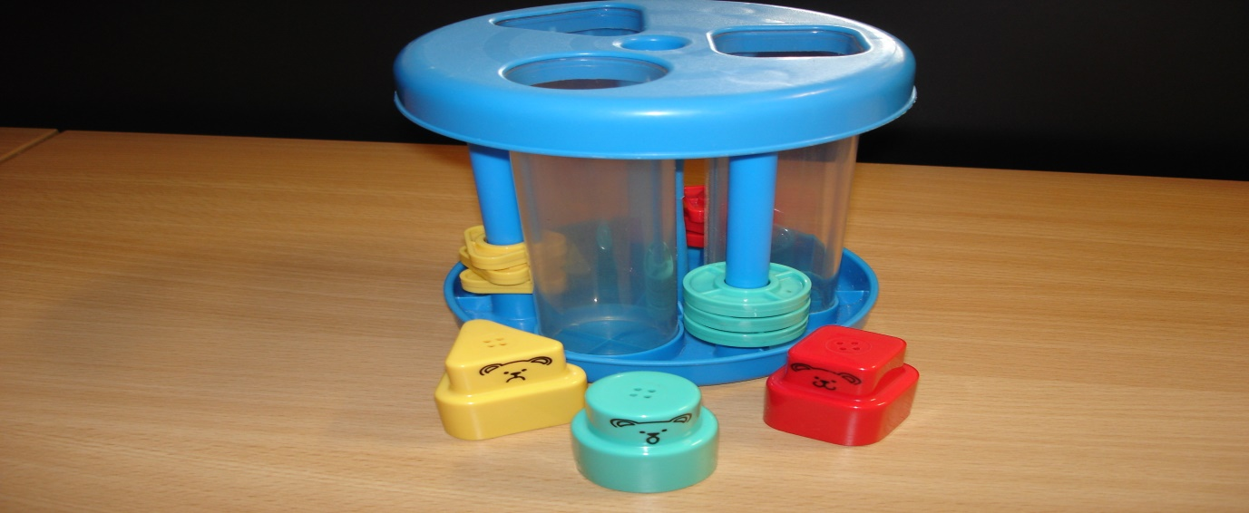
This toy can also be used for cause and effect, when the shapes fall down they make a sound. It can be used for recognising colours and shapes and fitting them into the holes. It can also be used for turn taking activities with an adult.
Stacking cups.
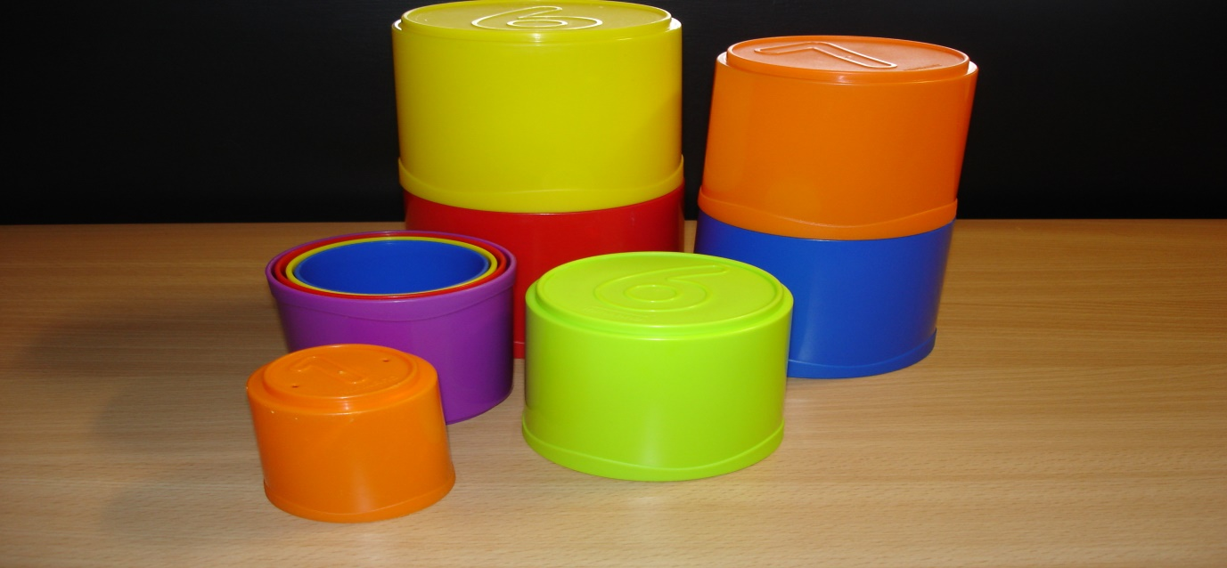
These have lots of different uses; they can be used to stack and knock down, showing cause and effect, to introduce counting, to introduce concepts of colour and colour matching. Sometimes they have holes in them and can be used in the bath or water tray for emptying, filling, pouring and watching the water drain out. Or you can use them to encourage anticipation and eye contact by putting one on your head then saying “ready steady” (pause) and then “go” wait for a response (eye contact/vocalisation) and then let it fall. You can then take turns with your child with this activity.

Car run
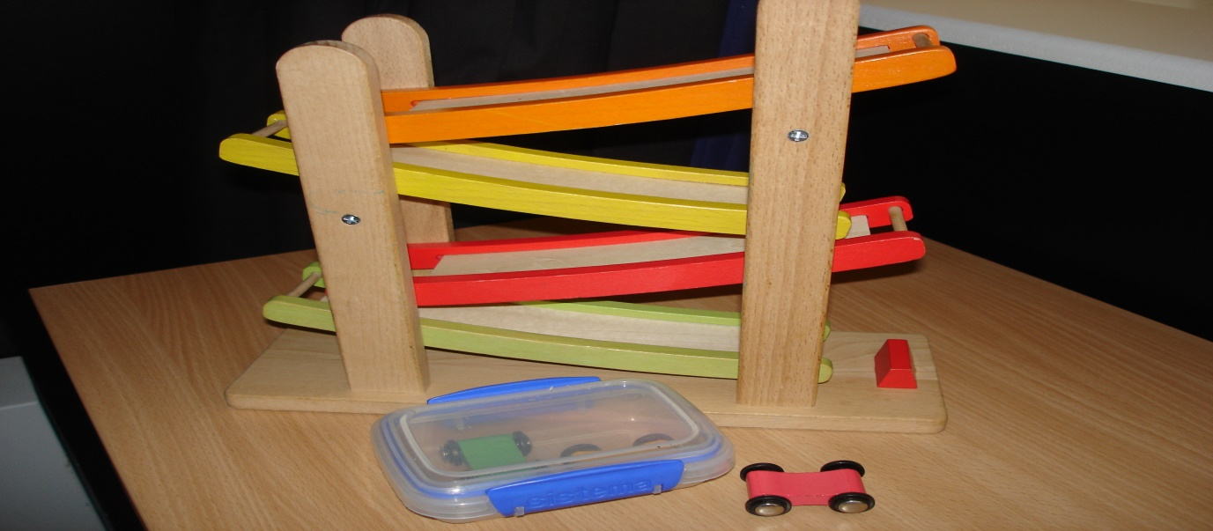
This is a great toy to help your child to share attention with you. The cars make a loud clickety clackity noise as they go down the run which will help to engage your child. Then when you have their attention this is a great toy to encourage eye contact and anticipation by holding the car at the top, saying “ready steady” (pause) and then “go” wait for a response (eye contact/vocalisation) and then let it go. This can also be used to take turns with your child.
Animal puppets
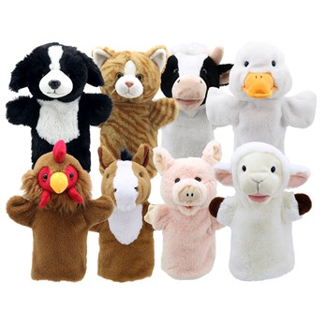
These are a great resource for imaginative play, naming animals, making animal sounds or singing Old Macdonald and encouraging your child to join in and make the sounds or name the animal.

