Hi everyone,
For today’s PE lesson we are going to start with a warm up song that we all know and love “Action song” is attached to these post.
Now that we are warmed up and ready, we are going to play a board play a board game “race to 100”. All you need is a bit of space, a dice and a family member to play with you.
Rules are simple:
Each player has their own 100’s sheet.
Players go at the same time.
Roll the dice, each person performs the exercise (you can use alternatives if are struggling or a wheel chair user), cross off that many numbers on the sheet (attached). See who gets to 100 first.
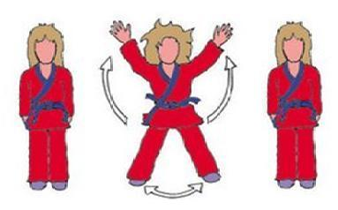
1= 7 Jumping Jacks (7 ab crunch)

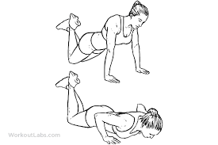
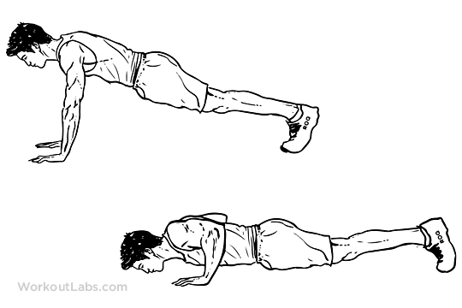
2= 5 Push-ups (with knees on floor)

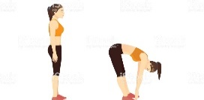
3= 5 Toe Touches

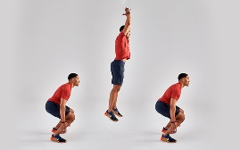
4= 4 Squat Jumps (4 elevations using chair arms)
5= 8 Mountain Climbers (8 lifts of leg alternately)
6= 10 Second V-Sit (10 second arms stretch up)

Can you get to 100 before your partner does?
Play the game as many times as you want and good luck.
Remember to keep safe and be mindful of your surroundings.

