Fiddly Fingers
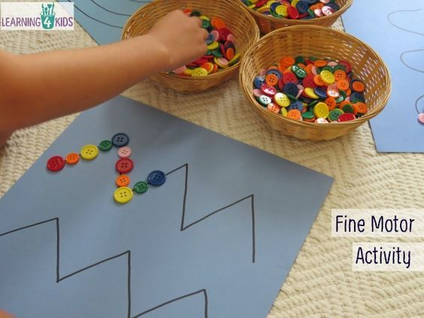
You will need: some card, a pen, some buttons and some glue (optional)
- Draw a wiggly, wavy or zig zag line on a large piece of card.
- Use buttons, counters or small pasta pieces and carefully place or glue them as you follow the line.

