# Making faces

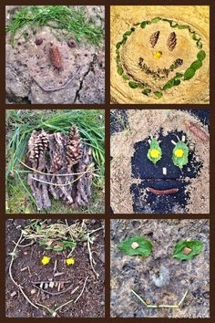

* Go outside and collect lots of different materials to make a face
* Feel the different things you have collected. Are they smooth or rough?
* Choose some of the things you have collected to make a face.
* Can you make a big face and a small face?
* Can you make a happy face and a sad face?
* Take a photo and post it on the blog

If you can’t go outside find different things in your house to make a face.