Cloud Gazing

Today you’re going to look at clouds and then make a cloud picture.

What You’ll Need
• A blue sky with clouds.
• An open, comfortable space to lie.
• A rug or equivalent to lie on if the ground is damp.
• Or a seat by a window, where you can comfortably relax.
• Items to make a cloud picture.

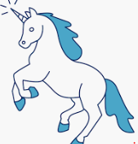
What to do.

Look at the clouds in the sky.
• Can you see a face?
Can you see a unicorn?
Can you see a fairy-tale castle?
Can you see a whale or a dolphin?
What do the clouds make you think of?

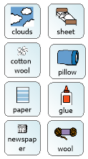
Now make a picture of the clouds you have seen in the sky.
You could use cotton wool, newspaper, wool or maybe sheets and cushions.
Use your imagination and have fun.
Take some photos to share with others.

