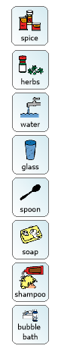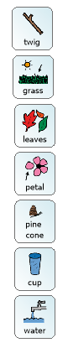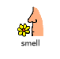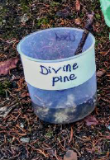

Why not make your own perfume outside. You will need a cup, water and a stick. Have a smell of things outside and choose somethings to go in your perfume. What will you call it? See what the rest of your family think.

If you can’t go outside you could make a perfume indoors. Perhaps you could mix some spices and herbs together in some water or mix some soap and shampoo together. Remember to give your perfume a name.

Make your own perfume