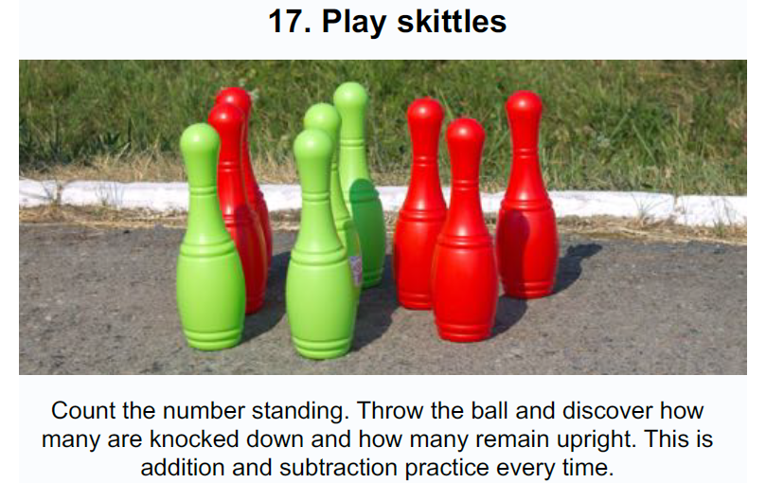

Find 10 objects such as plastic bottles, tins etc. to use as skittles. Find something to knock them down with such as a ball or lots of rolled up socks. Play the game and keep a note of your score. Good luck!