Build a Nest

Look for sticks, stones grass, leaves mud and moss to build
your nest . You don’t have to use everything- choose what you think
will work best.
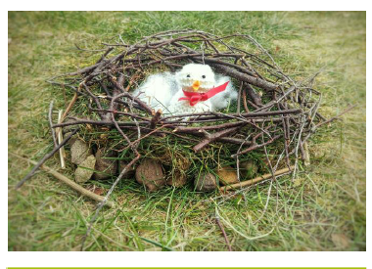
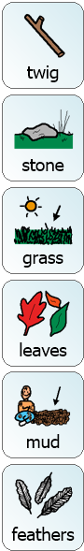
If you can’t get outside perhaps you could build a nest inside for one of your toys or even yourself!
Once you have built it put some soft materials in the nest.
If you can take a picture of your finished nest.

Have fun!

