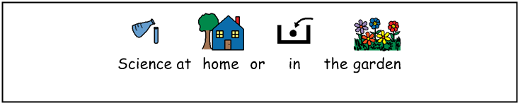
Materials:
- Find things made of different materials. Write down what they are and what they are made of.
- Find things with different properties:
  - Rough or smooth things
  - Hard or soft things
  - Bendy or rigid things
Forces
- Find things which you can:
  - Pull
  - Push
  - Twist
  - Squeeze and ask someone to take a photo of you doing it!
- Play forces charades. Act out one of the forces shown above and get people at home to guess what you are doing.

Living things
- Take photos or draw pictures of 10 different living things (NB remember that animals, humans and plants are all living things)
- Write a list or talk to someone about the things that things do.

Senses
- Try to find 5 things (25 in total) that you can:
  - Smell
  - Taste
  - Touch
  - Hear
  - See
- On a piece of paper draw round your hand. Make each finger one of your senses. Like this:
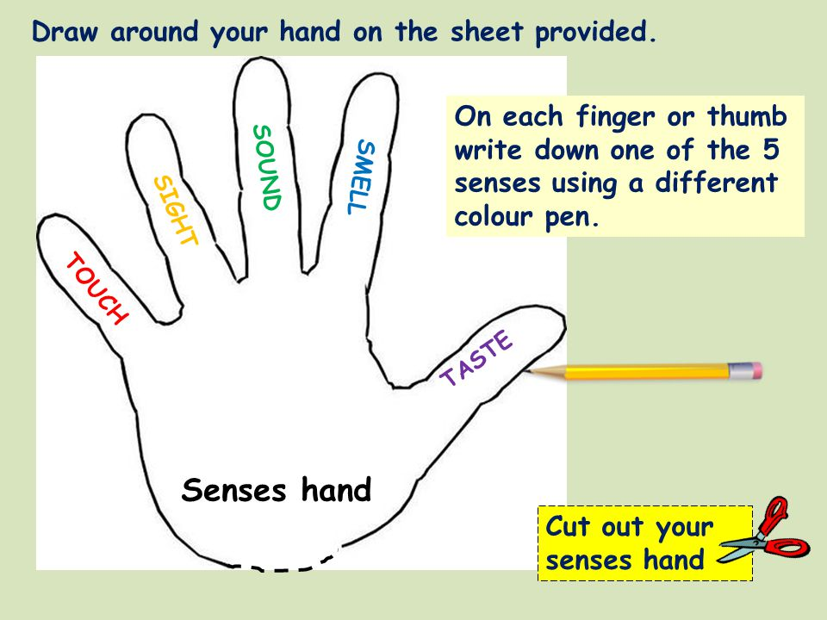

At the end of each finger draw something that you have found using the sense written on the finger. For example, you might draw an apple at the end of the finger which says taste.

Our bodies
- Sing ‘Head, Shoulders, Knees and Toes’ and remember to do the actions.
- Make up your own song for some other body parts. Try to include your:
Fingers Heart
Elbows Lungs
Neck or Intestines
Armpits Kidneys
Feet Brain
- Ask someone to draw round you on a large sheet of paper or outside using chalk or just using water. Draw on your body parts and say their names.

